**WEB-BASED ALUMNI PORTAL AND TRACKING SYSTEM FOR**

**BATANGAS STATE UNIVERSITY - ALANGILAN**

**A Capstone Project Presented to the**

**Faculty of College of Informatics and Computing Sciences**

**BATANGAS STATE UNIVERSITY**

**The National Engineering University**

**Batangas City**

**In Partial Fulfillment**

**of the Requirements for the Degree of**

**Bachelor of Science in Information Technology**

**Major in Business Analytics**

**Joseph Daniel G. Lansang**

**Allyssa Kate B. Maranan**

**Mathew L. Mendoza**

**RAYMOND KIT M. RODRIGUEZ, MSCS**

**Adviser**

**DECEMBER 2022**

**APPROVAL SHEET**

**This capstone project entitled WEB-BASED ALUMNI PORTAL AND TRACKING SYSTEM FOR BATANGAS STATE UNIVERSITY - ALANGILAN prepared and submitted by JOSEPH DANIEL G. LANSANG, ALLYSSA KATE B. MARANAN, and MATHEW L. MENDOZA in partial fulfillment of the requirements for the degree of Bachelor in Science in Information Technology major in Business Analytics, has been examined and is recommended for acceptance and approval for oral examination.**

**RAYMOND KIT M. RODRIGUEZ, MSCS**

**Adviser**

**Approved by the Committee on Oral Examination with a grade of _______.**

**PANEL OF EXAMINERS**

**RIA L. CASTILLO, MSCS**

**Chairperson**

**JEROME M. FABREGAR LOVELY T. HERNANDEZ, MSCS**

**Member Member**

**Accepted and approved in partial fulfillment of the requirements for the degree of Bachelor of Science in Information Technology major in Business Analytics.**

**_________________ PRINCESS MARIE B. MELO, DIT**

**Date Dean, CICS**

**ABSTRACT**

| **Title :** | **WEB-BASED ALUMNI PORTAL AND TRACKING SYSTEM FOR BATANGAS STATE UNIVERSITY - ALANGILAN** |
| --- | --- |
| **Researchers :** | **Joseph Daniel G. Lansang**  **Allyssa Kate B. Maranan**  **Mathew L. Mendoza** |
| **Degree :** | **Bachelor of Science in Information Technology** |
| **Year :** | **2022** |
| **Adviser :** | **RAYMOND KIT M. RODRIGUEZ, MSCS** |

**Alumni are one of the university’s most important constituents. The university keeps records of their alumni for monitoring and tracking purposes. The manual process of registration and filling-out of paper forms makes it difficult to maintain the records of the graduates. The study aimed to automate the alumni monitoring and tracking process of the university. The researchers developed a Web-based Alumni Portal and Tracking System for Batangas State University - Alangilan that would benefit its alumni and alumni coordinators with ease of access to the survey information and tracking forms, keep track of the employability of the alumni, dissemination of information through the use of email notification, and management on surveys, announcements, and alumni records.**

**ACKNOWLEDGMENT**

**First of all, the researchers would like to thank our Almighty Father for the continuous guidance, love, and support.**

**Moreover, the researchers would also like to extend their sincere appreciation to the following people :**

**To the college dean, Dr. Princess Marie Melo for her never-ending support, guidance, welcoming personality, and words of encouragement to fulfill this study.**

**To the capstone instructor, Mrs. Lanie Palad for her constant reminders, uplifting words, and advice for the betterment of the study.**

**To the capstone adviser, Mr. Raymond Kit Rodrigez for his endless assistance, countless reminders and advice, imparting of knowledge, and constructive criticisms to improve and accomplish this capstone project.**

**To the CICS alumni coordinator, Mr. Israel Peñero for being approachable and sharing his knowledge with regard to the study.**

**To their parents and friends for their continuous support, may it be through inspiring words, motivation, and assistance.**

**Joseph Daniel G. Lansang**

**Maranan, Allyssa Kate B.**

**Mathew L. Mendoza**

**DEDICATION**

**This piece of work is dedicated to**

**Our ALMIGHTY FATHER,**

**to our Parents who keeps us going despite such circumstances,**

**to the Alumni of BatStateU - Alangilan,**

**to our respected Professors who guided us all throughout, and**

**to Batangas State University - Alangilan.**

**We are grateful to all who have taken part in this achievement**

**and the success of this study.**

**Thank you and God Bless us all always.**

**J.D.G.L**

**A.K.B.M.**

**M.L.M**

**TABLE OF CONTENTS**

| **TITLE PAGE** | **i** |
| --- | --- |
| **APPROVAL SHEET** | **ii** |
| **ABSTRACT** | **iii** |
| **ACKNOWLEDGMENT** | **iv** |
| **DEDICATION** | **v** |
| **TABLE OF CONTENTS** | **vi** |
| **LIST OF FIGURES** | **x** |
| **LIST OF TABLES** | **xiii** |
|  |  |
| **CHAPTER** |  |
| 1. **I INTRODUCTION** |  |
| **Project Context** | **1** |
| **Purpose and Description** | **3** |
| **Objectives of the Study** | **4** |
| **Scope and Limitation of the Study** | **5** |
| **Definition of Terms** | **8** |
|  |  |
| 1. **II REVIEW OF RELATED SYSTEM AND STUDIES** |  |
| **Technical Background** | **11** |
| **Related System and Studies** | **15** |
| **Local Related Studies** | **15** |
| **Foreign Related Studies** | **21** |

| **Related Systems** | **32** |
| --- | --- |
| **Conceptual Framework** | **47** |
|  |  |
| 1. **III DESIGN AND METHODOLOGY** |  |
| **Project Concept** | **48** |
| **Development Model** | **49** |
| **System Development Process** | **50** |
| **Requirements Analysis** | **52** |
| **Analysis of Existing System** | **53** |
| **Fishbone Analysis** | **54** |
| **System Boundary** | **55** |
| **Hardware Requirements** | **56** |
| **Software Requirements** | **57** |
| **Functional Requirements** | **58** |
| **Non-functional Requirements** | **59** |
| **Standards** | **60** |
| **Constraints and Multiple Design** | **60** |
| **Trade offs** | **62** |
| **Design** | **62** |
| **System Architecture** | **63** |
| **Context Diagram** | **64** |
| **Use Case** | **65** |
| **Sequence Diagram** | **66** |

| **Database Design** | **68** |
| --- | --- |
| **Software Development Tools** | **69** |
| **Operating System** | **70** |
| **Database** | **70** |
| **Subscriptions** | **70** |
| **Hardware for Development** | **71** |
| **Testing** | **72** |
| **Testing Procedure** | **72** |
| **Data Gathering** | **73** |
| **Deployment Plan** | **74** |
| **Maintenance Plan** | **75** |
| **Risk Management Plan** | **75** |
|  |  |
| 1. **IV RESULTS AND DISCUSSIONS** |  |
| **Results and Discussion** | **79** |
| **Alumni TrackiIV ng Surveys** | **79** |
| **Dashboard with Descriptive Analytics** | **86** |
| **Email Notifications** | **94** |
| **Modules Management** | **97** |
| **Testing and Survey Results** | **106** |
|  |  |
|  |  |
|  |  |

| 1. **SUMMARY, CONCLUSIONS, AND RECOMMENDATIONS** |  |
| --- | --- |
| **Summary of Findings** | **154** |
| **Conclusions** | **156** |
| **Recommendations** | **157** |

| **BIBLIOGRAPHY** | **158** |
| --- | --- |
| **APPENDICES** | **163** |
| 1. **Schedule and Timeline** | **163** |
| 1. **Project Teams and Responsibilities** | **164** |
| 1. **Budget Cost and Management Plan** | **165** |
| 1. **Source Code** | **166** |
| 1. **User’s Guide** | **186** |
| 1. **Bionote** | **192** |

**LIST OF FIGURES**

| **FIGURE NO.** | **TITLE** | **PAGE** |
| --- | --- | --- |
| **1** | **Conceptual Framework** | **47** |
| **2** | **Development Model** | **49** |
| **3** | **Data Flow Diagram using Manual Process** | **53** |
| **4** | **Fishbone Analysis** | **54** |
| **5** | **System Boundary** | **56** |
| **6** | **System Architecture** | **63** |
| **7** | **Context Diagram of the System** | **64** |
| **8** | **Use Case Diagram** | **65** |
| **9** | **Sequence Diagram** | **66** |
| **10** | **Database Model Diagram** | **68** |
| **11** | **ISO 9126** | **72** |
| **12** | **Risk Assessment Matrix** | **76** |
| **13** | **Risk Mitigation Grading Matrix** | **78** |
| **14** | **Risk Matrix** | **78** |
| **15** | **Alumni Signup** | **80** |
| **16** | **Alumni Registration Page** | **80** |
| **17** | **Alumni Survey Page** | **81** |
| **18** | **Alumni Information Survey** | **82** |
| **19** | **Alumni Tracking Survey** | **83** |
| **20** | **Alumni Tracking Survey - Employed** | **84** |
| **21** | **Alumni Tracking Survey - Unemployed** | **85** |

| **22** | **Admin Login Panel** | **87** |
| --- | --- | --- |
| **23** | **Employability Status of Alumni** | **88** |
| **24** | **Career Fields** | **89** |
| **25** | **Relevance of Alumni Degree to Job** | **90** |
| **26** | **Employment Types of Alumni** | **90** |
| **27** | **Waiting Time Before Employment** | **91** |
| **28** | **Unemployment Reasons** | **92** |
| **29** | **Sample Analysis on Employability Status of Alumni** | **92** |
| **30** | **Sample Analysis on Career Fields** | **93** |
| **31** | **Sample Analysis on Relevance of Alumni Degree to Job** | **93** |
| **32** | **Sample Analysis on Employment Types of Alumni** | **93** |
| **33** | **Sample Analysis on Waiting Time Before Employment** | **93** |
| **34** | **Sample Analysis on Unemployment Reasons** | **94** |
| **35** | **Email Verification** | **94** |
| **36** | **Setup Credentials** | **95** |
| **37** | **Email Notification for New Announcement** | **96** |
| **38** | **Email Notification for New Survey** | **96** |
| **39** | **Alumni Account** | **97** |
| **40** | **Admin Account** | **98** |

| **41** | **Admin Activity Log** | **99** |
| --- | --- | --- |
| **42** | **Admin Alumni Records** | **100** |
| **43** | **Alumni Announcements** | **101** |
| **44** | **Admin Dashboard** | **102** |
| **45** | **Admin Post** | **102** |
| **46** | **Admin Add Announcement** | **103** |
| **47** | **Admin Add Survey** | **104** |
| **48** | **Alumni Survey** | **105** |

**LIST OF TABLES**

| **TABLE NO.** | **TITLE** | **PAGE** |
| --- | --- | --- |
| **1** | **Hardware Requirements** | **57** |
| **2** | **Software Requirements** | **57** |
| **3** | **Design and Technology Stack** | **61** |
| **4** | **Software Matrix for the System Development: Operating System** | **70** |
| **5** | **Hardware Matrix for the System Development** | **71** |
| **6** | **Deployment Plan** | **74** |
| **7** | **Maintenance Plan** | **75** |
| **8** | **Risk Management** | **76** |
| **9** | **Response Plan** | **77** |
| **10** | **Risk Monitoring** | **77** |
| **11** | **Analysis and Rankings** | **78** |
| **12** | **Risk Category** | **78** |
| **13** | **Efficiency Testing** | **106** |
| **14** | **Maintainability Testing** | **107** |
| **15** | **Alumni Portal Portability Testing** | **108** |
| **16** | **Admin Panel Portability Testing** | **108** |
| **17** | **Reliability Testing** | **109** |
| **18** | **Usability Testing** | **110** |
| **19** | **Accounts Module Testing** | **111** |
| **20** | **Activity Log Module Testing** | **119** |

| **21** | **Alumni Records Module Testing** | **122** |
| --- | --- | --- |
| **22** | **Announcements Module Testing** | **124** |
| **23** | **Dashboard Module Testing** | **126** |
| **24** | **Post Module Testing** | **142** |
| **25** | **Survey Module Testing** | **146** |
| **26** | **Security Test Plan** | **148** |
| **27** | **Alumni Performance Testing** | **151** |
| **28** | **Admin Performance Testing** | **151** |

**CHAPTER I**

**INTRODUCTION**

**This chapter presents the background of the study, its objectives, significance, scope and limitations, and the definition of terms for better understanding of the study.**

**Project Context**

**Alumni are one of an institution's most important constituents. They acquire experiences and become professionals after graduating by utilizing their specialization to benefit the modern world.**

**In order to monitor the progress they have accomplished, graduate tracing is one effective indicator that perceives the effectiveness of an institution in providing quality education and assistance to the graduates. It is important to acknowledge and analyze the different factors which impact the competency and skills of the alumni. This could be achieved through constructing an accurate and effective survey that would cover the significant fields of being an alumni and a professional. In line with this, the institution will be able to discover and evaluate the outcomes that may help them to re-evaluate and reassess to enhance and improve the various program curricula being implemented.**

**The different colleges in Batangas State University - Alangilan, The National Engineering University have produced remarkable and successful graduates that now take different career paths. Their employability is expected to depend on the program curriculum that has been accomplished and completed. The alumni also play an important role in boosting the institution’s name when notable achievements are attained.**

**Every year there are new sets of graduates from different fields of study and the way of registering to the university as an alumnus is being performed in a manual process. A typical scenario of going to the university and filling-out the form process which is time consuming and inefficient. In the manual process, there are inconsistencies and incomplete details in the form being submitted to the alumni coordinator. Moreover, it is evident that the alumni stop engaging with the university once they leave the campus and instead focus more on their careers which contributes to the difficulty of data collection and tracking.**

**The study entitled Web-based Alumni Portal and Tracking System for Batangas State University - Alangilan aimed to resolve the aforesaid issues. The system served as an online platform to monitor and trace various information and employment details of the alumni. This is also to analyze and associate the program curriculum to the profession pursued by an alumnus. The gathering of alumni information is automated which makes it more efficient and easier to track. The dissemination of important events and information to notify the alumni is through the use of emails. With this, the university was able to know and monitor the career and different endeavors of an alumnus and benefitted from the alumni’s experiences and skills as well.**

**Purpose and Description**

**This study aimed to develop a web-based alumni portal and tracking system for Batangas State University - Alangilan to strengthen the relationship between the institution and alumni, trace their employment status, determine the effectiveness of the course taken to their current profession, and automate the manual process of alumni application and information management. Moreover, the study had significant impacts on the following beneficiaries.**

**The alumni coordinator was able to manage and supervise the alumni information and management effectively and efficiently. The centralized storage of the data gathered from the alumni ensures that it is organized and secured. Information retrieval and dissemination is automated, easier and orderly.**

**The different colleges in BatStateU - Alangilan were able to maintain its relation with the alumni. The tracking feature of the project enabled the colleges to determine whether the completed program curriculum had an impact on the employment career of an alumnus. The result was used to reflect on the current curriculum of a course. Also, the university benefited from the expertise, experiences, and skills of the alumni.**

**The alumni batch 2017 onwards was able to keep in touch with their alma mater. The system paved the way for the alumni to be informed and notified regarding the university’s announcements and surveys through their provided emails. This also encouraged the alumni to be involved in such activities and future events of the university.**

**The students benefited in a way of knowing where to inquire when in need of respondents for their study whose target audience is the alumni and needs guest speakers or judges with a specific expertise for a certain event.**

**The researchers were able to enhance and use the learning acquired in order to design and develop the project. The utilization of existing related studies were incorporated into the system.**

**Last but not least, the future researchers may make use of the study as reference to improve such related research, studies, and systems.**

**Objectives of the Study**

**The main objective of this study is to design and develop a web-based alumni portal and tracking system for Batangas State University - Alangilan that serves as a platform to track the employability and maintain the connection of the alumni and university. The specific objectives of the study are as follows:**

1. **To conduct a survey for alumni tracking.**
2. **To generate dashboard and reports employing descriptive analytics.**
3. **To notify the alumni by means of email about the application and events.**
4. **To manage the different modules integrated in the system.**
5. **Accounts**
6. **Activity Log**
7. **Alumni Records**
8. **Announcements**
9. **Dashboard**
10. **Post**
11. **Survey**

**Scope and Limitations of the Study**

**The web-based alumni portal and tracking system for Batangas State University - Alangilan focused on automating the process of alumni application and information management of the alumni coordinator, gathering, processing, and tracking the information of the alumni, and visualizing the survey results through an analytics dashboard.**

**There are two identified users of the system namely the alumni and admin. The system covers features such as acquiring information from the alumni in the registration phase. The alumni were sent email notification regarding email verification upon registration. When verified, the alumni were able to login using their valid username and password.**

**The admin can post announcements and surveys, edit and remove contents, and view the activity logs by year, date, and user. Also, the admin had access to the analytics dashboard for the viewing of the different visualizations. On the other hand, the alumni had pages for the announcements and surveys. The system also had security features like requiring the admin and alumni to login with their correct username and password. The survey that was generated included different sections such as personal information, family background, alumni information, training programs, employment information, and other information such as special skills and membership in associations or organizations. The results of the survey were reflected on the analytical dashboard.**

**The analytics section of the study revolved around the comparison, distribution of variables, and identification of the trends and outliers by utilizing data visualization such as bar graphs and stacked column charts to present the gathered facts from the survey.**

**The survey played a crucial part on the tracking of alumni as it is the main source of data used in the analysis. Moreover, the data collected from the aforesaid sections of the survey were demographic profile such as name, age, gender, permanent address, contact number, email, and civil status under personal information. Basic information from the family background of the respondents were also included such as their father’s and mother’s first, middle, and last names. Then, for the alumni information, it consisted of course/program, major/specialization, batch/year graduated, highest educational attainment, sr-code, and optional G-suite account. The training programs, seminars, conferences, workshops, and short courses attended including the date/s of attendance and sponsorship were also included. Consequently, the employability information of the alumni covered the current nature of work or profession, employment status and characteristics, status of professional registration, location, name of company, waiting time before employment, work contact number, and job satisfaction. The special skills and membership in associations of the alumni were also included. Additional data collected when applicable contained previous profession/s, reasons for changing job/s, reasons of unemployment, and difficulties encountered in looking for a job.**

**In relation to the analysis of the relevance of the curriculum to the profession, this includes the acquired skills or competencies, and degree relevance to job.**

**The system was limited to the alumni batch of 2017 and onwards from the four (4) colleges: College of Architecture, Fine Arts and Design (CAFAD), College of Engineering (CoE), College of Informatics and Computing Sciences (CICS), and College of Industrial Technology (CIT) in Batangas State University - Alangilan, The National Engineering University. The list of courses and specializations offered in the university were gathered from the official website of BatStateU. The undergraduate students do not have any engagement with the system. Lastly, in order to access the system, the users must have an adequate internet connection since the study is a web-based portal and tracking system.**

**Definition of Terms**

**This section discusses the conceptual and operational definition of the terms used for a more comprehensive understanding of the study.**

**Alumni. The plural of alumnus refers to the graduates from a university and commonly used in a gender-neutral way (Random House Unabridged Dictionary, 2022). In the study, they are identified as the main target audience, user, and beneficiary of the system that have graduated in year 2017 onwards from the different colleges in BatStateU - Alangilan.**

**Curriculum. It is the collection of lessons, assessments, and other academic contents taught in a university by an instructor (Stauffer, 2020). In the study, the term pertained to the relevance and effectiveness of the curriculum taken by the alumni in their current profession.**

**Dashboard. It is a tool that businesses use to help track, analyze, and display data for them to gain deeper insights into the overall well-being of an organization or department (Microsoft, 2022). In the study, it was the comprehensive view of the visualizations generated in the portal and tracking system.**

**Email notification. It is an email sent to inform the users regarding the changes or updates in the website such as new features, products, announcements, etc. (SendPulse, 2022). In the study, its purpose was to notify the alumni through their provided working email address in the form.**

**Employability. It measures how desirable an individual is in the work field while exercising personal and practical attributes (Workplace Testing, 2018). In the study, it is the state of an alumnus being in a professional field in relevance to the taken program curriculum and their data related to their work profession.**

**Graphical visualization. It is the process of translating information into a visual context such as different types of graphs to make data easier for the audience to understand and pull insights from (Brush & Burns, 2020). In the study, these were the graphs that illustrated the analytics based on the survey results which were visible in the dashboard page of the admin.**

**GUI. It is an acronym for Graphical User Interface which enables the users with a computer to communicate with the system through the use of symbols, visual** [**metaphors**](https://www.merriam-webster.com/dictionary/metaphors)**, and pointing devices (Levy, 2022). In the study, it is the designed interface for the user and enables them to interact with it through the use of different buttons, forms, icons, and many more.**

**Portal. It is a web-based platform which collects information from various sources put into a single user interface and presents user relevant information for their context (Liferay Inc., 2022). In the study, the portal served as the platform for the alumni to be informed with the announcements and surveys and for the admin to monitor the alumni records, activity log, post, and visualizations.**

**Survey. A flexible method of collecting information from a group of people by asking them questions with different fields (McCombes, 2019). In the study, the survey is incorporated in the web-based portal and tracking system used to gather data from the alumni for their application such as their personal, alumni, employability, and program curriculum relevance information.**

**Web-based. This is typically used through web-browsers such as Microsoft Internet Explorer, or Google Chrome (Sturm, 2017). In the study, the system is web-based in which users must have adequate internet connection to be able to access the portal and tracking system.**

**CHAPTER II**

**REVIEW OF RELATED SYSTEMS AND STUDIES**

**This chapter presents the technical background of the study, the various systems, studies and other literatures that have significant impact on the study, and illustrates also the conceptual framework of the study.**

**Technical Background**

**The Web-Based Alumni Portal and Tracking System for Batangas State University - Alangilan was developed to provide a website platform for the engagement between the institution and alumni. This system has two core functionalities, one of them is the alumni tracking system where the data of the alumni are analyzed and visualized to provide descriptive analysis about the employability and program related factors, and the alumni portal. The other core functionality is the alumni portal where administrators can disseminate announcements or surveys that alumni can browse and respond to. Various website technologies such as front-end frameworks, backend frameworks, and database technologies were used to develop the system and achieve the system requirements.**

**The alumni portal and tracking system consists of various user interfaces. Layouts where navigation bars, main content, and footer were positioned and behave according to different screen sizes. User interfaces such as forms, charts, tables, search bar, and cards were also included in the system. These user interfaces were provided to collect input from the user or store data in the database, to display output based on user inputs, and to provide navigation on each page. React JS, Tailwind CSS, and Chart JS were used in the development of the frontend and will be discussed below.**

**In the development of front-end in website technologies, the three languages used were HTMLl, CSS and Javascript. The HTML provides skeletal structure on the website. For instance, the texts, images, navigation bar, footer, buttons etc. were created through the use of HTML. The HTML tags were used to define what element should be displayed on the screen. By default, all the html elements were not rendered in an organized manner. All elements were positioned at the left side of the screen that looks unattractive to the user. CSS were used to define the styling on the HTML elements. Some use cases that CSS can be used are positioning elements, changing the sizes of elements, defining colors for the selected elements, and making the GUI responsive to smaller devices. JavaScript is a scripting language for the website. JavaScript provides key functionalities that a website or web application must have such as dynamic loading of the contents based on the events made by the user.**

**Moreover, React JS was used in the development of the user interfaces of the system. ReactJS is a JavaScript library and uses a component-based approach of developing the different elements of the website where each code for the user interfaces are modularized and reusable. The React JS has a syntax called JSX where HTML was coupled with JavaScript that results in a declarative view on the code file that makes debugging easier.**

**In styling the user interface, Tailwind CSS was used. Tailwind CSS is a CSS framework that provides pre-made classes like “flex”, “pt-4”, “text-center”, and “rotate-90”. The advantage of using Tailwind CSS compared to plain CSS is that it provides a list of CSS classes which makes the process of styling more convenient, prevents the users from writing lengthy code, and makes it safer for modifications.**

**For visualizing the different datasets, the charting library used is Chart.js. It supports various chart types such as area, bar, bubble, pie, line, scatter, etc. that enables the user to choose which is appropriate for the visualization of the data. The animation and interactivity of the created graphs allows the users to engage and explore with the visualizations. Charts were used to present trends in data, comparison of multiple data sets, proportions of data, variations, and such. With this, proper reports were derived by applying descriptive analysis.**

**On the other hand, the technologies used for the back-end development of the system were Express JS, MongoDB, Mongoose, MongoDB Atlas, Cube JS, and JWT authentication. The back-end plays an important role for the validation and storage of any information provided and shared by the end users into the database as well as retrieving and presenting the data obtained to the user interfaces.**

**The Express JS is a website application framework that is utilized to create a web server and to handle API routing. One of the benefits of using Express JS is that it supports scalability which enables the system to handle more users and evolving datasets.**

**Mongoose is an Object Data Modeling library for MongoDB and Node JS that manages data relationships, provides validation of schema, and translates the object in code and its representation in MongoDB. For the database, MongoDB was used to store and manage the data. MongoDB is a document-oriented database program and the entities in the database will be represented in a JSON-like format or similar to data with format of key and value pair. Then, MongoDB Atlas was used to deploy, manage, and scale MongoDB in the cloud.**

**Furthermore, the Cube JS is a headless BI platform used to describe the data model, manage security, and process queries faster. It was also used for the analytics which accelerates the activities when developing the visualizations.**

**The JWT or JSON Web Token authentication is an open standard that was used to share security information between the client and server. JSON objects were included in each JWT.  JSON stands for JavaScript Object Notation and is in text-based format used for data transmission across web applications. The use of JWT is beneficial in terms of authorization and information exchange.**

**Last but not least, Visual Studio Code was utilized for writing and debugging the code throughout the system development. It supports different languages and provides helpful features in developing website applications. And, GitHub was used in order to track the changes in the source code and for collaboration.**

**IEEE Std 830-1993 described the content and qualities of a good software requirements specification. Its recommended practice was aimed at specifying requirements of software to be developed. The IEEE 830 standard 4.3 entitled “Characteristics of a good SRS” stated that an SRS should be correct, unambiguous, complete, consistent, verifiable, modifiable, and traceable.**

**Related Systems and Studies**

**There are numerous related systems and studies gathered to be used as technical references for the development of the web-based portal system.**

**Local Related Studies**

**The tracer study of Hazaymeh & Dela Peña (2017) covers the engineering graduates of La Salle University. The graduate surveys provide comprehensive information of the whereabouts of the alumni which enables them to stay connected to the institution. Descriptive research was employed as the purpose of the study is to collect and present facts about the graduates’ demographics and employment details. Just like in the study, the connection between the alumni and university must be enriched and maintained for the benefit and improvement of both ends.**

**Based on the study of Pontillas (2018), the experiences of the graduates in the university reflects in their employability, thus it is necessary to have a continuous enhancement of curriculum to keep up with the trends and technologies by getting feedback from the graduates. The tracer study focused on graduates with a degree in electrical engineering from a Polytechnic College in the Philippines from 2007 to 2010. Some of the included data in their study are personal profile, training undergone after college, professional registration, employment status and salary, nature of work, reasons for staying and/or leaving their job, and waiting time before getting employed. In relation to the study, the researchers also specified the batch year to be covered which is from 2017 onwards and the target colleges with various programs and specializations offered by the university.**

**According to the study of Cuadra et al. (2019), the data that was generated from a tracer study may re-evaluate the aspects or factors affecting and contributing to the employment status of the alumni. The structured survey-questionnaire is composed of three parts - general information, educational background, and employment status of the respondent. Moreover, the study aimed to discover the employment status and job experiences of the graduates as well as identify policy implications and recommendations to further improve the curriculum of undergraduate programs in the university. In connection with the study, the findings from the survey will benefit the institution to improve their offered curriculum per program through reviewing and re-assessing the results then applying appropriate actions.**

**The study of Quitevis (2019) is about tracking the alumni of the graduate school in a Philippine higher education institution. The findings covered the fields of the skills acquired by alumni that are most useful in their present job, status of the graduate school in its program delivery and implementation along the different areas, and the correlation between the skills acquired and the present job of alumni. The overall mean and percentages in every field were calculated and were shown in tabular format. The study was conducted using descriptive research design and structured questionnaires to gather relative data. In relation to the study, the correlation between the acquired skills and current work profession of the alumni is one of the key metrics which will be analyzed, described, and visualized.**

**The study of Albina & Sumagaysay (2020) determined the employability of graduates from a state university in the Philippines with a degree in information technology. The graduate tracer study developed by CHED was the research instrument utilized by the researchers. The findings include statistical interpretation about the employment status, relevance of the program to their first job, time frame of the alumni to get in their first job, and competency skills learned in college which helps them in their job. In addition, the result for the socio-demographics of the respondents, reasons of unemployment, and gross monthly income in respondent's first job are presented in tabular form by program, batch, frequency, and percentage. They have concluded that the curriculum content is relevant to the graduate’s profession and two of the most useful competencies are communication and information technology skills. With this study, curriculum related issues, reasons for unemployment, and job search duration may be addressed and recognized. Just like in the study, most of the employability and curriculum related questions are present in the survey form crafted by the researchers.**

**According to the study of Corpuz (2020), the higher education institution's essence is to produce employable graduates. The methodology used in the study is descriptive as it involves describing, analyzing, and interpreting existing conditions. In addition to the data collected from the previous related studies, this also includes the name of agencies in which the graduates of Nueva Ecija University of Science and Technology - State are currently working. In connection to the study, the company name under employability data of alumni is included and will also utilize a descriptive survey method to comprehensively analyze and interpret the results.**

**Based on the study of Reusia et al. (2020), enabling the graduates to have feedback through a tracer study is a reliable indicator to know the effectiveness of the institution in providing quality education and services to its constituents. It is important to determine whether the graduates have acquired useful competencies in their undergraduate studies and apply it to their current nature of work. The study focused on the science graduates of a state university from 2008 to 2018. The types of data collection utilized in the study are pre-survey, survey, and post-survey. The demographic, educational profile, employment data, job profile, competencies learned in college, and relevance of the curriculum program outcomes were analyzed and described with the use of both quantitative and qualitative methods. Just like in the study, it also aims to analyze the connection between the program curriculum and current work profession of the alumni which may benefit the university to further improve its offered education and services.**

**The study of Capili-Kummer & Corpuz-Batugal (2021) entitled “Dynamic Alumni Monitoring with Decision Support System” focused on the collection of real-time data of the employability of graduates. The development model used by the researchers to progress with the study is the agile methodology. Moreover, the system monitors the information of alumni, updates them about certain events by means of the provided email addresses, and generates important reports. Various statistical tools were used such as frequency counts, percentages, and weighted mean to assess and present the results. In line with this, a descriptive interpretation for the equivalent scale and range was crafted to interpret the weighted mean. The main purpose of the study is to serve as an online tool for tracking the graduates from St. Paul University Philippines. In relation with the proponent’s project study, the same development model was utilized to ensure the quality work and collaboration. Also, statistical tools will be used to analytically describe the survey result of the curriculum relevance and employability of the alumni.**

**According to the study of Mangiduyos & Subia (2021), the students must be taught with 21st century skills in order to have a higher chance of being hired as professionals after graduation. The researchers studied the employability graduates from the college of education in Wesleyan University Philippines. In addition, descriptive design was employed and the data gathered were analyzed by means of the frequency, percentage, ranking, and weighted mean. The results and discussion proper of the study includes the profile of the respondents, employment data, reasons for being hired in the current job, and the relevance of the 21st century skills of the alumni in their current work. In relation to the study, the different competency skills acquired during the stay in the university will be analyzed as those skills would have an impact on their work profession.**

**According to the study of Rosa & Galang (2021), the employability of graduates is one of the university's successes which makes it an important component to providing quality education to students. Having a tracer study for the employability of the alumni determines the effectiveness of the current program curriculum being offered by the college, thus, helps in enhancing the curriculum for the betterment and produce greater employability outcome. The conceptual framework of the study is divided into two sections - demographic profile and employment data. By utilizing a descriptive survey method, the researchers were able to achieve the goal of the study which is to trace and determine the employability of information technology graduates of BulSU main campus from year 2015 to 2019. The necessary data needed to trace the employability of the graduates are the nature and status of employment, work location, first job search duration, gross monthly income, first job level position, useful acquired skills in college used in the work field were surveyed. The gathered data were tallied and tabulated and were described using frequency, percentage, and ranking. In relation to the tracking system of the study, socio-demographic profile, employment data, and curriculum relevance and data interpretation plays an important role to meet the main objective of the project.**

**Foreign Related Studies**

**The study of Sabri et al. (2017) is to design and implement a student and alumni web portal. For this related foreign study, the alumni part of the study will only be given emphasis. Their alumni portal system provides an ability for the alumni to register online. In the alumni administration page, the admin gives a high level of authority to manage and control the user's account and all activities of the overall system. The main admin page contains a list of services such as a dashboard, common tools like college, department, and news, announcement, alumni list, volunteer list, and current work of the alumni. On the other hand, every member of the alumni association can access their account after the registration process and upon being verified. The alumni have permission to search and see other members, have access on their profiles, and can update information regarding their work. They can also create an event and send it to their co-alumni. Just like the other studies, the system allows the users to view and update their profile, then the admin is only the person authorized to manage the information. An analytics dashboard is also incorporated in the system for the comprehensive viewing and monitoring of the responses.**

**According to Singh et al. (2017),the purpose of their study was to let the new and old students of the college have an interaction. The authors stated that they proposed a dynamic design of the alumni portal to enable the duplex interaction between all the students of the college. Having an Alumni portal is a must for an institution to fully use the expertise of the alumni to help the students of the institution. The authors saw the benefits of having an alumni portal and decided to develop an alumni portal for their institution. In this study, the author made the BVDUCOE College Alumni Portal for the Bharati Vidyapeeth College of Engineering in Pune, India. Just like the study, having an alumni portal benefits both the institution and the alumni, the monitoring and managing the information will be efficient as well as the dissemination of important announcements.**

**The study of Suryani & Syahmaidi (2017) aims to design an online graduate tracking system for Bung Hatta University in order to meet the standards required by National Accreditation Board of Higher Education Institutions of Indonesia (BAN-PT) and the university stakeholders. The system is called Tracer Study, it is programmed using MySQL for database, PHP for front-end designing, and CMS Bootstrap for the CSS framework. The Tracer Study has four (4) actors, primarily the alumni, the university officials, employers of the alumni, and the administrator of the system. The system used the waterfall model as the software development methodology. The proposed alumni portal and tracking system for batangas state university also aims to track and communicate with the alumni.**

**The study of Marisa & Mumpuni (2018) aims to improve the participation of the alumni. The researchers propose to develop a tracer study system entitled “Portal Tracer Study System Based on Multiple Platform and Social Network Approach to Improve Alumni Participation”. The proposed system uses a multi-platform portal for tracer study based on social networking and according to its concept, social networking covers the three main criteria such as informative, security, and community. Using the number of alumni participating in the experiment, the performance of the user improves up to 130% on average compared to traditional methods. Just like the study, the proposed system will have an interactive, user-friendly and easy-to-navigate user interface for the users, this user interface will increase the number of users and will improve the performance of the proposed system.**

**The study of Soegoto et al. (2018) is about tracking alumni using the tracer study entitled “E-tracer study implementation of Indonesia Computer University alumni”. Social Media, email blast, and short message systems are used by the researchers to communicate with the alumni. The researchers provide username and password for the graduates to enter the website of the search tracker. The questions for the research were adopted from Indonesia Higher Education Directorate (Dikti) questioner. The researchers modified the questioner to implement UNIKOM main subjects which are the computer application, entrepreneurship, and hardware. The researchers provide a survey link for the alumni as well as for the administrator. This research focuses on the response percentage and alumni characteristics (transition period, job nowadays, vertical and horizontal relevance, competence). The proposed system has a survey module that enables the administrator to post a survey that the alumni can access and answer.**

**The study of Khasanah (2019) has three goals. The first is to identify the profile of the alumni and their absorption in the employment. The second is to describe their assessment to the organization and the quality of services they provide. Lastly, to describe the user ratings performance of the alumni. The study includes qualitative descriptive research through a survey approach which includes the development of concepts and instruments, data analysis and reporting, and data collection. The primary data used in the study was collected through an online structured survey in Google Forms, POS, and direct dissemination. The proposed system also aims to identify the alumni and gather not only their personal information but also their employment information and use it to generate analytical reports regarding their employment.**

**According to Octafian (2019), the tracer study application is designed to record the alumni’s situations in terms of job search, work situation, and utilization of competency acquisition while studying. In this study, a prototyping method is used for designing the tracer study application. The alumni will fill the forms provided by the Ristekdikti standard of the tracer study. The researcher will provide a URL for the alumni of PalComTech College to access the tracer study application. Using the tracer study application, the PalComTech will be able to monitor and track the alumni and their conditions. The Information that will be gathered from the tracer study application will be used to make policies that increase the education quality and produce a qualified alumni. The proposed system will also gather the information of the alumni which includes the employment information that will be used to generate analytical reports that the university can use to improve the education quality of the university.**

**The study of Permana et al. (2019) aims to build an information system that can provide services and special attention to the alumni of UPI Cibiru campus obtaining work-related information in accordance with their specific fields. The information system is based on SMS Gateway technology, designed as a media that can provide information directly to the alumni. The Rapid Application Development method was used as the information system design method in this study. The information system was built using HTML, PHP, and Bootstrap as a CSS framework. Just like the study, the proposed system provides universities the access to communicate with the alumni and help them when they need assistance.**

**According to Rami et al. (2019), alumni web portal is a platform to exchange ideas. The researchers aim to develop a Web Alumni Portal where students can easily interact with the alumni of the university. The Alumni Web Portal will serve as a “two-way street” for the student and alumni for them to interact with each other. This portal highlights the feature of communication, which will enable the current students to interact with the alumni of the college for getting various updates on current industry trends, Internship opportunity, and sponsored projects. The proposed system has a survey module that gathers information including the employment information of the alumni and uses that information to generate analytical reports that might help the university in developing the quality of education that can be provided to the students.**

**According to Razak & Kamaruddin (2019), the study aims to explore the information from the alumni regarding the competencies needed by the job market for the improvement of the curriculum materials of the university. The study also aims to search the occupations, workplaces, first salary, current job, and other information of the STKIP alumni Andi Matappa. The data collection method used in the study is the QTAFI (Question Table and Figure) online method. The instrument used in the study was a standardized, completely adapted Indotrace questionnaire that included questions listed in the Kemristekdikti Tracer Study online questionnaire. Just like the study, the proposed system aims to gather the information of the alumni. The proposed system has a survey module that helps in gathering information of the alumni.**

**According to Shinu et al. (2019), the aim of the study entitled “Customized Alumni Portal implementing Natural Language Processing techniques” was to develop a platform that connects the students and alumni. Creating an interactive collaboration and communication platform that can effectively and easily connect students, faculty, alumni and industry. There are several modules that are included in the proposed alumni portal such as events and calendar module, opportunities module, mentoring and collaboration module, and a discussion forum module. All content posted in the portal is summarized and tagged as per the preference of the user, enabling easy search and recommendation systems. The portal also obstructs obscenity in textual content, and keeps the portal professional. The portal would also be a platform that uses natural language processing and machine learning to build a completely intelligent human-like social media platform, focusing on customization. The proposed system will gather information from the alumni and use that information as input to generate analytical reports that might help the university in improving the quality of education within the university.**

**The study of Supriyadi et al. (2020) aims to develop an effective tracer study which is easy to use, easy to access, and able to provide detailed feedback and information. The study needs the PEP study programs about the alumni and users, the researchers declare that it is necessary for the development of study programs and accreditation. The study used the waterfall method as the development methodology with the aim to develop an online tracer study system based on the website in the PEP Study Program Graduate School UNNES. Just like the proposed alumni portal and tracking system, it also aims to develop a system that is effective, easy to use, easy to access, and able to provide information that the users need.**

**According to Thomas & Wagui (2019), the aim of the study entitled "Graduate Tracer Study Design System Using Web-Based GPS(Case Study Universitas Advent Indonesia)" was to develop a system that handles the information of the graduates from Universitas Advent Indonesia. The goal of the system Graduate Tracer Study using GPS - based site was to make it easy for the university to access the information, location, amount of time before landing a job, and the activities of the graduates. The Graduate Tracer is a web - based system. The users of the system can be the university authorities or the graduate itself to see their own report. The system is built using the waterfall method, laravel framework, and Global Positioning System (GPS) for the location. The researchers expect that in the future, the future researchers can add some features like searching for scholarships that are helpful for the students and searching for employment for the graduates. Just like the study, the proposed alumni portal tracer aims to collect the data of the alumni to analyze and generate analytical reports.**

**The study of Hafiz & Dewayani (2020) is about developing a Tracer Study Information System for Tarumanagara University. The purpose of developing a tracer study information system is to collect alumni data and establish alumni data reports that can be used for university accreditation. The result of tracer study can be utilized by the university to check the result of the educational process that has been done towards the students. The legacy tracer study of Tarumanagara University has flaws, the data collected was not optimized to use for the accreditation and reporting purposes of the university. The process of the tracer study begins with the alumni filling a form and questionnaire. The data input by the alumni will be processed to be used for data reporting. The system development model used in developing the system was the waterfall model. The system is designed with the use of PHP scripting language that is especially suited for web development and Laravel framework. Just like the study, the proposed alumni portal tracer aims to collect the data of the alumni to analyze and generate analytical reports.**

**The study of Tajidan (2020) discussed the tracer study for alumni and graduated users of agricultural faculty at Mataram University. The study aimed to find the percentage of alumni who are employed and unemployed, period of time before the alumni lands a job, grouping the field of work of graduates with areas of graduate expertise, classify the workplace of graduates, classify the level of satisfaction of graduate users, and analyze the relationship between outcomes and satisfaction of graduate users. The researchers used the descriptive method and analysis of frequency and percentage. The proposed system has dashboard features that allow the administrator to view the analytical reports. The analytical reports are generated from the data collected from the alumni through the use of survey forms.**

**According to Iskandar & Siswantini (2021), the study aims to explain the process of development of e-tracer study Smk Negeri 2 Bandung, namely “Pensil Juara”. The application is a School-Specific Job Fair (BKK) empowerment program. It aims to gather the real data about the rates of employment of the alumni such as alumni profile, type of job, job position, company information, and the types of job that the alumni can apply for employment. The study used the applied research method, which aims to obtain information that can be used to solve a problem. The study used Laravel as the framework of the application. The researchers hope that the application can become the source of data and information in improving the learning education process in gaining public trust and industry. The proposed alumni portal and tracking system also aims to collect the data of the alumni and use it to generate analytical reports that can be used by the university.**

**According to Nti Asamoah et al. (2021), the objective of the study is to track the graduates to determine the employability rate, progression to higher studies, and to evaluate the competency-based training concept of teaching and learning. Data obtained from both print and online questionnaires were organized by MS Excel and analyzed using IBM SPSS Statistics 22.0. The study recommended that standard construction software be incorporated in the delivery of the Civil Engineering programme. Subsequently, the survey could be replicated in other departments and technical universities to inform facilitators and decision-makers. The proposed system has the same ideas as the study, the proposed system also tracks and collects the data of the alumni to be analyzed and generates reports to evaluate the competencies of the alumni in their field of work.**

**According to Yunanto et al. (2021) “A good education system has a looping system in which the responsibility of higher education for students does not end at graduation but also related to the sustainability of graduates careers so that they are better prepared to work in the community.”, the study aims to develop a one-door tracer study information system managed by the university of Universitas Negeri Jakarta (UNJ). The result of the study will be used as an input for the education system, curriculum, student activity direction, and Universitas Negeri Jakarta (UNJ) policies which include the development of student hard skills, soft skills, and life skills. The study used the waterfall method as the development methodology. The proposed alumni portal and tracer system also aims to collect the information of the alumni including the employment information and use it as input to generate analytical reports the university can use to develop the education quality within the university.**

**In the study of Hasibuan et al. (2022), the purpose of conducting a tracer study is to acquire information about the distribution of graduates, activities, positions, and roles carried out and accomplished by the graduates. Questionnaires were distributed to the graduates from 2019 at Medan State University with data analysis through the use of SPSS. The data gathered will be analyzed descriptively that mainly aim to summarize and describe the data and interpret the inferences of samples and the entire population. In addition, statistics such as frequency, mean, and mode were used to interpret the descriptive statistics of the demographic information and academic characteristics of the alumni. Based on the analysis, there are 26% of respondents who have decided to work due to several reasons, then 44% for the opinion very closely about the relevance between the fields of science and alumni profession, and 92% of the respondents get their first job within 6 months. In connection with the study, the researchers will use descriptive analytics to interpret the data to be gathered from the alumni of batch 2017 onwards from BatStateU - Alangilan through the use of the generated survey that covers different parts from personal information up to employability aspects.**

**According to Rohman et al. (2022), the researchers aim to conduct a tracer study among the electrical engineering graduates from Universitas Negeri Surabaya. It aims to find the competency profile of graduates and alumni’s workability about user needs. The study is significant to assess and improve the relationship between the alumni’s characteristics and the alumni’s field of work. The study used a descriptive approach. The study used the university website and google forms to conduct a survey from the alumni. Likert scale was used in the survey, the data gathered from the conducted survey will be used as an input to generate a descriptive analysis. Just like the study, the proposed alumni portal and tracer system will conduct surveys and the data gathered from the survey will be used as an input to generate analytical reports using descriptive analysis.**

**Related Systems**

**The study of Culla et al. (2017) is a CICS website with graduate tracer using naive bayes algorithm. The researchers’ objective is to develop a website application that will eliminate the manual process of filling out graduate tracer form. Moreover, their study also aimed to identify the reasons of the alumni being not employed based on the data they have gathered through the use of naive bayes algorithm. It is said that the result from the analysis may assist the institution to weigh the probability of revising their curriculum. The features of their study includes sending messages to alumni containing announcements and future events, has a section where admin can post information and has a dashboard to present the current status of the information, and enables the graduates to answer tracer surveys that will assess their employability. The problem mentioned above is also one of the problems that the researchers of this study want to resolve which is to improve the manual process of collecting information and shift to using the system which is more efficient and effective compared to the manual process.**

**The study of Landingin & Publico (2017) regarding BatStateU graduate tracer portal aimed to analyze the existing system and added additional features to improve their system. A survey is incorporated in their system mainly for the collection of the graduates’ personal information, educational profile, and employment data. The admin in their study can generate analysis through graphical reports and is able to manage and modify the questionnaires. The said study has similarity with this study, a comprehensive survey is integrated in the system which aims to collect important details from the alumni.**

**According to the study of Anggraini et al. (2019), the alumni is one of the important aspects in accreditation which assess the quality of higher education and as comparison to the program curriculums. The development of an islamic higher education institution tracer study information system and analyzing its performance using ISO/IEC 25010 paved the way for UIN Syarif Hidayatullah to collect and monitor the alumni information effectively and efficiently and satisfied the characteristics of ISO/IEC 25010. In the development of the website, the researchers used PHP and CSS frameworks. Laravel was used as the PHP framework. Then, the aspects that determine the quality of application includes functional suitability, performance efficiency, compatibility, usability, reliability, security, maintainability, and portability. For the system design, the researchers used Umlet, Visio, WebSequenceDiagram, and Draw.io. The wireframe pro is the tool used for designing the user interfaces and visual studio code for the coding environment. In relation to the study, the researchers have utilized different tools to present different diagrams for the system and will also assess and evaluate the characteristics and quality of the system through the use of ISO 9126 to recognize whether the system is working as expected based on the declared functionalities and requirements.**

**In the study of Dattatray (2019), the web portal allows the students to communicate with each other and provide effective data management and retrieval processes. The administrator is capable of accepting registration requests, then the event manager monitors and manages events, and the alumni is capable of searching, sending or receiving mails and queries. Having an alumni web portal enables multiple campus management, effective and efficient communication, complete automation of operations as data is stored centrally without redundancy. In relation to the study, managing a database enables the researchers to effectively and efficiently manage the data gathered from the alumni through the crafted survey and retrieve needed data accordingly.**

**In the study of Lucitasari & Khannan (2019), it is emphasized that alumni tracing is one of the most strategic actions that must be done by every educational institution. The designed mobile alumni tracer system using android achieved a 78% in level of reusability and has a good level of compatibility of 100% results from 3 different hardware devices. Included in the objectives of their study was to identify the competency profile and skills of graduates, know the curriculum relevance and professional development, and evaluate the relationship of curriculum and studies. The development tools used in the making of android application design are Java JDk, Android SDK, Eclipse IDE, and Android ADT and was developed using the waterfall model. Just like the study, the researchers also aim to analyze the professional skills and competencies of the graduates and evaluate the curriculum relevance of the taken course to their profession. The system also requires the users to accurately and properly register and login to the portal and tracking system.**

**Mukherjee et al. (2019) stated that a strong alumni system plays a vital role in reaping enormous benefits for student-student networks as well as institution-student networks. Their study is about a centralized alumni management system. Their system provides two versions - the basic version and the premium version for an affordable price. An alumnus using the basic version can connect with alumni, send messages to contacts, block unnecessary contacts, search for alumni and common alumni, access open forums and be able to write, like, or comment, and send invitations to other alumni. On the other hand, an alumnus that has a premium account has privileges to become a mentor and seek for mentors, get notifications of upcoming events hosted by the institute, and message and access alumni filtering. Institution is also involved in their study in which they need to register with minimal credentials, then the administrator will verify and once verified, the institution can connect to alumni and access profiles, host events, send messages to connected alumni, send customized messages to certain group of alumni based on batch or domain of work, and can also access open forum. Just like the study, the system has also a notification feature which informs the alumni regarding new posted announcements and surveys through their provided email.**

**The study of Ponte et al. (2019) is about an online graduate tracer with mobile application. It aimed to provide the Liceo de Cagayan University with an application that enables its users to look for job opportunities and post jobs efficiently. The actors identified in the study are the alumni, industry, company affiliates, and system administrator. With the use of Hypertext Markup Language (HTML) tag and PHP: Hypertext Preprocessor (PHP), the application was able to function accordingly. The different integrated development environments that were used were the android studio for mobile development, eclipse application to tailor the system environment, and bluestack application to connect with other platforms. The users are expected to input their correct ID number and password to be able to access the application as it will be matched for system authentication. Incorporated in their interfaces are icons to interact with the application and enable the user to communicate with the app through the use of symbols, visual metaphors, and pointing devices. In relation to the study, various visual indicators will be used which allows them to navigate and interact with the system, the users are also required to enter their correct email address and password to access and explore what the system offers, HTML tags will also be used to develop the system, and the platform to be used for coding is visual studio code.**

**The study of Luciano et al. (2020) is about designing and developing an alumni tracking system for public and private higher education institutions. Their study is an alumni portal system that is accessible to all alumni and also serves as a platform for the graduates to keep in touch with their respective college alumni coordinator and fellow alumni. The website can be accessed through their mobile devices in which they can register, monitor, and update their information. Important data like employment details of the alumni are compiled in their application. A SMS notification feature is also incorporated in their study to inform and encourage alumni to regularly update their information. In addition, the system has also a dashboard in which the admin can see the total number of registered users and the statistics of employed and unemployed alumni. The said study has similarity with this study in a way that they have the same purpose of making the portal a platform for engagement and interaction.**

**According to the study of Sucipto et al. (2020), the mission of vocational high school education in Indonesia is to produce efficient and skilled graduates. One effective method is through assessing and evaluating the achievements of the alumni with the use of programmed tracking processes. However, the manual methods of conducting tracer studies are being carried out by vocational schools in Kediri. Thus, improving the performance of alumni achievement assessment by integrating website based tracer study information systems and telegram were necessary. The users are divided into entities which are admin and alumni. For the system development, the researchers utilized sublime text 3 as the platform to code, PHP, SQL, CSS modules such as JQuery, bootstrap, awesome and ionic fonts were used as well. In addition, the database of the system is designed using two different engines which are InnoDB and MyISAM. The program modules include PDF, excel, and server-side data table modules. The telegram API is also incorporated in the system as it will notify the concerned personnel via telegram when the alumni fill out the questionnaire. In connection with the study, the users will be notified through their provided emails. The researchers also identified admin and alumni as the main users of the portal and tracking system. And, for the backend development of the system, the researchers will utilize Express JS, MongoDB, Mongoose, MongoDB Atlas, Cube JS, and JWT authentication.**

**The study of Abi Hamid et al. (2021) aims to design and develop a web-based information system using PHP for front-end designing and MySQL for back-end. The web-based information system will be used to solve the problem of Electrical Engineering Vocational Education Universitas Sultan Ageng Tirtayasa in gathering alumni information. The process of gathering alumni information in Electrical Engineering Vocational Education Universitas Sultan Ageng Tirtayasa is still manual and it lacks some features like career information about soft skills training and development, tracer studies, and job vacancies information. The web-based information system will be used to gather the career information and alumni data quickly and effectively. The study used a modified R & D and waterfall methodology as a development method. For the testing phase of the project, the researchers utilized ISO 9126 which consists of different aspects to assess the quality of the system. Based on the result, the aspects range from feasible to very feasible. The functionality aspect had a score of 77, the usability aspect obtained a score of 87.8, the reliability aspect scored 100%, and the average load time of a page was 3.48 seconds. In relation to the study, the researchers aim to collect the information of the alumni including their employment information and use it to generate analytical reports that can be used by the university and make use of the ISO 9126 as guide to evaluate the system quality with regard to each testing procedure.**

**According to the study of Aliyu et al. (2021), one of the major challenges faced by the university academics is the enormous amount of data being encountered in day-to-day operation and the use of traditional paper-based transactions are ineffective, inefficient, and costly in Nigerian universities. The functionality for the alumni focused on maintaining their information, tracking their achievements, and whereabouts as it is one of the core functions in an academic department. This includes the generated list of alumni visible on the public pages and statistics for internal pages. Also, the tracking of alumni to maintain connection and for other university purposes. The university’s events, newsletters, and services will be provided as well to the graduates. The IS framework and user centered design were applied for the data flow diagram and web interfaces. The entity relationship model is used for the database design of the system and object-oriented programming paradigm for the design and code implementation. The developed web-based academic information system for Nigerian universities is robust, in large scale, and a well-designed object-oriented application. As a result, it improved the efficiency in various daily operations in the institution. Just like in the study, the researchers also used various development tools and diagrams to conceptualize and design the database and system together with the identified functionalities.**

**The study of Ardiansyah (2021) is a web-based Abulyatama alumni information system. The researchers came up with the study due to the problem faced by STMIK Abulyatama in collecting data from their alumni as it is being conducted manually through the distribution of questionnaires and telephone interviews to the graduates and companies. The tools used for the development of the system are HTML, CSS, JQuery, JSON and PHP and MySQL for the database. In addition, the implementation of tracer study can benefit the higher education institutions as they can assess the program curriculums for improvement. Through the system, the gathering of information is easier, accurate, and more efficient. It will also simplify and make the administrative processes and transactions faster at Abulyatama University. In connection with the study, the researchers crafted a survey divided into different sections that will cover from the graduates’ personal information up to the graduates’ employability and is incorporated in the system.**

**Babu et al. (2021) cited that “colleges depend on alumni to give mentoring to the students which will help the college students to have contact with the alumni of the college to get various information regarding job opportunities”. The purpose of the study according to the authors was to give details regarding the data about colleges, special events, careers, and post campus placements. The study focuses on connecting the students and alumni of the institution to help the students to have a knowledge about the internship opportunities, industrial trends, etc. The proposed system used the SMS4-BSK cryptosystem for data security. The SMS4-BSK cryptosystem was used to encrypt data before sending it to the database. SMS4-BSK is a block cipher with a 128 bits block size. The study also aims to notify the alumni regarding the special events and webinars posted in the system and will be notified through SMS. The system also requires the user to input the correct details in the login page for authentication purposes.**

**According to Bista et al. (2021), the tracking of alumni is difficult for an institution that has been running for a long time. Given also the problem that the information of the alumni is unmanaged and out of date. With this, the researchers have come up with a web-based system that can integrate the data of alumni into a well-managed database. In addition, the system acted as a portal in which alumni can view their current status and view online alumni yearbooks. The researchers have utilized the use of google forms to collect responses about the current status of the alumni. The data includes location, employment status, area of expertise, passed year and program, and such. The alumni are capable of logging in and updating their information in the system. The system was built using Django which is a Python web framework and is served through the use of Gunicorn, an application server, and Nginx, a webserver. The system will also utilize a database which is MongoDB for the storage of the alumni’s information and will use google forms to collect information from the alumni.**

**The study of Cocosa et al. (2021) is a web-based graduate tracing building tools which aimed to create a set of questionnaire as method to collect data from the graduates, generate statistical reports with visualization, provide announcement page for alumni, provide university admin access to the data collected, and establish partnerships with alumni. The tools used by the researchers to develop the system were HTML, CSS, and JavaScript for the structure, design, and generating HTML markup with plain JavaScript, respectively. The NodeJS framework was also utilized in the development of the system because of its ability to build faster and efficiently. As for the database, the researchers used MongoDB to store data as documents in JSON format. Moreover, chart js library was employed to visualize data with the use of JavaScript. In connection to the study, the researchers will also use HTML, CSS, JavaScript, and MongoDB for the system development. Included to the development tools to be utilized are ReactJS, NodeJS, Express JS, and JWT or Json Web Token.**

**The study of Ghosh & Patel (2021) is about the development of the college alumni website. The main objective of the project is to develop a web-based application that paved the way for the former college students to keep in touch with one another and eliminate the manual system in the alumni office. The project is composed of mainly three modules which are the general, admin, and alumni modules. The general module consists of home, about, their team, and news pages. For the admin module, it is composed of alumni registration, alumni list, enquiry, news, and logout. Then, the alumni module includes user home, profile setting, enquiry, and logout. In order for the data to be stored, tracked, and retrieved, a centralized database is designed to manage the details of the alumni. The designed database tables are registration, enquiry, and news table. The researchers have utilized HTML, CSS, JavaScript, and Python for the development of the system and used Visual Studio as the development environment. In relation to the study, the system to be developed also consists of various modules and a database to be integrated for the system to work as expected and match the defined functional and non-functional requirements of the project.**

**The study of Putra et al. (2021) is about the development of a tracking system integrated with big data based on the tracer study to enhance the social networking of graduates in the era of society 5.0. The system executes the tracking of alumni information accurately and efficiently. Its main features are a mapping system, live chat, system login, filling out questionnaires, data networking, and graduate statistics. The tracking system will acquire various information from the alumni such as waiting period of graduates, fields of work, and user community responses to alumni which are stored in a database. Also, the tracking result can improve the quality of program curriculums in a higher education institution. The validation result of the system for encryption, security, no error, and easy access has a percentage of more than eighty percent in each aspect mentioned. As a result, the development of the system had a positive impact on improving the social networking capabilities of the alumni effectively. In relation to the study, testing procedures will also be conducted to the system with regard to its efficiency, functionality, maintainability, portability, reliability, and usability to know whether the system is working accurately, correctly, and properly.**

**In the study of Rosnita et al. (2021), alumni tracing plays an important role to know the outcome of the degree obtained as the graduate transitions from college to field of work. The collection of alumni data at the Faculty of Social and Political Sciences Malikussaleh University was done in a manual manner. The development of a web-based tracer alumni information system facilitates and manages the details and facts of the graduates. The recorded data is stored in a structured manner in a database. The researchers used XAMPP which is a tool used for running PHP and MySQL for the database design. The structured diagrams utilized in the development of the system are context diagram, data flow diagram, and entity relationship diagram. It includes the connection of one process to another and data flow in the system aligned to users of the system which are the alumni and admin. The system mainly consists of login, access data, prodi name data, alumni data, and report. With this, the monitoring and tracking is more efficient and effective and the system can be one of the values for accreditation in the institution. In relation to the study, the main users of the alumni portal and tracking system are also admin and alumni. The researchers also identified the core functionalities and processes of the system which will be done with the use of different development tools that aim to automate the process of collecting data from the graduates.**

**In the study of Sengar et al. (2021), the alumni network is important as it benefits the institution due to their endless capabilities and potentials. To continue the relationship between the alumni and institution, an alumni hub was designed and developed using Java and MySQL. The modules that were involved in the system are the admin, alumni, and event manager. These modules are composed of even more specific functionalities for the system to be interactive and working as defined. As a result, the management of historical data in the database and the records of the graduates’ information were efficient and more secure. In relation to the study, the different modules were created accordingly and aimed to track and manage the alumni information effectively and efficiently in contrast to the manual process of recording and monitoring of the information.**

**The study of Navarro (2022) focuses on the development of an alumni databank for Nueva Ecija University of Science and Technology. The university’s office of alumni affairs and placement does not have an automated alumni database system that could monitor and trace the graduates’ information. Due to the said issue, having an alumni databank would benefit the office particularly with the management of the alumni information, notifying them, as well as generating statistical reports with data analytics. To ensure the safety of the stored data, there are protective measures and protocols incorporated which includes the user maintenance that only allows two kinds of accounts that can access the system. These are the admin account and the end-user account. Only users with authorized and verified username and password may access the system. An internet connection is required in order to facilitate the connection between alumni and the database. The front-end of the system was developed with the use of HTML5, CSS3, JavaScript, and JQuery for the web structures, design, system’s functional behavior, and representation of tables, respectively. On the other hand, the back-end development involved PHP and MariaDB for the integration and definition of database structure together with MySQL Workbench and Sublime Text 3 for the platform for coding. With the developed system, the difficulties encountered by the in-charge office for the alumni were lessened as the system will be the gateway to collect information from the graduates. In relation to the study, the researchers also impose security measures to prevent data breach as well as use similar development tools for the front-end development of the system.**

**Conceptual Framework**

**The conceptual framework of the project presents the connection between the different entities involved, functions declared, and tools for the development of the web-based alumni portal and tracking system.**

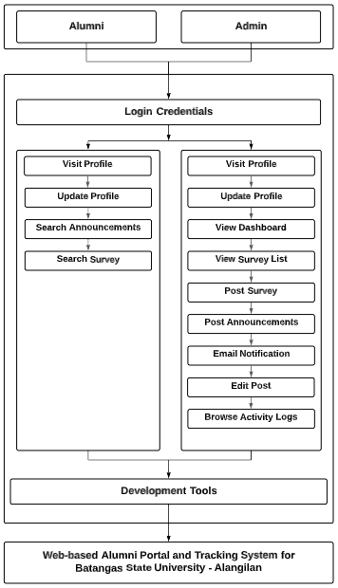

***Figure 1.* Conceptual Framework**

**Figure 1 shows the entities involved in the system namely admin and alumni. The users must have and input correct and proper login credentials to access the system. In addition, the different activities designated depending on the user classification are indicated. And, various software development tools will be used such as React JS, Tailwind CSS, Express JS, MongoDB, Mongoose, MongoDB Atlas, Cube JS, and JWT authentication.**

**CHAPTER III**

**DESIGN AND METHODOLOGY**

**This chapter discusses the development model, requirement analysis, various diagrams, and needed hardware and software requirements for the development of the system. The functional and non-functional requirements are also emphasized.**

**Project Concept**

**The Batangas State University - Alangilan had an alumni association mainly for those students who have completed the allocated units in a particular program curriculum. An alumni coordinator handles the information of the graduates which serves as a record of their education in the university. The web-based alumni portal and tracking system for the aforesaid university would assist the alumni coordinator to track the endeavors of an alumnus. On the other hand, the alumni would also have the opportunity to engage with other alumni and be informed of the future announcements from the institution. The system would be able to monitor the records of batch 2017 onwards and visualize the data gathered based on the personal, alumni, employability, and curriculum relevance information. The project is designed to automate the manual tracking and recording of alumni records which makes it more efficient and effective to monitor and manage the information of the alumni from the stated batch. Last but not the least, the university would acquire insight and understanding on how effective the accomplished program curriculum is to the employability or work profession of the alumni.**

**Development Model**

**The development model to be used for the development of the project is the agile methodology. This includes the requirements, design, development, testing, deployment, and review phases.**

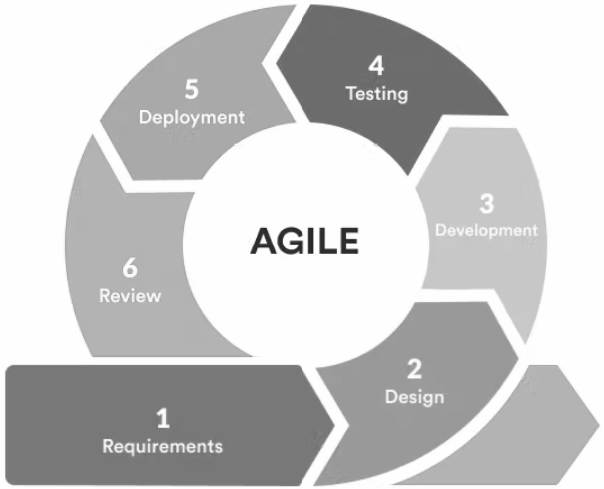

**Source:https://targettrend.com/wp-content/uploads/2021/03/AgileMethodology-1-768x460.png**

***Figure 2.* Agile Development Model**

**Each phase plays an important role for the development of the web-based portal and tracking system. It was necessary to comply and complete each and every phase in the agile methodology to ensure the quality of the system to be developed. This also allows the researchers to collaborate effectively and efficiently.**

**System Development Process**

**The system development process serves as the guideline of the researchers to effectively analyze, plan, and track the activities, requirements, and tools to be implemented and utilized in the system.**

**In the planning and requirements phase, the researchers brainstormed and exchanged ideas regarding the identified problem and the appropriate solution to address it which was through an alumni portal and tracking system. Various requirements are defined for starting points such as the system’s objectives, target users, functional and non-functional, and hardware and software requirements. The predefined requirements by the researchers can be retained, changed or enhanced as the system development progresses. A schedule and timeline is crafted to monitor and track the activities and progress of the system development. This is also to ensure that the researchers are guided with the target dates and accomplish the tasks accordingly.**

**The design phase consists of the different diagrams, conceptual designs, and graphical user interfaces. The flow of the system and its different functions were more clear and comprehensive. The inputs and outputs in/from the system are specified in the data flow diagram to have a grasp of what is being entered and displayed by the system. Key modules are specified which need to be integrated when developed and tested.**

**For the development phase, the requirements defined in the initial phase served as the guide for the researchers to develop the alumni portal and tracking system. The different software tools were used in the frontend and backend development. For the frontend development, HTMLl, CSS and Javascript were utilized. And, for the backend development, Express JS, MongoDB, Mongoose, MongoDB Atlas, Cube JS, and JWT authentication were used. The key modules integrated in the system were accounts, activity log, alumni records, announcements, dashboard, post, and survey which must function accurately and properly. The system should display the correct result based on the interaction made and appropriate visualizations to its end users.**

**The testing phase ensures that the alumni portal and tracking system is functioning according to its objectives and requirements. This phase examines the possible issues, errors, and software bugs in the code or functionalities which should be resolved as soon as possible to prevent from affecting the entire system. The system should undergo a series of different kinds of testing to validate that the multiple modules are working as expected. In unit testing, each module declared in the previous phase must be inspected and tested to fix early bugs and to verify its correctness. Upon testing each unit, the modules need to be integrated and tested as a group. Defects may arise when modules are integrated, thus, the interaction and flow between modules should be checked thoroughly. The data communication between these modules should be accurate and correct. Afterwards, the system should be tested as a whole. The end-to-end functionalities and specifications of the system will be evaluated. Since the system is designed and developed for the alumni and alumni coordinators, it is necessary to involve them in the project development and allow them to experience using the alumni portal and tracking system before deployment. Such comments and feedback from the target users will help the researchers to enhance the system.**

**In the deployment phase, the alumni portal and tracking system is to be utilized by the alumni batch 2017 to 2022 and the alumni coordinator of BatStateU Alangilan. The users will be provided with the manual for them to know how to navigate and understand the flow of the system. The system is expected to function with regard to its objectives and functionalities. Feedback from the users will be monitored continuously.**

**Last but not least, the review phase keeps track of the system’s progress and development. The requirements met are documented and the functions are inspected and assessed from time to time. This is to monitor the status and quality of the alumni portal and tracking system for its continuous improvement.**

**Requirement Analysis**

**This section discusses the needed requirements for the development of the system. The existing system was analyzed and specifications were identified for a deeper understanding of how the system would be developed.**

**Analysis of the Existing System**

**In the existing process of the alumni association of the Batangas State University - Alangilan, the alumni would attend the orientation regarding the careers that they chose and the future jobs that they can pursue. Before the orientation ends, the alumni coordinator would post the downloadable file for the personal data sheet for the alumni form in the facebook page of BatStateU alumni association. The alumni have two options of submitting the form, either through online or physical submission.**

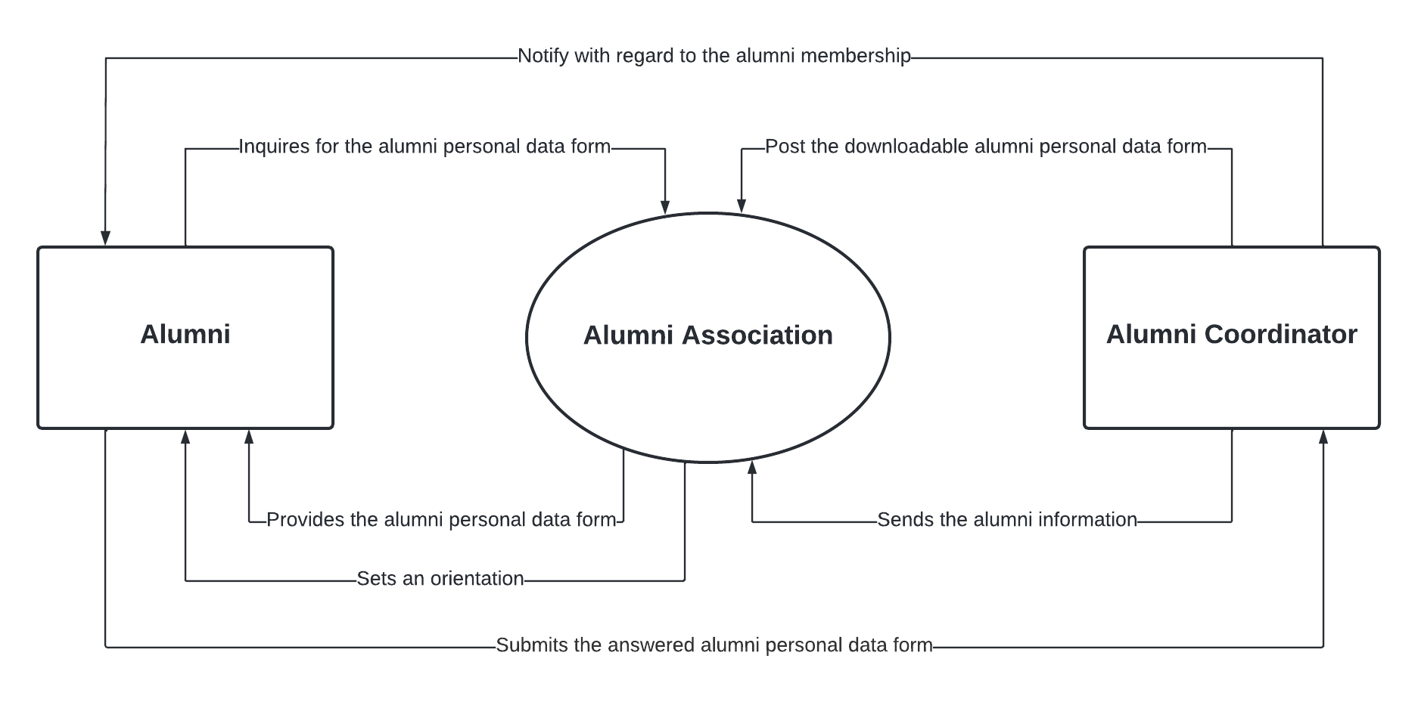

***Figure 3. Data Flow Diagram of Manual Process***

**The figure shows the manual submission process of alumni personal data form for the alumni membership. In the online submission , the alumni is required to download and answer the form then send it to the email address of the coordinator. The second option is the physical submission, the alumni would go to the university to physically inquire and answer the form in the alumni office. Both of the options have their own inconsistencies. In the online submission, most of the time, the alumni were not able to send the form to the alumni coordinator and sometimes the alumni coordinator forgets to print the form that the alumni have sent. In the physical submission, the alumni sometimes submit an incomplete form to the alumni coordinator. The alumni coordinator bears with the inconsistencies of the existing process which makes it difficult to manage the directory of the alumni information. The development of a web-based alumni portal and tracking system for the university aims to resolve the aforesaid circumstances.**

**Fishbone Analysis**

**The fishbone analysis reflects the different causes and effects in the manual process which leads to the development of the web-based alumni portal and tracking system. The causes of mishandled forms, unsorted forms, and incomplete forms are identified.**

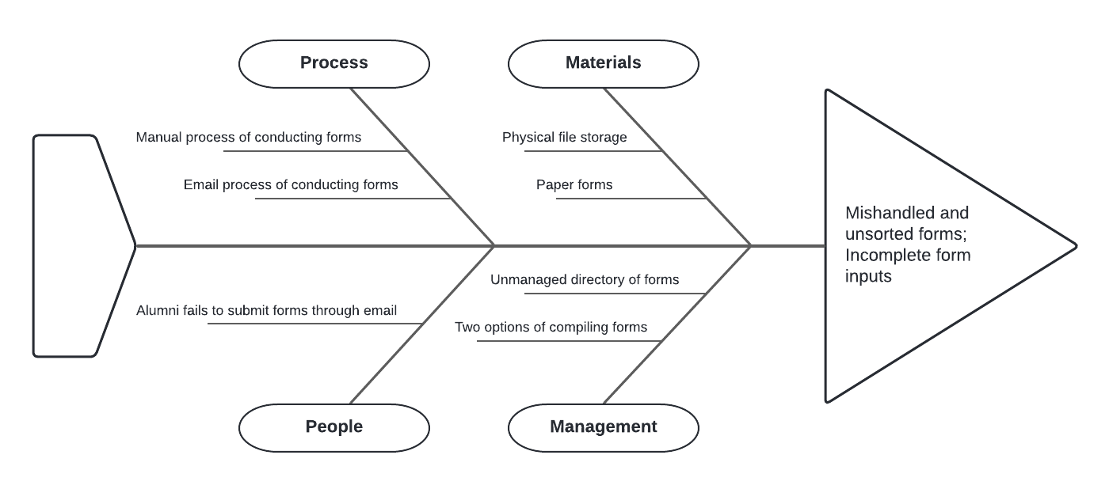

***Figure 4.* Fishbone Analysis**

**Using physical file storage and paper forms contributes to the unsorted and incomplete form inputs. Missing inputs from paper forms could have been overlooked and using physical file storage needs to be managed properly to avoid unorganized order of files. Manual process of conducting forms could also overlook the incomplete form inputs. In the email process of gathering inputs, it needs to print the file from soft copy and must be handed to the alumni coordinator in the office which adds up to piles of paper making it difficult to manage. There are also cases that upon answering the form, the alumnus fails to submit it through email therefore their answers would not be counted and recorded. Last but not the least, there are two ways of handling and managing forms which are the hardcopy and the softcopy. There is no centralized storage for the answered forms. In order to resolve the said predicament, a web-based alumni portal and tracking system would be designed and developed which also aims to manage all the information of alumni in a single storage.**

**System Boundary**

**The system boundary depicts the different units that are involved in the development of the study. It also represents the shared roles and responsibilities in establishing the regulations and integrity of the system.**

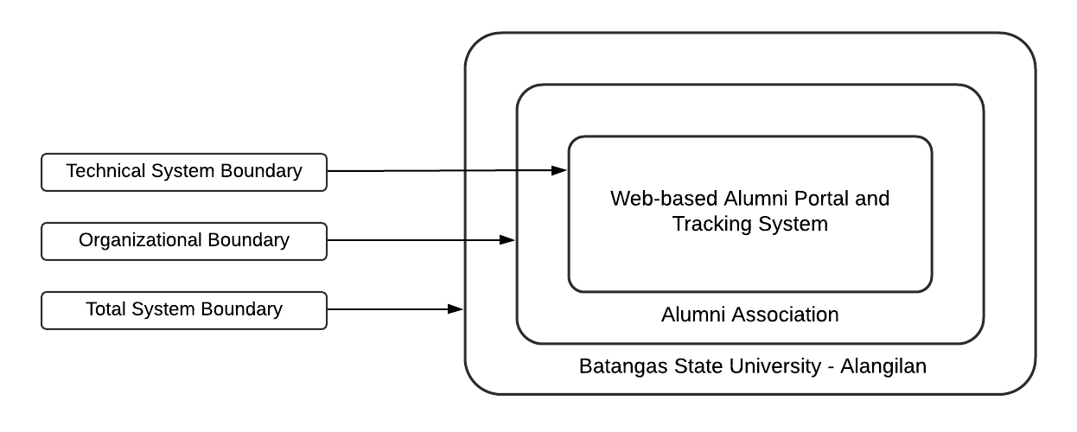

***Figure 5.* System Boundary**

**The system provides a convenient way of managing and monitoring the alumni information. In the technical system boundary, the alumni association was involved. They were bound to the web-based alumni portal and tracking system. The total system boundary was the Batangas State University - Alangilan in which the students have graduated and eventually become alumni. The information of the alumni would be managed and monitored by the system.**

**Hardware Requirements**

**The hardware requirements must be specified for the system to function efficiently and smoothly. These requirements are categorized into seven (7) different requirements namely processor, memory, hard disk, monitor, internet connection, keyboard ,and mouse.**

**Table 1**

***Hardware Requirements***

| **Hardware** | **Specifications** |
| --- | --- |
| **Processor** | **Intel Core i3,i5,i7,i9** |
| **Memory** | **4GB or Higher** |
| **HardDisk** | **8GB or Higher** |
| **Monitor** | **LCD, LED** |
| **Internet Connection** | **5mbps or Higher** |
| **Keyboard** | **USB Keyboard** |
| **Mouse** | **PS2 or USB Mouse** |

**The system requires at least an Intel Core i3 processor or higher, a 4GB RAM or higher, at least 8GB hard disk space, either LCD, or LED monitor, either PS2 or USB type keyboard, and a PS2 or USB mouse.**

**Software Requirements**

**Aside from the hardware requirements, the system would also use different software requirements. The software requirements are categorized into four (4) sections such as operating system, language, database, and IDE.**

**Table 2**

***Software Requirements***

| **Requirements** | **Specification** |
| --- | --- |
| **Operating System** | **Windows 7 or Newer** |
| **Language** | **HTML, CSS, React JS, Express JS** |
| **Databases** | **MongoDB** |
| **IDE** | **VS Code** |

**Table 2 shows various software that enable it to run the system efficiently. The operating system required in these systems must be Windows 7 or newer. The programming language required is HTML, CSS, React JS, Express JS, while for the database was MongoDB and the IDE that would be used is VS Code.**

**Functional Requirements**

**This section discusses the functional requirements. The following are what encompasses the web-based alumni portal and tracking system for Batangas State University - Alangilan.**

**1. Account**

**1.1 The system would allow user to create an account and collect required information.**

**1.2 The system would enable users to visit their account/profile info and be allowed to edit if desired.**

**2. Alumni Tracking**

**2.1 For primitive surveys such as employability and curriculum review, the system would analyze and visualize the responses in the tracking system.**

**2.2 For newly added surveys, the responses would be visualized only in google forms.**

**2.3 The system should display the admin account first once the admin is authenticated.**

**2.4 The system should display key metrics including the employability status of the alumni in the dashboard.**

**2.5 The system should provide a descriptive explanation on the findings in the employability rate.**

**2.6 The system would provide interactivity to the data charts such as filtering dimensions and hover feature.**

**3. Admin**

**3.1 The system would enable users to post announcements.**

**3.2 The system would enable the user to edit/delete announcements.**

**3.3 The system would enable the user to send survey/s to all registered alumni.**

**3.4 The system would allow users to browse through alumni records and export into a pdf file if desired.**

**Non-functional Requirements**

**This section presents the non-functional requirements of the alumni portal and tracking system.**

**1. Usability**

**1.1 System should allow users to easily navigate with different pages and contents.**

**2. Performance**

**2.1 System should load the content faster.**

**2.2 System should utilize the rendering of the contents in an asynchronous manner.**

**3. Security**

**3.1 System should enforce authorization with the user in accessing data and API’s.**

**3.2 System should encrypt user passwords in the database.**

**3.3 System should have user authentication.**

**Standards**

**The researchers based the software requirements specification on the IEEE 830 standard. The 4.3 IEEE 830 standard was used as validation for the software requirements specification. The 4.3 IEEE 830 standard stated that the software requirements specification should be correct, complete, consistent, verifiable, modifiable, and traceable.**

**Constraint and Multiple Design**

**This section discusses the different software tools which are analyzed and considered for the development of the system as well as the constraints that can have an impact to the development proper.**

**Multiple Design**

**Table 3**

***Design and Technology Stack***

| **Specifications** | **Design A** | **Design B** |
| --- | --- | --- |
| **HTML**  **CSS(tailwind)**  **ReactJS**  **NodeJS**  **Chart JS**  **ExpressJS**  **MongoDB**  **JWT** | **HTML**  **CSS**  **Javascript**  **Jquery**  **PHP**  **MySQL** |

**The table shows the two technology stacks can be used in developing the system. In terms of system’s interactivity and performance, the design A was the best technology stack to use. The front-end technologies in design A conforms to the architecture of single page application or SPA and this kind of architecture was optimized for user experience. NodeJS was relatively fast in building real-time web applications. ExpressJS was used in building API and routing. APIs are important in loading the page asynchronously in the client. The APIs would be secured using JWT or Json Web Token. MongoDB on the other hand does not require a high level of database normalization unlike SQL. This characteristic of MongoDB improves the query performance of the system. The downside of this design was the SEO.**

**The design B used server-side rendering and this was better for SEO compared to the design A. Jquery was utilized to simplify the DOM traversal and manipulation. For the server-runtime, the design B used PHP. MySQL requires a high level of database normalization and this ensures the integrity of the data. The design B was insufficient in implementing security in the system.**

**Trade-Offs**

**There were various technologies considered in the aforesaid designs. The researchers would use the design A for developing the system. The design A satisfies all the constraints in terms of usability, performance and security.**

**Constraints**

**Constraints were the limiting factors for selecting the best design required. Usability, performance and security were the basis for the technology stack needed.**

**Usability and performance constraints would affect the user’s experience in terms of speed and satisfaction on the user interface. The page load time and content load time of the system should be in a reasonable time. A reliable backend technology would be considered in this case.**

**Security constraint defines the access privilege of the system’s resources or data. The design should limit the users from accessing data through authentication and authorization. The design should also secure the APIs involved in the system.**

**Design**

**This section presents the different diagrams used to further understand the flow and requirements of the system.**

**System Architecture**

**The system architecture aims to conceptually visualize the structure of the alumni portal and tracking system. Different hardware and software tools were involved which also affects the behavior and functionality of the multiple components incorporated in the system.**

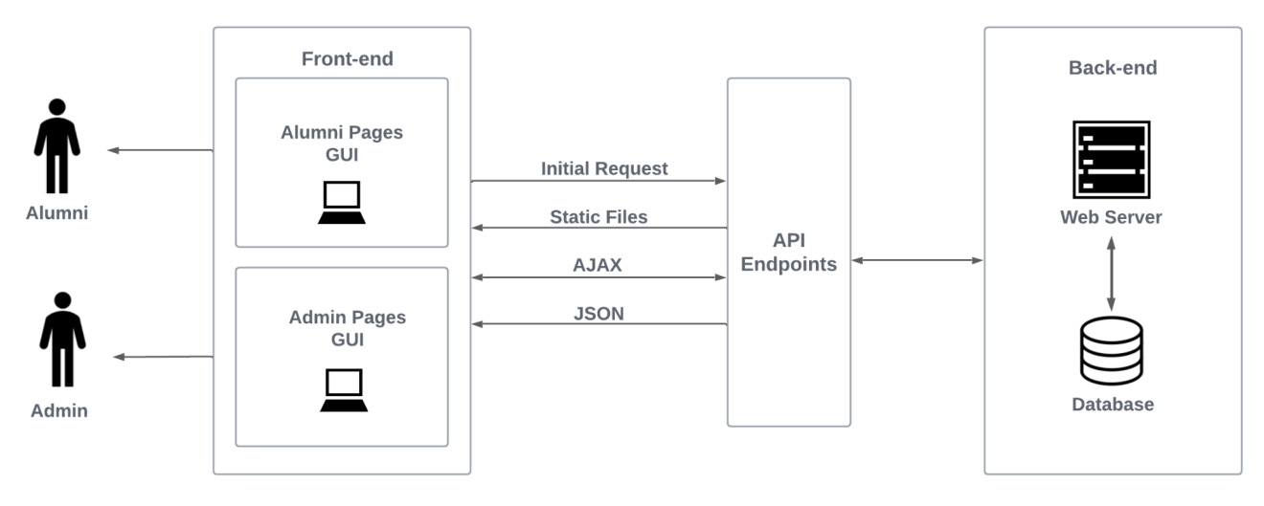

***Figure 6.* System Architecture**

**The figure presents the system architecture of this study. The structure of the system is based on Single Page Application. Single Page Application allows the front-end of the website system to dynamically change the contents without refreshing the page by utilizing APIs connected from the web server or third party apps. Static files such as HTML, CSS, JavaScript and media files are provided upon the initial request made by the client. The defined API endpoints in the Web Server would be used to retrieve resources. These resources could be JSON files and static files.**

**Context Diagram of the System**

**The context diagram provides the comprehensive view of the inputs and outputs of the external entities which are the admin and alumni into and from the alumni portal and tracking system. With this, there was an easy understanding with regard to the flow of data and the system itself.**

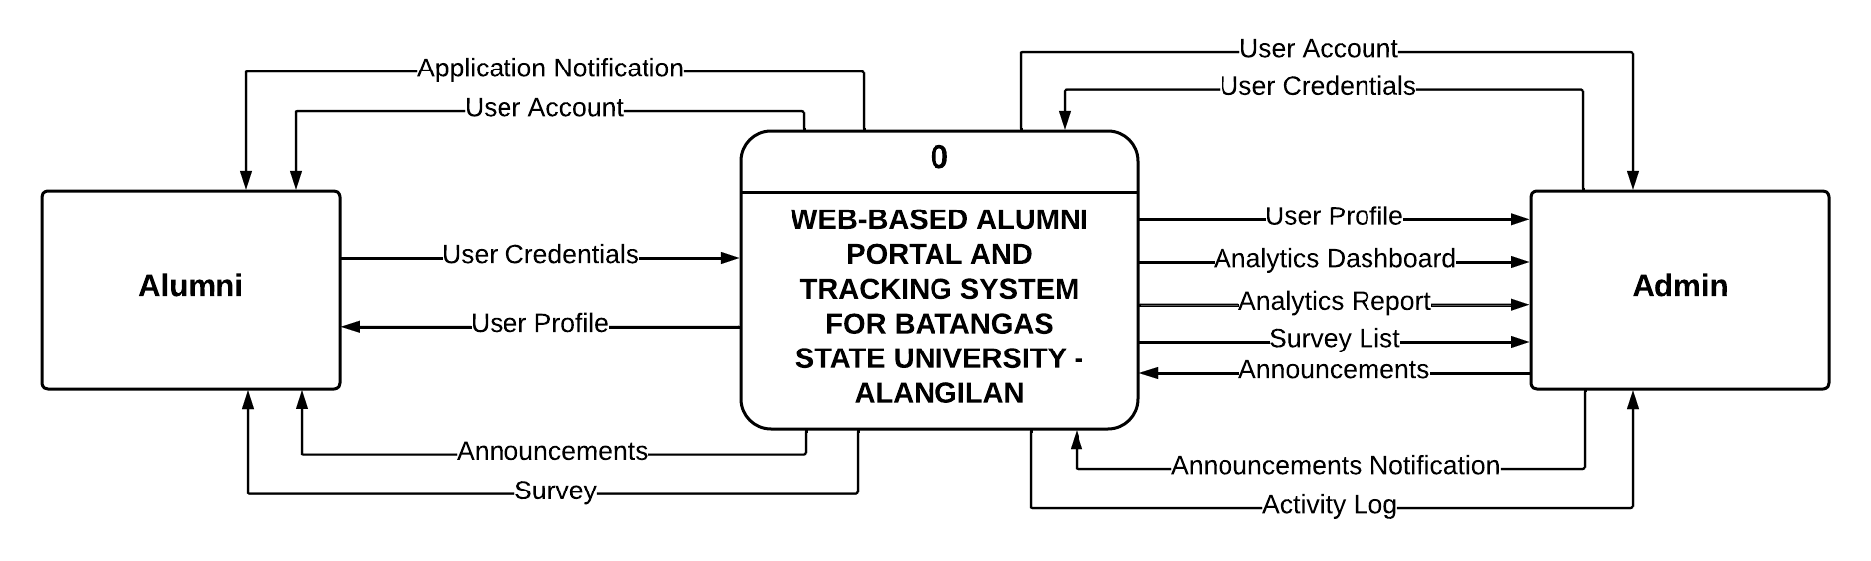

***Figure 7.* Context Diagram of the System**

**The figure illustrates the context diagram of the study. The alumni would be notified regarding their application status and upon approval, an account would be generated. Alumni would be provided unique credentials for their account and would be able to search announcements, and surveys. On the other hand, the admin also has an account after registration and being verified, and would manage the alumni profiles, surveys, announcements, and activity logs. Analytics dashboard and reports would also be available for the admin for monitoring and reference.**

**Use Case Diagram**

**The use case diagram provides an overview of the possible interactions between the identified actors and the system. It describes what the alumni portal and tracking system does and how the users will utilize it.**

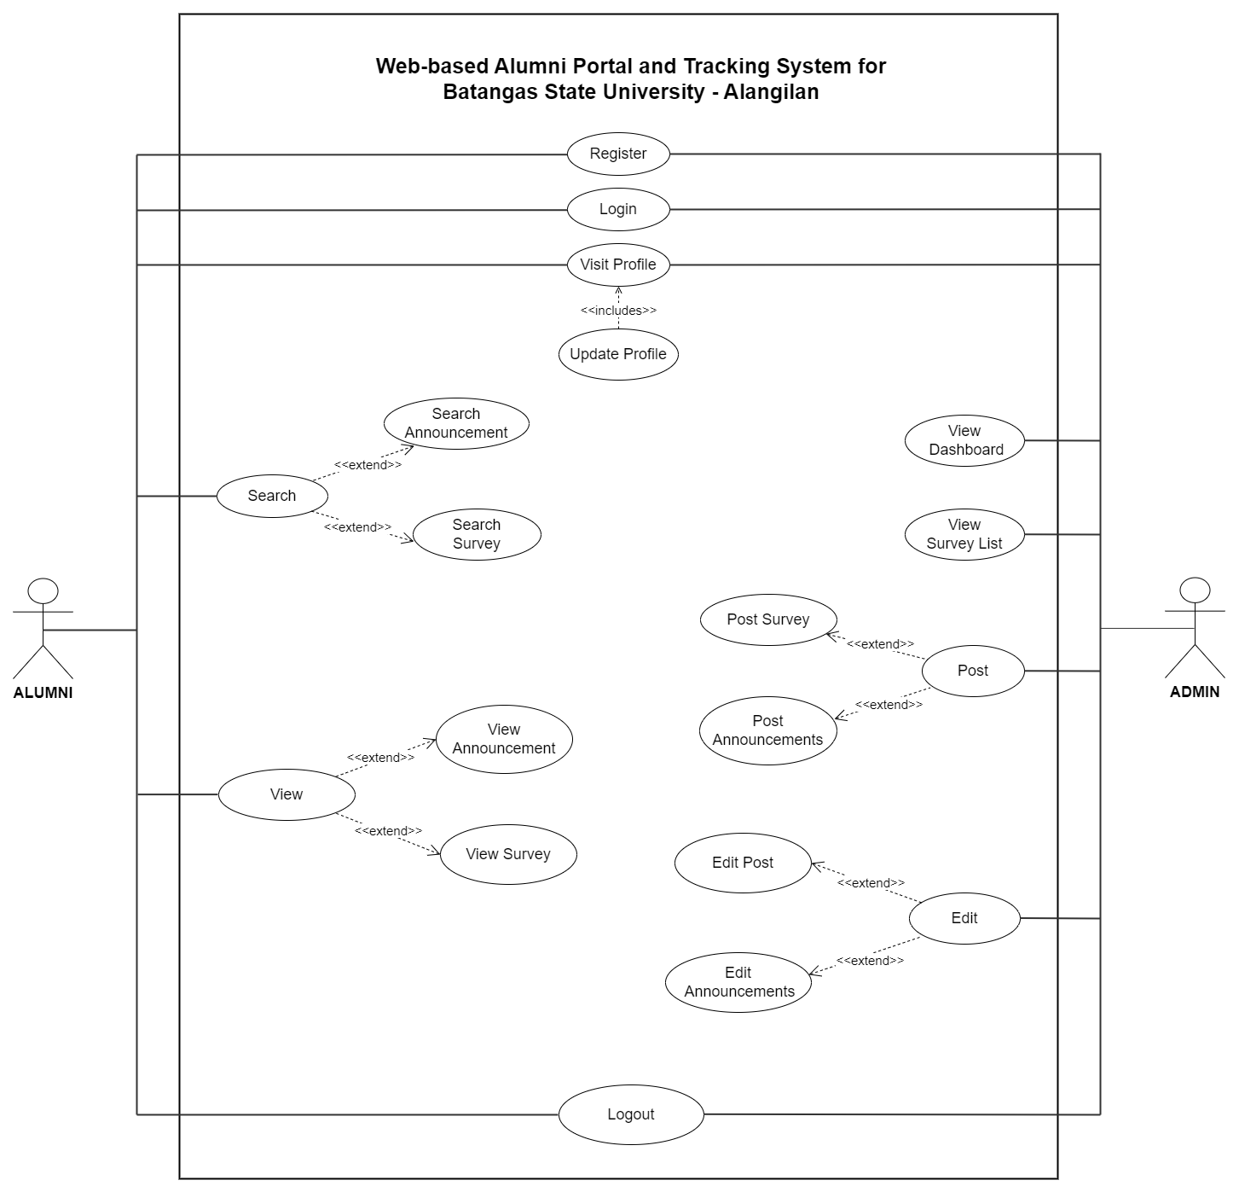

***Figure 8.* Use Case Diagram**

**The declared actors in the diagram were alumni and admin. It also presents the different functionalities the alumni and admin can do to interact with the system. The alumni can register, login, and visit their profile. Then, the admin can view the profile of the admin, view the dashboard, and view the list of surveys. Moreover, after registering and being verified, the alumni can update their profile, search announcements, and surveys. The admin can edit and remove posts such as surveys and announcements. Last but not least, the alumni can browse activity logs depending on the date, entry, and the user.**

**Sequence Diagram**

**The sequence diagram of the study serves as the system’s flow of processes to be performed by the declared objects namely the alumni and the admin. With this, the users would be guided with the order happening when operating the system. The alumni would be able to register and would be notified with their application status. Upon verification, the user would be able to login with their generated account and would be able to interact with the system. In addition, the admin must login by entering valid credentials for username and password to be able to manage and supervise the tracking system.**

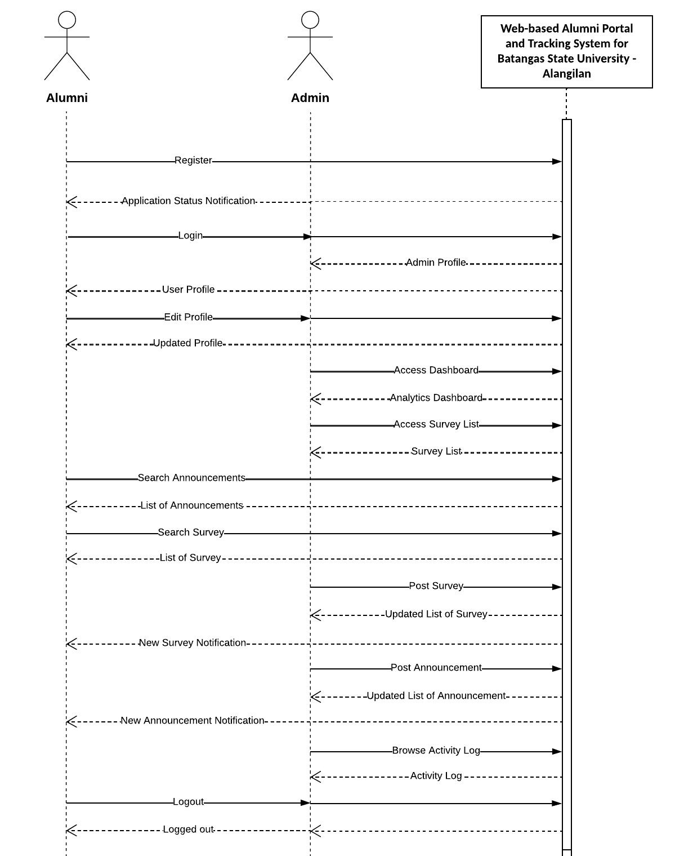

***Figure 9.* Sequence Diagram**

**The figure shows how alumni and admin interact with the system. A specific activity from an object had a corresponding result or message in return. The diagram outlines the different processes that can be executed to the system by the users in an arranged manner.**

**Database Design**

**The database design illustrates the logical structure of the database of the alumni portal and tracking system and shows the relationship of the different entities involved.**

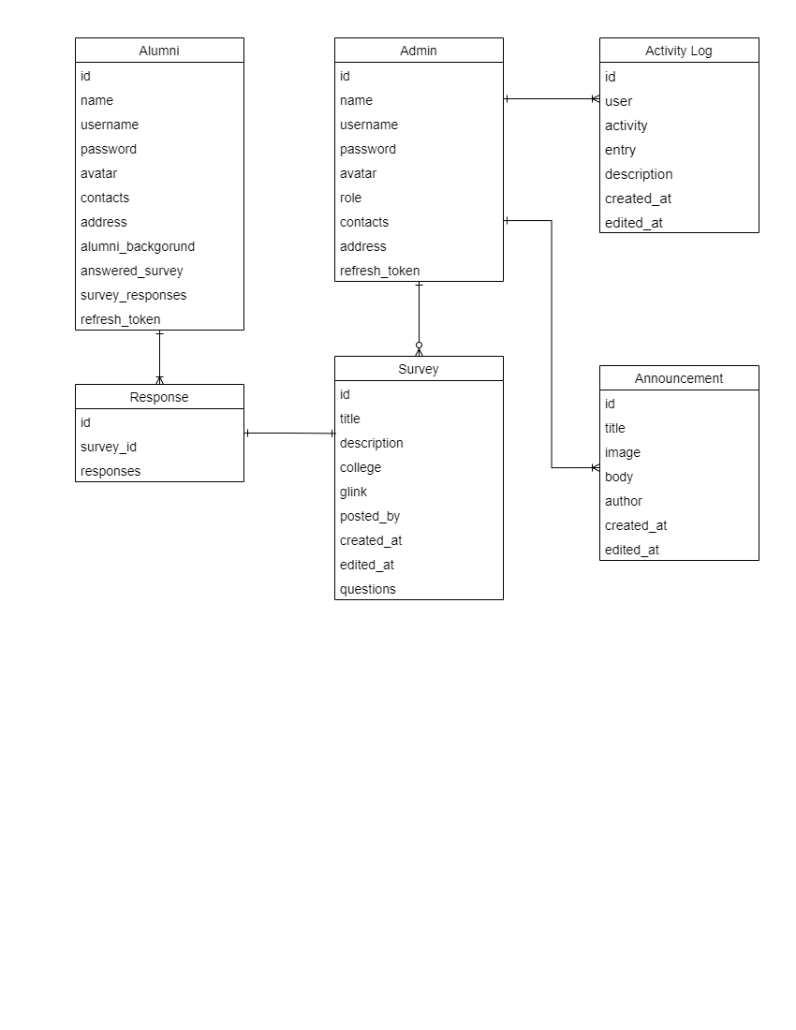

***Figure 10.* Database Model Diagram**

**The database model diagram was composed of different entities namely the alumni, admin, activity log, response, survey, and announcement. Incorporated to each entity are the various fields of data.**

**Software Development Tools**

**In this section, various software development tools were discussed for the front-end and back-end development, operating system, subscriptions for the database, domain, and hosting as well as the needed hardware and software matrix for the development of the system.**

**Front-End**

**HTML, CSS, Javascript, and ReactJS were the front-end technologies that were used in developing the client-side of the system. ReactJS was a Javascript framework used in developing user interfaces in a component-based manner. The styling of the interfaces was done with CSS.**

**Back-End**

**The technology utilized for communicating with the database was NodeJS and ExpressJS. ExpressJS is a web framework for NodeJS and provides a robust set of features for web and mobile applications.**

**Operating System**

**Operating system was the most important software that ran within the computer. It controls the processes, memory, softwares and hardwares within the computer.**

**Table 4**

***Software Matrix for the System Development: Operating System***

| **Operating System** | **Minimum Operating System** | **Bitness** |
| --- | --- | --- |
| **Windows** | **Windows 7** | **32 - 64 Bits** |

**The operating system used by the researchers was the Windows operating system. The minimum operating system version declared was Windows 7 with 32 bitness as minimum and 64 bitness as maximum.**

**Database**

**MongoDB is a NoSQL database program and uses a JSON-like data structure for handling the data. For managing the MongoDB database, MongoDB atlas was used and it runs on the cloud platform.**

**Subscriptions**

**In order for the system to be deployed properly on a web browser, there were necessary subscriptions on domain, hosting, and database that were considered. For the domain, the researchers subscribed to GoDaddy. The domain was batstateu-alumni.com. For the hosting, the researchers subscribed to Digital Ocean. Last but not least, the researchers subscribed to mongodb for the database of the system.**

**Hardware for Development**

**Hardware requirements for development indicated the specifications that should be met and be utilized by the researchers.**

**Table 5**

***Hardware Matrix for the System Development***

| **Hardware** | **Requirements** | **Applicable Operating System** |
| --- | --- | --- |
| **Disk Space** | **4GB or More** | **Windows** |
| **Memory** | **Minimum: 4GB RAM**  **Recommended:8GB RAM or More** | **Windows** |
| **Processor** | **Intel i5-10400 4.30 GHz** | **Windows** |

**The matrix presented the needed hardware requirements in order to have a smooth process on the development of the system. The hardware considerations were the disk space, memory, and processor.**

**Visual Studio Code**

**Visual studio code would be used in writing and debugging the code. Visual studio code is free and provides useful features for developing website applications. The researchers were able to customize the IDE based on their needs such as color themes, text formatter etc.**

**Testing**

**The researchers utilized the ISO 9126 which served as a guide for the evaluation of the quality of the system. The system was expected to work accordingly based on the requirements and functionalities declared.**

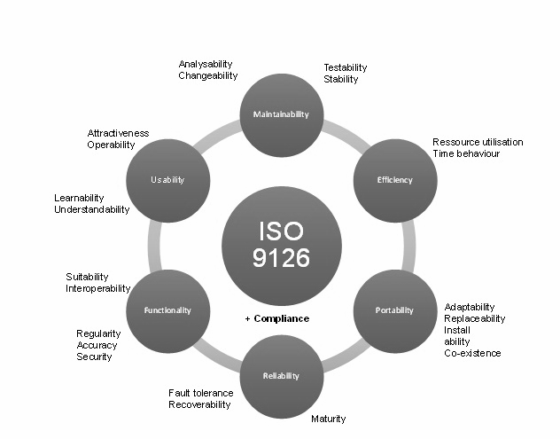

**Source: https://ibimapublishing.com/uploads/fig3-58.jpg**

***Figure 11.* ISO 9126**

**The six quality characteristics incorporated in the ISO 9126 were maintainability, efficiency, portability, reliability, functionality, and usability.**

**Testing Procedures**

**The following testing procedures were executed to assess whether the declared requirements and identified functionalities were met and were working accurately when navigated by the users.**

**Efficiency Testing. This test was executed to ensure that the functionalities were working accordingly and met the expectations of the users when the system was explored.**

**Functional Testing. This test was executed to ensure that the various declared functions incorporated in the system worked accurately and properly when accessed by the users.**

**Maintainability Testing. This test was executed to ensure that the system worked as expected when there were updates and modifications made in the system.**

**Portability Testing. This test was executed to examine whether the system was working on different browsers.**

**Reliability Testing. This test was executed to check whether the system can perform its functions accurately and properly after deployment and used in different circumstances.**

**Usability Testing. This test was executed to ensure whether the functions of the system are met when navigated by the users. The system was evaluated by the users depending on their interaction with the system.**

**Data Gathering**

**In order to know whether the developed system is working properly. The researchers conducted a survey through google forms which contains sets of questions that served as an evaluation for the alumni portal and tracking system.**

**Deployment Plan**

**The deployment plan was important in deploying the system. It increased the chances of success on deploying the system. If the deployment plan were followed, the deployment of the system would be progressive.**

**Table 6**

***Deployment Plan***

| **Phase** | **Deliverable** | **Responsibility** |
| --- | --- | --- |
| **Pre-Deployment** | * **Deployment Planning Meeting** * **Distribute Project Plan** * **Review Project Schedule** | **Project Manager** |
| **Identify Phase** | * **Identify project strategy report** * **Identify the budget report** | **Project Manager** |
| **Deployment** | * **Deploy the website** * **Achieve successful deployment** | **Developer, Project Manager** |
| **Testing** | **Table 6 (cont’d)**   * **Test the website** * **Identify bugs** * **Fix the bugs** * **Identify the test result report** * **Update the website** | **Developer, Tester** |
| **Monitoring** | * **Track website performance** * **Identify the progress report** | **Project Manager** |

**Deployment plan would prevent missing out important details in the deployment of the system. The deployment plan phases included the pre-deployment, identify phase, deployment, testing, and monitoring.**

**Maintenance Plan**

**The maintenance plan would play a big role in sustaining the effectiveness of the system after the deployment.**

**Table 7**

***Maintenance Plan***

| **Procedure** | **Time Interval** | **Responsible Person** |
| --- | --- | --- |
| **Performance Monitoring** | **Weekly** | **Project Manager** |
| **Bug Checking** | **Monthly** | **Tester** |
| **Regular Updates** | **Monthly** | **Developer** |
| **Checking back Ups** | **Monthly** | **Developer** |
| **Code Debugging** | **Monthly** | **Developer** |

**Maintenance plan would ensure that the system would be maintained and protected after the deployment. The maintenance plan included the procedure of maintenance, time interval, and the person responsible for the procedure.**

**Risk Management Plan**

**A risk management plan was a guide that project managers use to classify possible project threats, estimate the impact and likelihood of them occurring, and then determine responses.**

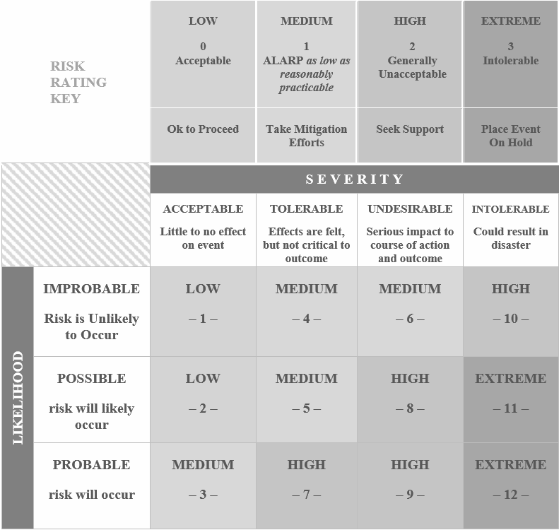

***Figure 12.* Risk Assessment Matrix**

**Risk Assessment Matrix was also known as a Probability and Severity Risk Matrix and was designed to minimize the probability of potential risk to optimize project performance. The risks were divided depending on their likelihood and their effects, with this process, the worst case scenario would be determined quickly.**

**The identified risks were internet connection, system downtime, security threats, and human error.**

**Table 8**

***Risk Management***

| **Risk** | **Livelihood** | **Consequences** | **Overall Risk** |
| --- | --- | --- | --- |
| **Internet Connection** | **Low** | **Very High** | **High Risk** |
| **System Downtime** | **Low** | **Medium** | **Medium Risk** |
| **Security Threats** | **Low** | **Very High** | **High Risk** |
| **Human Error** | **Low** | **Very High** | **Medium Risk** |

**The Risk Management Table would show the risks that the users could encounter. It also showed the chances of the risk occurring, as well as the effects or impact on the system and user.**

**Table 9**

***Response Plan***

| **Risk** | **Response Plan** |
| --- | --- |
| **Internet Connection** | * **Always check the internet cable of the internet if it’s working properly.** * **Always check the wireless internet connection.** |
| **System Downtime** | * **Always check with the internet provider.** * **Contact the server administrator to fix the issues that arise.** * **Debug the system.** |
| **Hack** | * **Always do a security scanning** * **Install an IDPS** |
| **Human Error** | * **Always check the Data** |

**Table 10**

***Risk Monitoring***

| **Risk** | **Risk Frequency** | **Responsible** |
| --- | --- | --- |
| **Internet Connection** | **This may occur when there is a low bandwidth coming from the internet provider** | **Third Party Provider( ISP and ESP)** |
| **System Downtime** | **This may occur due to internal issues of the host.** | **Host or Server Administrator** |
| **Security Threats** | **This may likely happen when there is an internal problem in the system.** | **Programmer** |
| **Human Error** | **This may likely happen when the user didn't understand the direction.** | **Stakeholder** |

**Table 11**

***Analysis and Rankings***

| **Risk** | **Likelihood** | **Consequence** | **Vulnerability** | **Speed** | **Rank** |
| --- | --- | --- | --- | --- | --- |
| **Internet Connection** | **5** | **4** | **4** | **2** | **1st** |
| **System Downtime** | **2** | **4** | **2** | **2** | **2nd** |
| **Security Threats** | **2** | **4** | **4** | **2** | **3rd** |
| **Human Error** | **1** | **1** | **2** | **1** | **4th** |

**Table 12**

***Risk Category***

| **Risk** | **Risk Likelihood** | **Risk Severity** | **Risk Category** |
| --- | --- | --- | --- |
| **Internet Connection** | **Probable** | **Tolerable** | **High** |
| **System Downtime** | **Probable** | **Undesirable** | **High** |
| **Security Threats** | **Probable** | **Intolerable** | **Extreme** |
| **Human Error** | **Probable** | **Tolerable** | **Medium** |

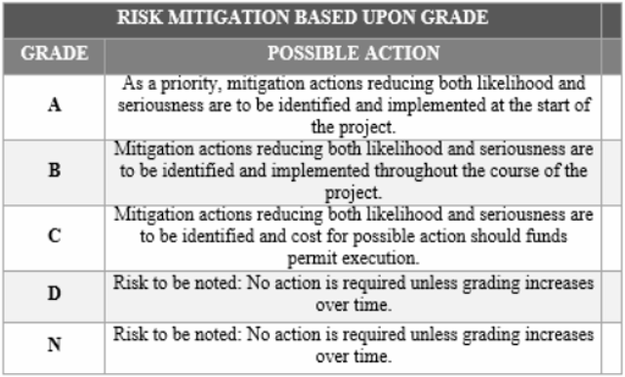

***Figure 13.* Risk Mitigation Grading Matrix**

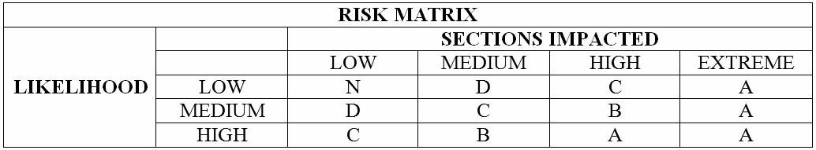

***Figure 14.* Risk Matrix**

**CHAPTER IV**

**RESULTS AND DISCUSSIONS**

**This chapter discusses the development details of the Web-based Alumni Portal and Tracking System for Batangas State University - Alangilan. This also explains how the objectives of the study have been satisfied. The graphical user interface of the system was also present with its respective functionalities in the system. Different testing methods were conducted to evaluate the functional and non-functional requirements of the developed system.**

**Alumni Tracking Surveys**

**The surveys created for the alumni tracking are alumni information survey and alumni tracking survey. This can be accessed on the survey page of the alumni portal. To be able to access the alumni portal, an alumnus must register first.**

**Figure 15 shows the alumni portal in which an alumnus can sign up that can be accessed through batstateu-alumni.com.**

**Upon clicking the sign up button, the alumnus will be redirected to the registration form page. They should input the needed information and must also provide a valid email address for there will be a verification of email afterwards.**

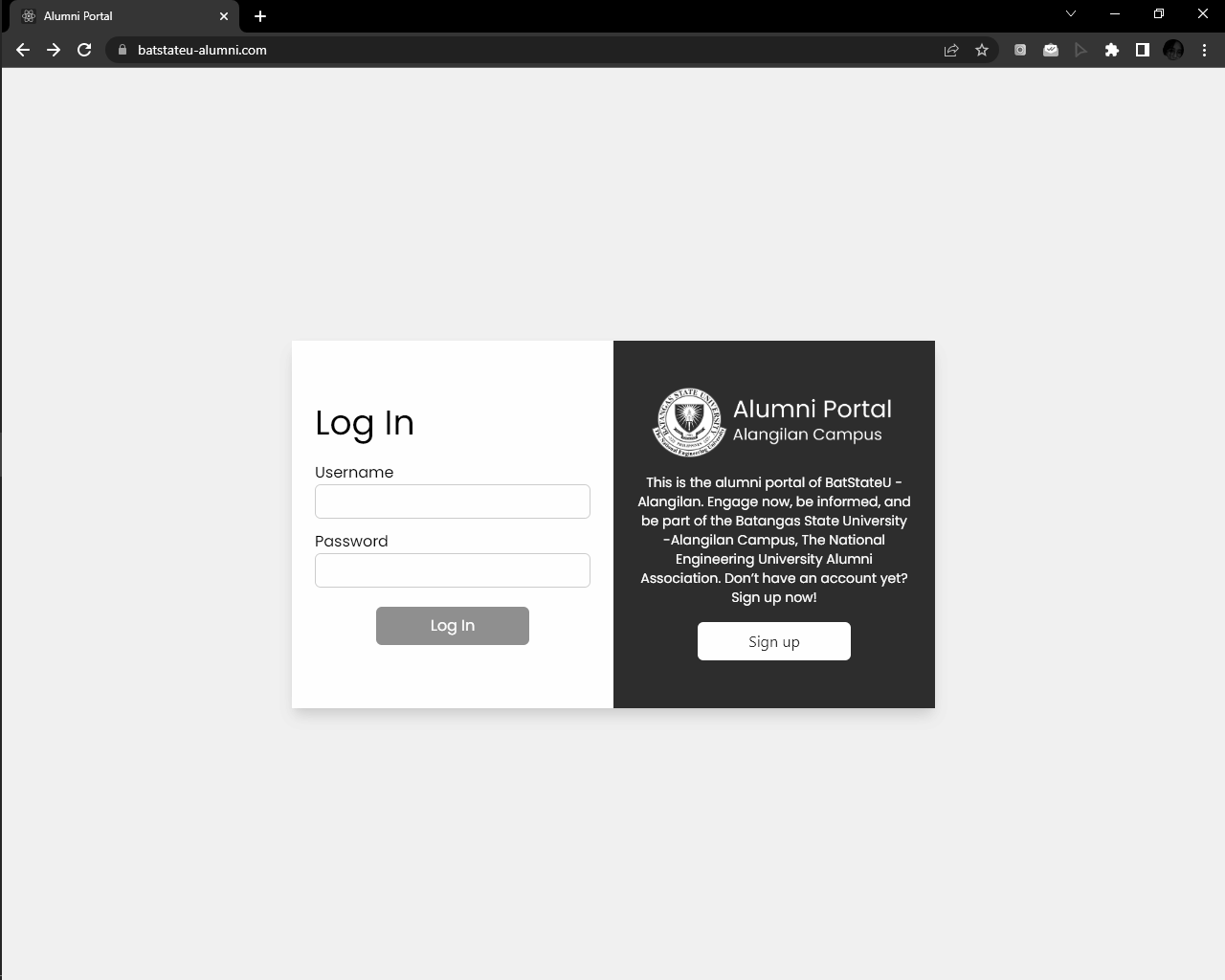

***Figure 15.* Alumni Signup**

**In the alumni registration in figure 16, fields under the personal information, contact information, and alumni information must be filled-out.**

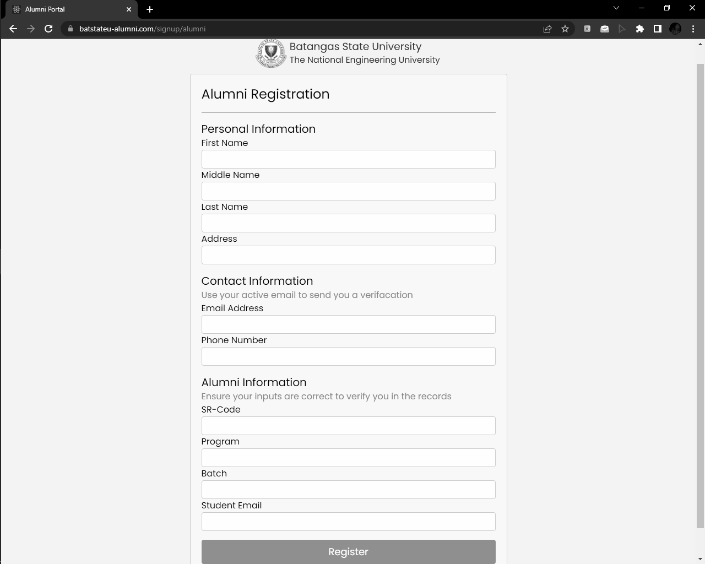

***Figure 16*. Alumni Registration Form**

**In the personal information section, the alumni must input their first, middle, and last name and address. Under contact information are email address and phone number. And, for the alumni information are sr-code, program, batch, and student email if applicable.**

**The alumni must finish setting up their account. In the alumni login page, the alumni must input their valid username and password to access the portal. The default page after logging in is the announcement page.**

**In figure 17, the alumni should click on the survey button for the survey page to be shown. This page is divided into two sections, the alumni tracking surveys and the surveys via google forms.**

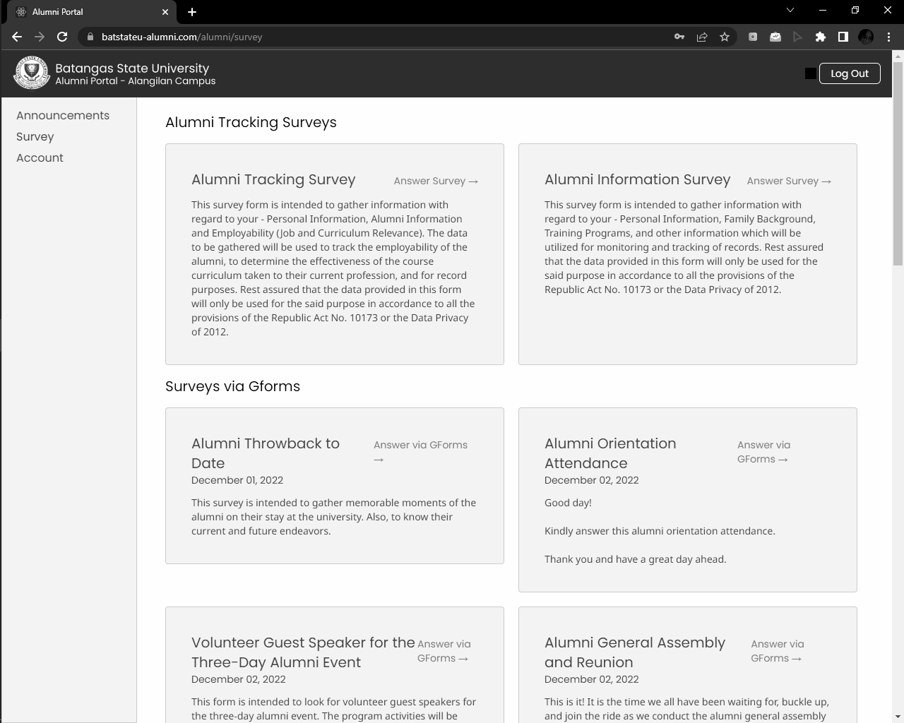

***Figure 17.* Alumni Survey Page**

**The alumni tracking surveys are intended to gather information with regard to the alumni’s personal information, alumni information, family background, training programs, and employability details for monitoring and record purposes.**

**Figure 18 presents the first survey from the alumni tracking surveys which is the alumni information survey. This consists of the personal information, family background, training backgrounds, and other information.**

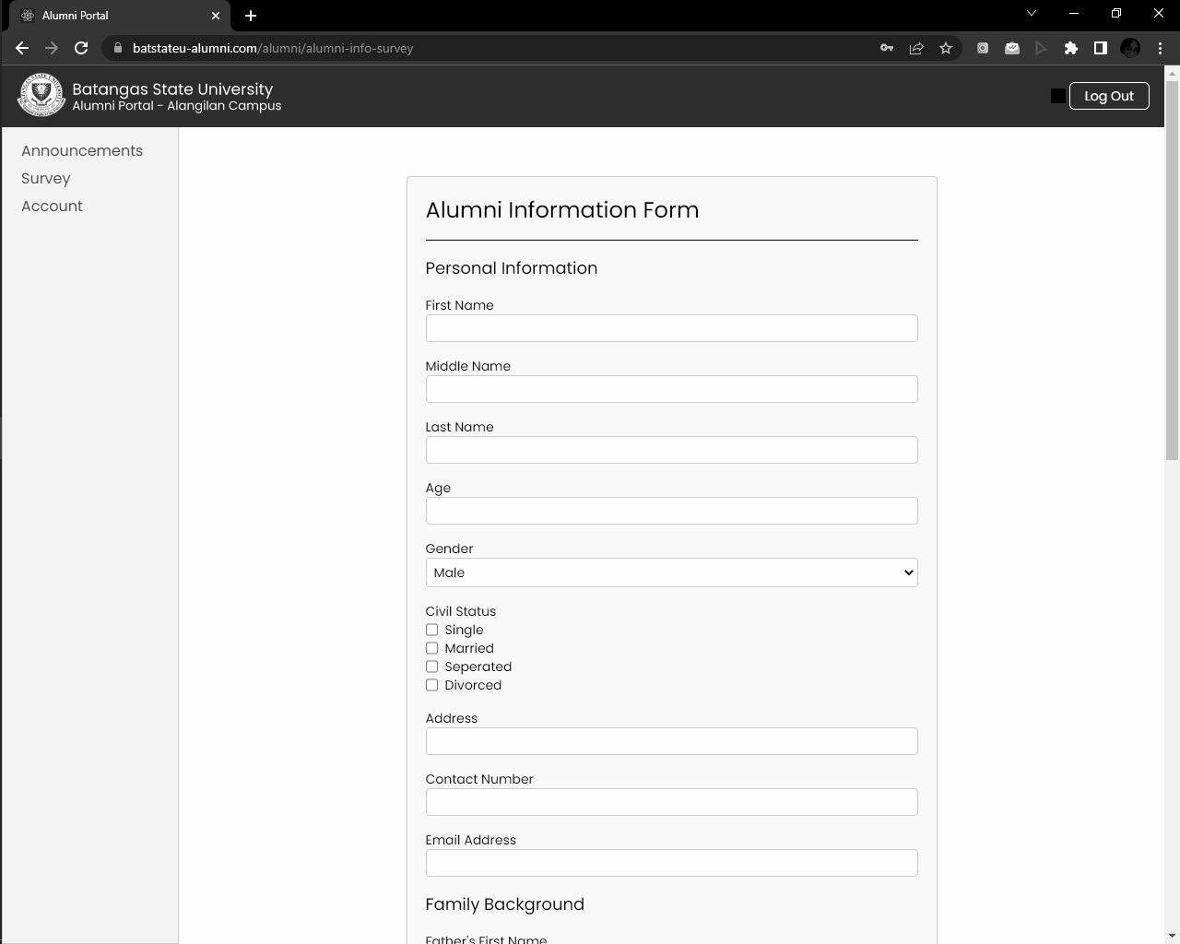

***Figure 18.* Alumni Information Survey**

**The personal information asks for the first, middle, and last name of an alumnus, their age, gender, civil status, address, contact number, and contact number. For the family background, the names of the father and the mother will be collected. In the training backgrounds, the name of the seminar attended, date attended and event organizer must be filled out. And, other information such as special skills/hobbies and membership in associations/organizations as well.**

**The information provided by the alumni will be used for the monitoring of alumni records. The second survey is for tracking the employability of the alumni shown in figure 19.**

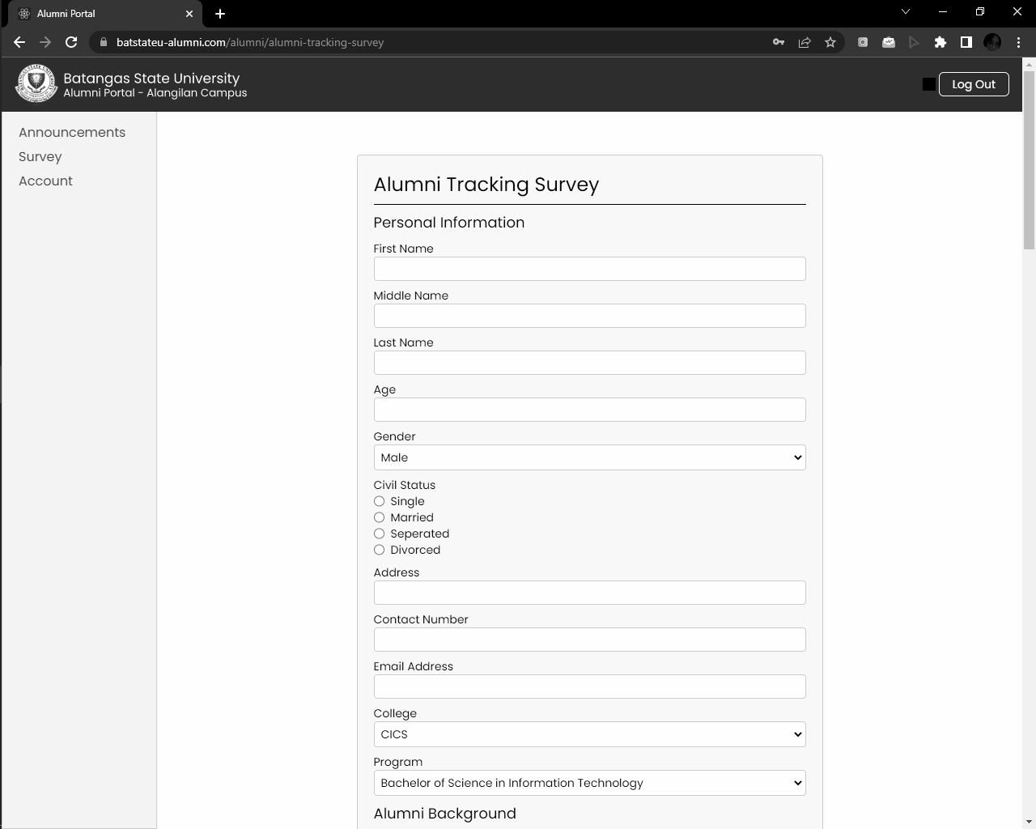

***Figure 19.* Alumni Tracking Survey**

**It consists of sections for personal information, alumni information, and employability. The third section is divided into two parts, the job and curriculum relevance.**

**The alumni background asks for the year graduated, highest educational attainment, sr-code, and student email if applicable.**

**Figure 20 shows the employability section of the alumni tracking survey. When an alumnus’ current nature of employment is employed, the nature of work field, employment characteristics, status of professional registration, location of work, company name, waiting time before employment, job satisfaction, degree relevance, curriculum relevance, and competencies acquired in college must be answered.**

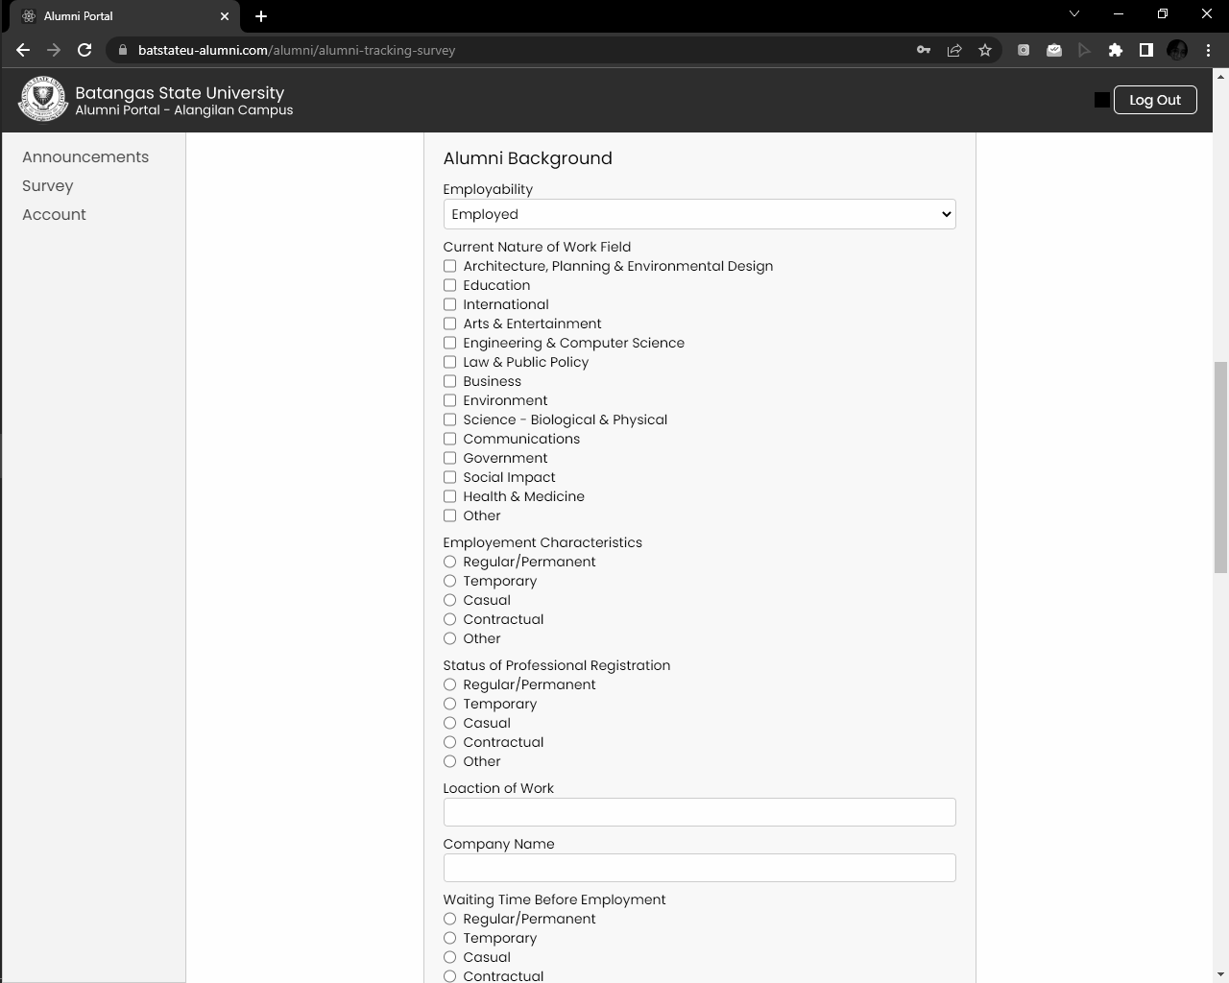

***Figure 20.* Alumni Tracking Survey - Employed**

**There are also statements to be rated by the alumni with regard to the usefulness of their studies. The range is from not useful to very useful. The statements include the usefulness of their studies for finding an adequate job, for fulfilling their present professional tasks, for their future professional development or career, for the development of their personality, and for the economic development of their country.**

**On the other hand, when an alumnus’ current nature of employment is unemployed, the previous nature of the work field and reasons of unemployment must be answered as shown in figure 21.**

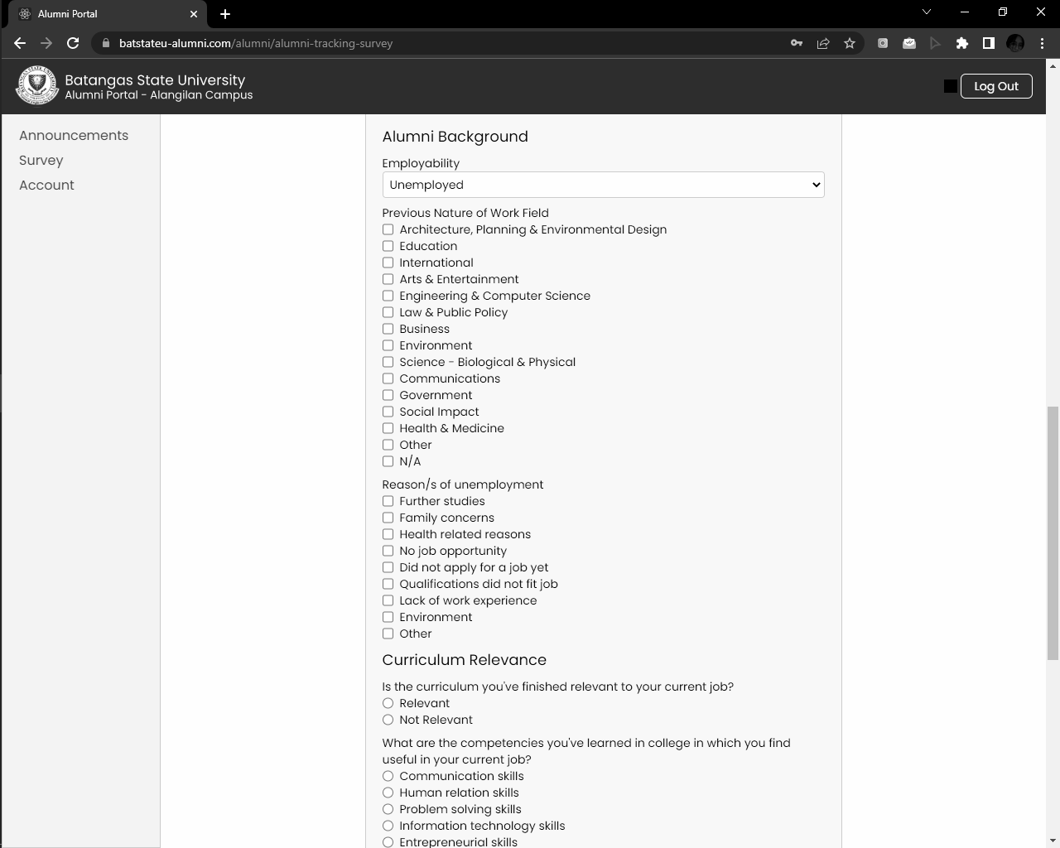

***Figure 21.* Alumni Tracking Survey - Unemployed**

**In addition to the tracking of alumni employability, this survey was also used to know the effectiveness of the course curriculum taken to their current profession, and for record purposes.**

**Dashboard with Descriptive Analytics**

**The generated dashboard and reports employed descriptive analytics. The visualizations are the graphical representations of the data acquired from the alumni tracking survey.**

**The researchers selected fields of employability status of alumni, career fields, relevance of degree obtained to job, employment types of alumni, waiting time before employment, and unemployment reasons for the admin dashboard.**

**The admin must input first the valid credentials for the username and password in the admin login panel as shown in figure 22 to be able to access the admin portal.**

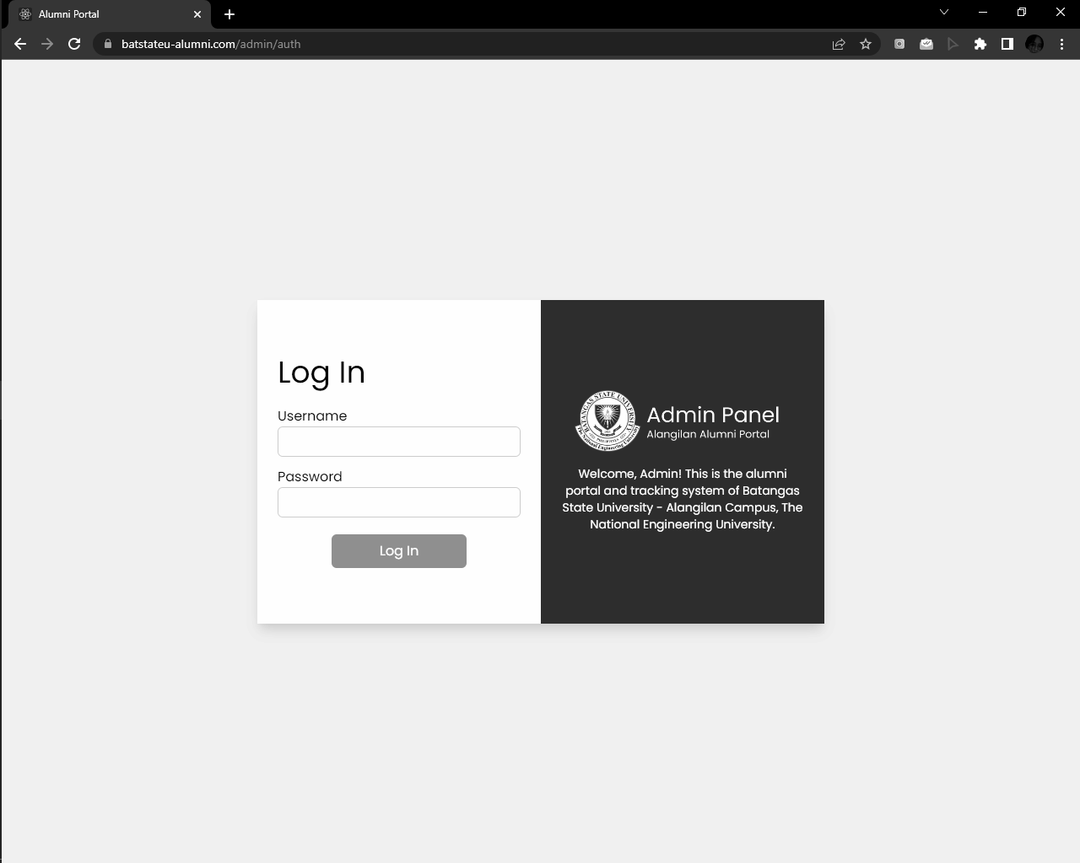

***Figure 22.* Admin Login Panel**

**The default page upon logging in the admin portal is the account page. The dashboard must be clicked to proceed to the visualizations.**

**In figure 23, it illustrates the employability status of the alumni from the CICS department. This department has two offered programs which are bachelor’s degrees in computer science and information technology.**

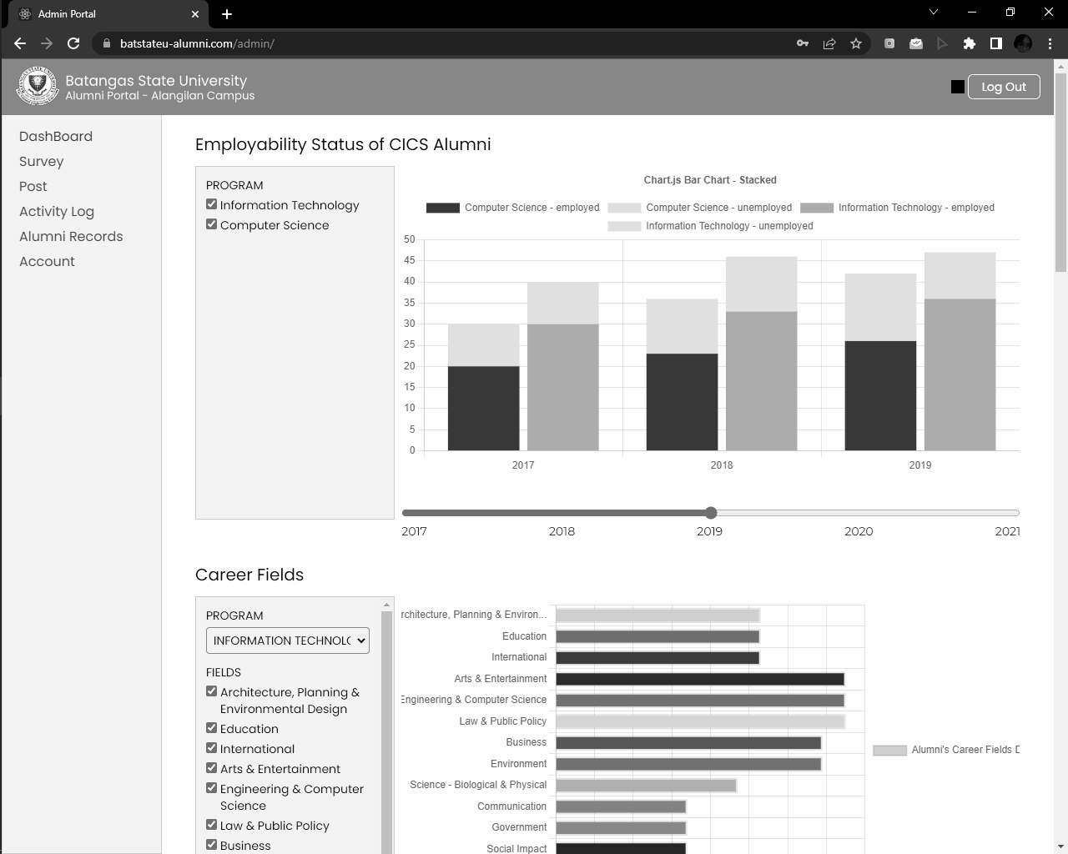

***Figure 23.* Employability Status of Alumni**

**The data incorporated in the graph are the program, batch, and employability status. The graph can be filtered based on the program by unchecking the program to view one program only in the graph, click on the year of graduates through slicer, and click on the legends of employed or unemployed status per program.**

**Figure 24 shows the different career fields of the graduates. There are thirteen (13) possible career fields in which an alumnus’ job may be classified into. The graph can also be filtered based on the program, career fields, and batch accordingly.**

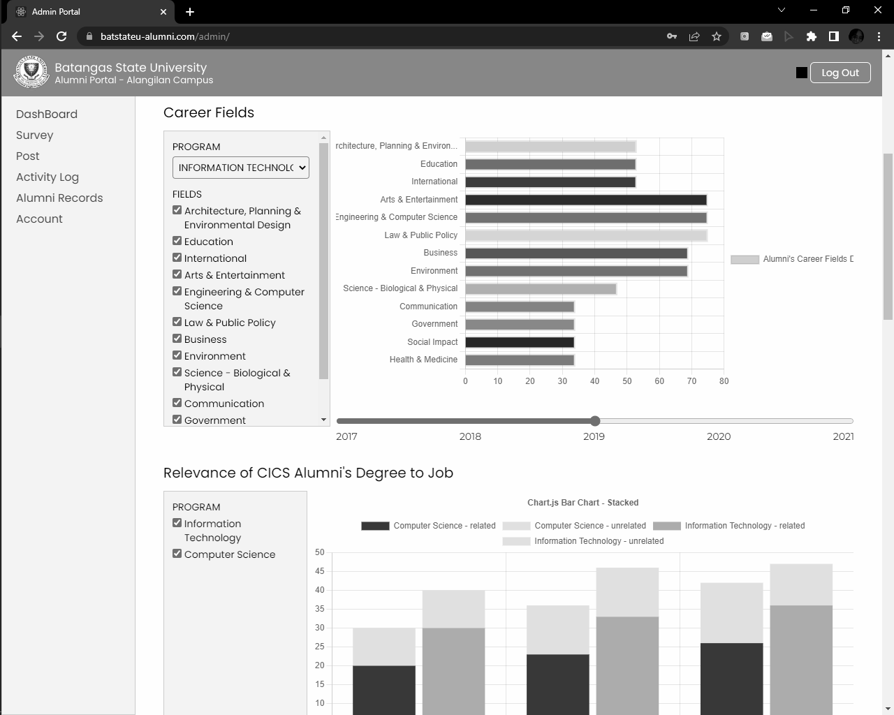

***Figure 24.* Career Fields**

**The career fields consist of architecture, planning, and design, education, international, arts and entertainment, engineering and computer science, law and public policy, business, environment, science, communication, government, social impact, and health and medicine.**

**For the visualization of the relevance of alumni’s degree to a job shown in figure 25, it depicts whether the degree obtained is related or unrelated to the current profession and can be filtered by program and year as well.**

**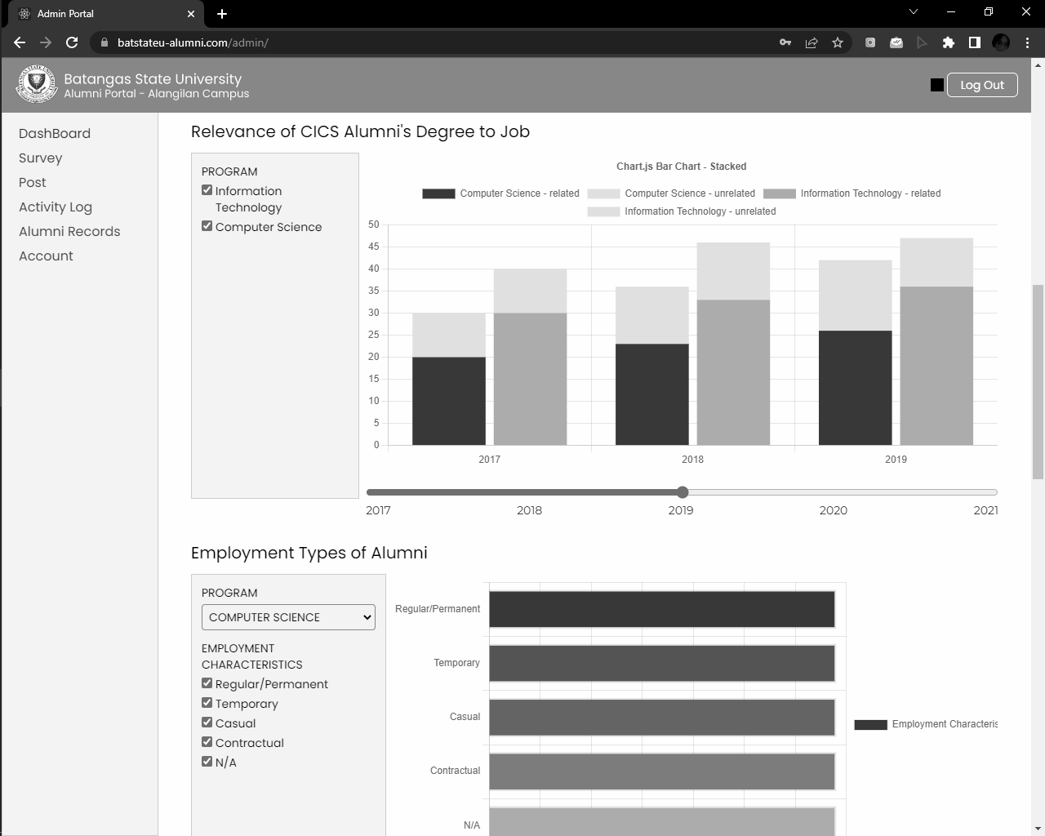*Figure 25.* Relevance of Alumni Degree to Job**

**The employment types of alumni is also illustrated in figure 26. The employment characteristics are divided into five parts which are regular/permanent, temporary, casual, contractual, and not applicable. The graph can also show the preferred employment type of a program by year when selected.**

**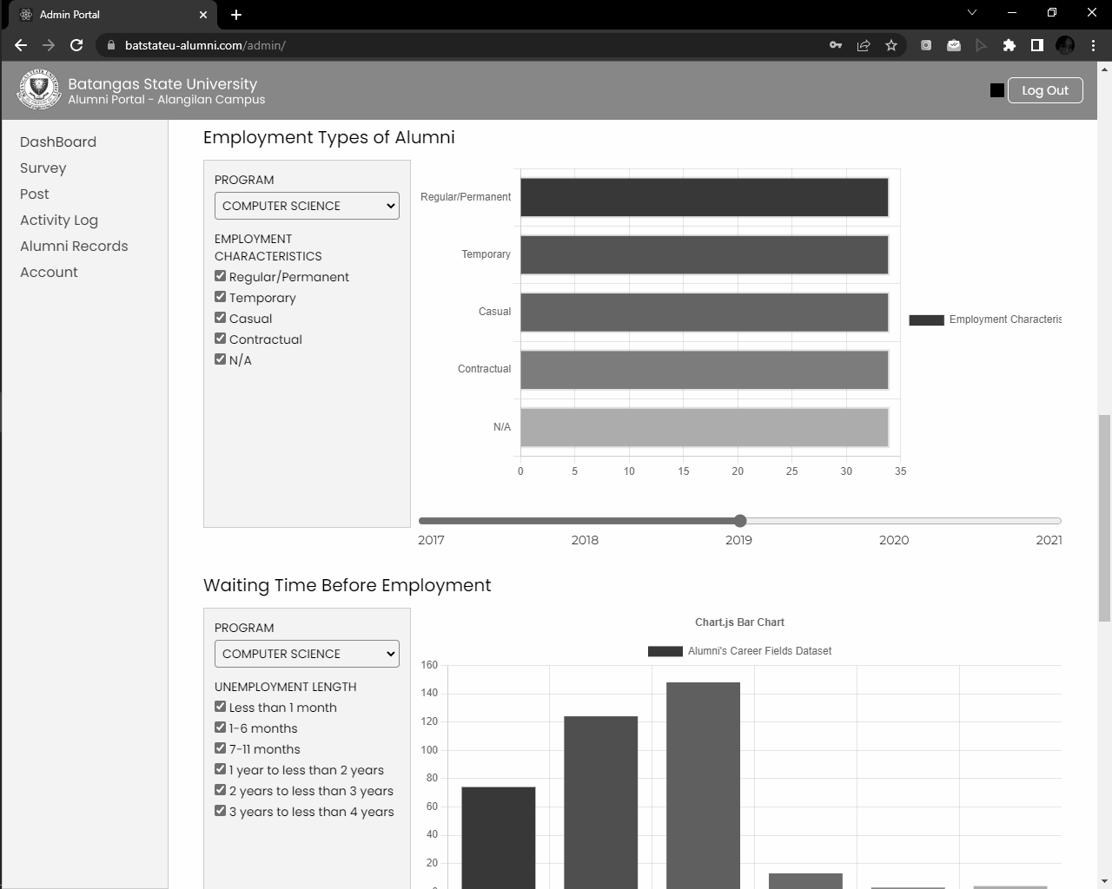*Figure 26*. Employment Types of Alumni**

**In figure 27, the graph for the waiting time before employment was presented. The filter options of the unemployment length per program and year includes less than one month, one to six months, seven to eleven months, one year to less than two years, two years to less than three years, and three years to less than four years.**

**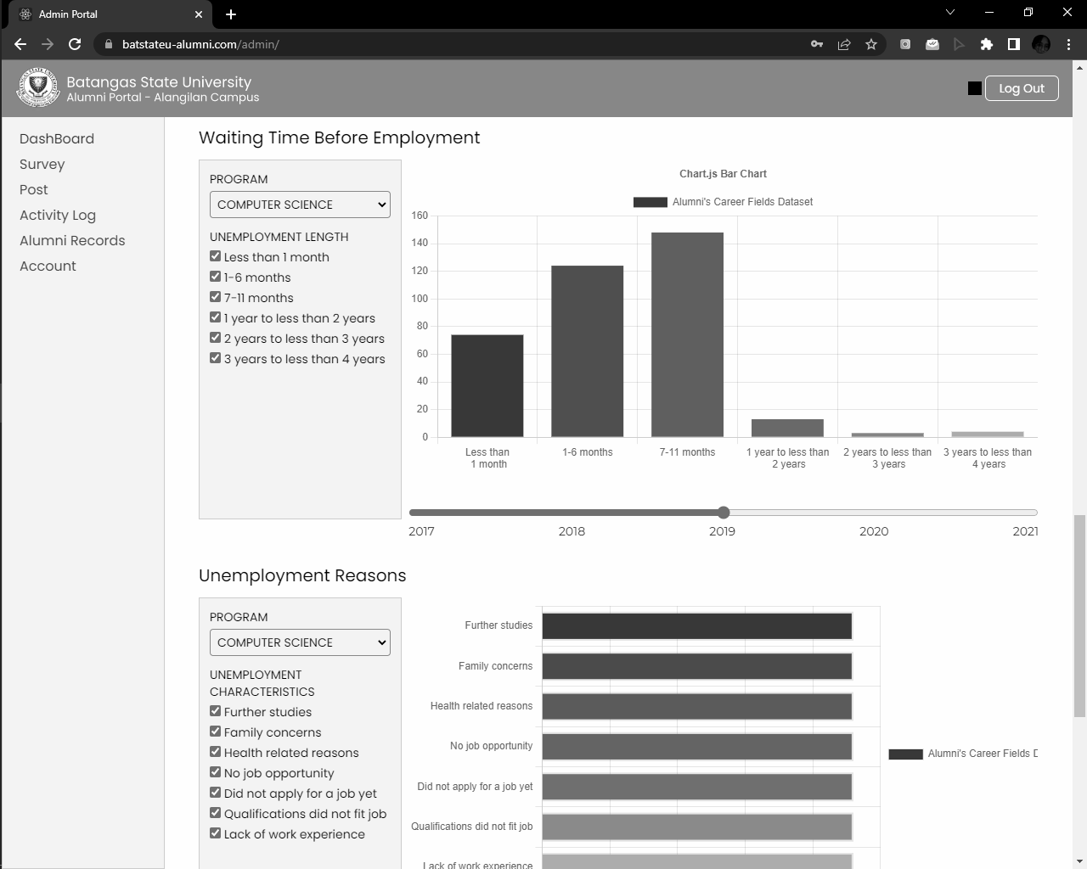*Figure 27.* Waiting Time Before Employment**

**In relation to the graph of employability status of alumni in which there are employed and unemployed alumni, the reasons for unemployment was also visualized in figure 28. The possible reasons include further studies, family concerns, health related reasons, no job opportunity, did not apply for a job yet, qualifications did not fit the job, and lack of work experience. The graph can be filtered by program and batch.**

**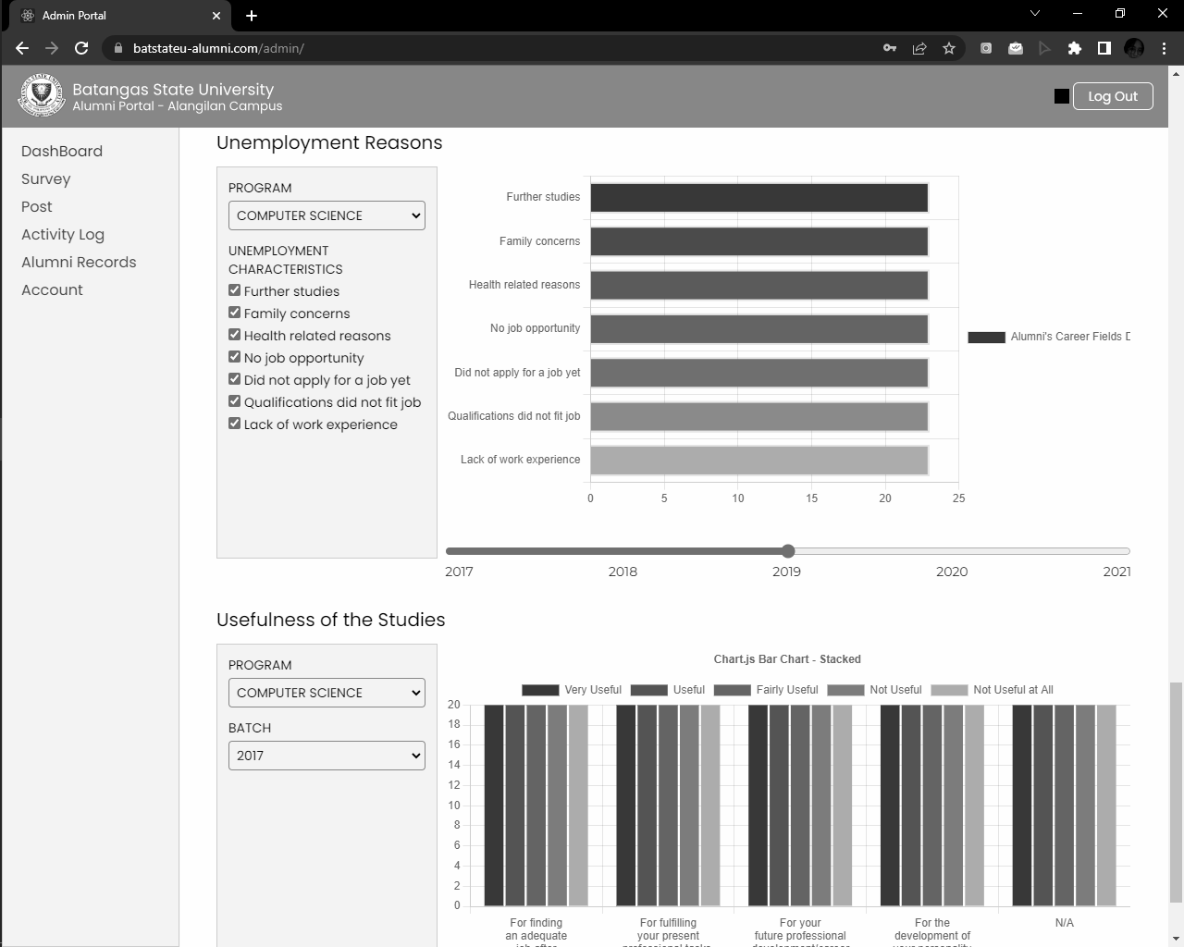*Figure 28.* Unemployment Reasons**

**This illustrates the rating of alumni for the statements such as for finding an adequate job after finishing their studies, for fulfilling their professional task, for their future professional development and career, for the development of their personality, and for the economic development of their country ranging from very useful to not useful. This graph can be filtered by selecting a program and batch from the dropdown list.**

**In employing the descriptive analytics, each graph has a descriptive analysis of what was derived from the visualization. For the employment status in figure 29, the total number of employed and unemployed alumni are specified by program and by year graduated.**

**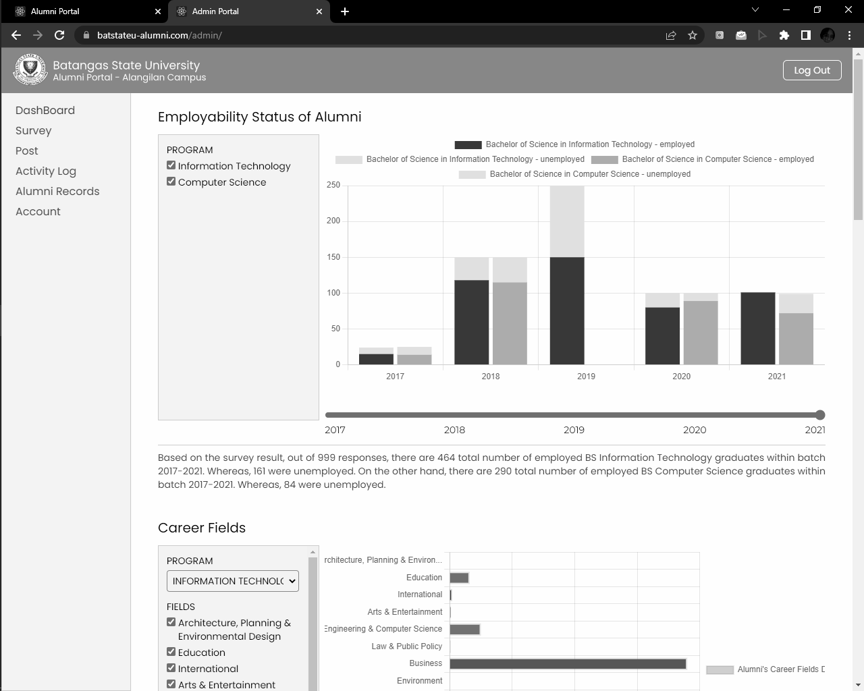*Figure 29.* Sample Analysis on Employability Status of Alumni**

**The most career fields the alumni are currently in are identified as well as the least career field. Specifically, the top three career fields by program were recognized in figure 30.**

**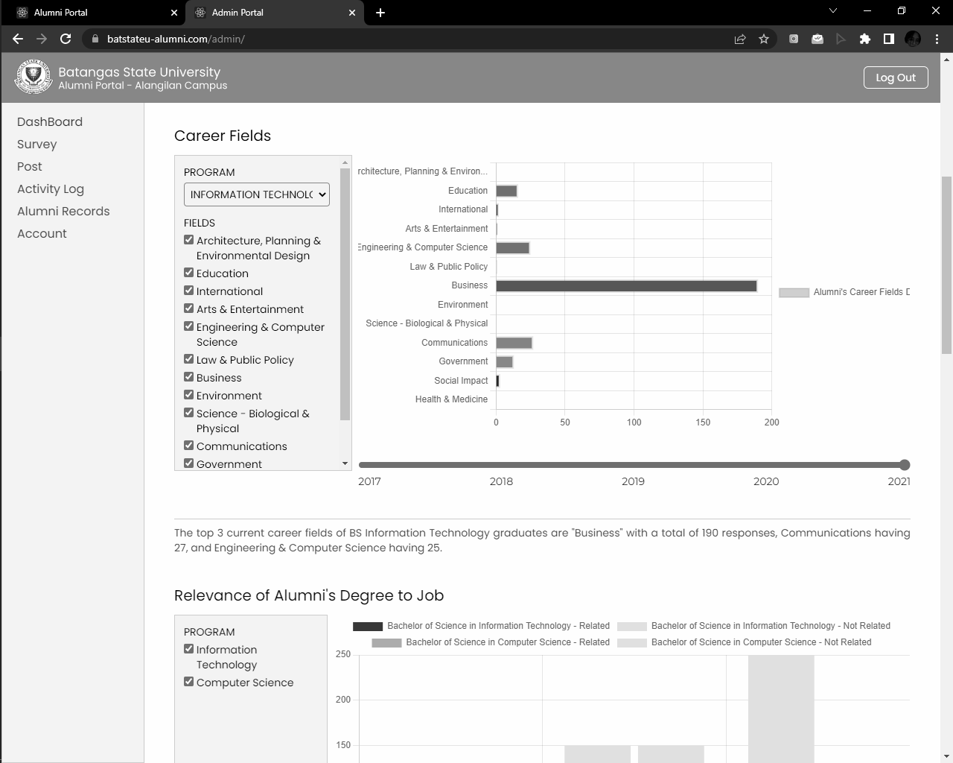*Figure 30.* Sample Analysis on Career Fields**

**In the relevance of degree obtained to their job in figure 31, the total number of alumni who agreed that their degree is related or not related to their job were known per program.**

**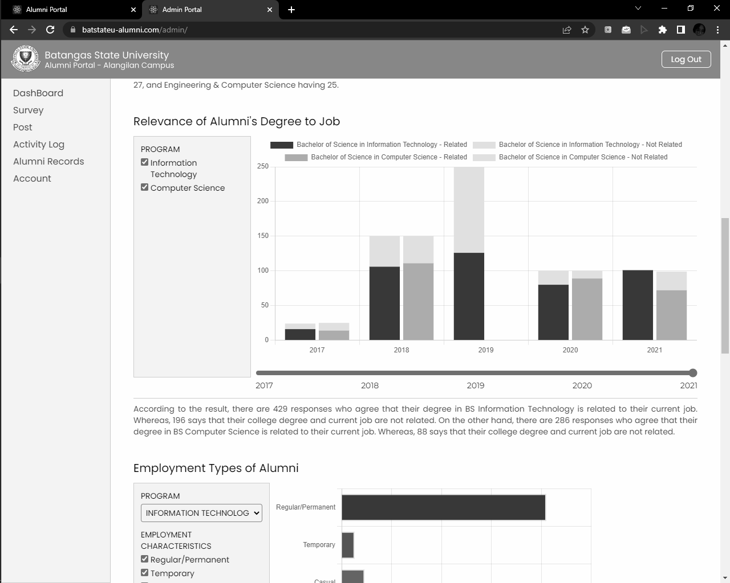*Figure 31.* Sample Analysis on Relevance of Alumni’s Degree to Job**

**For the employment types of alumni, the total count per employment characteristics per program were specified in figure 32.**

**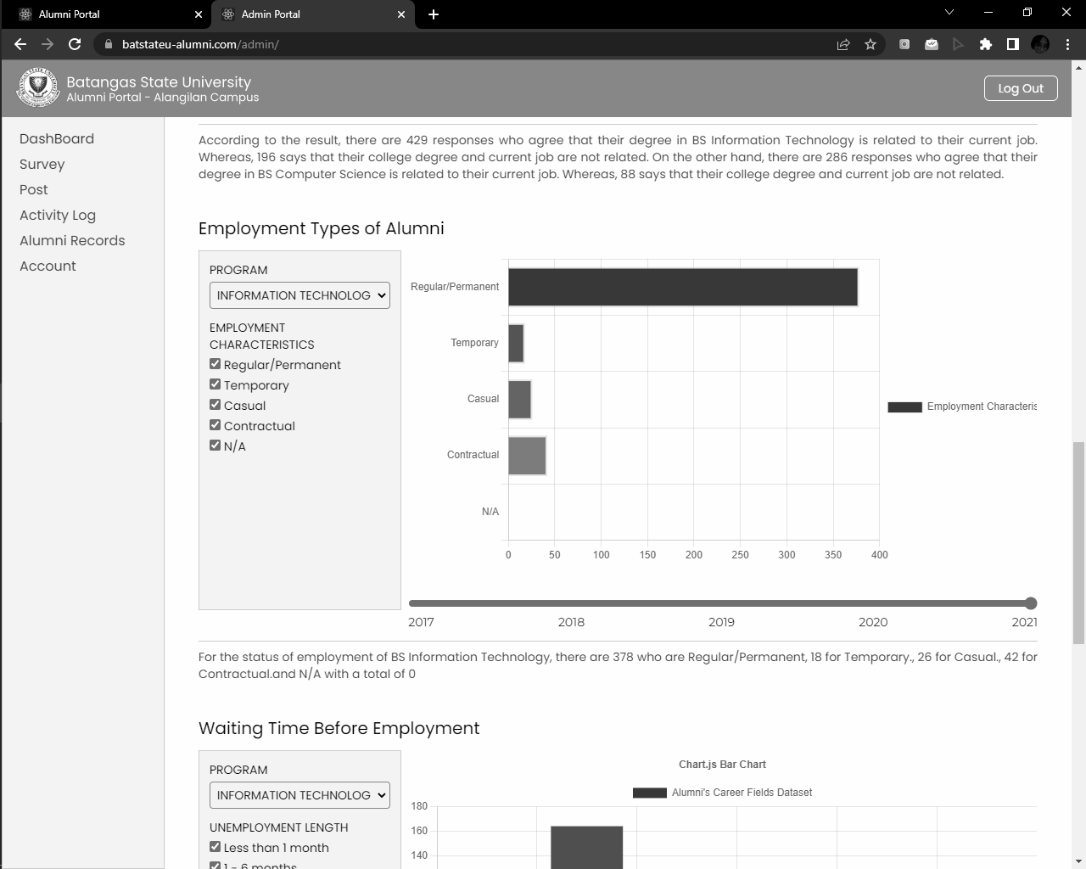*Figure 32.* Sample Analysis on Employment Types of Alumni**

**Then, for the waiting time before unemployment in figure 33, the time span that has the most and least responses were specified.**

**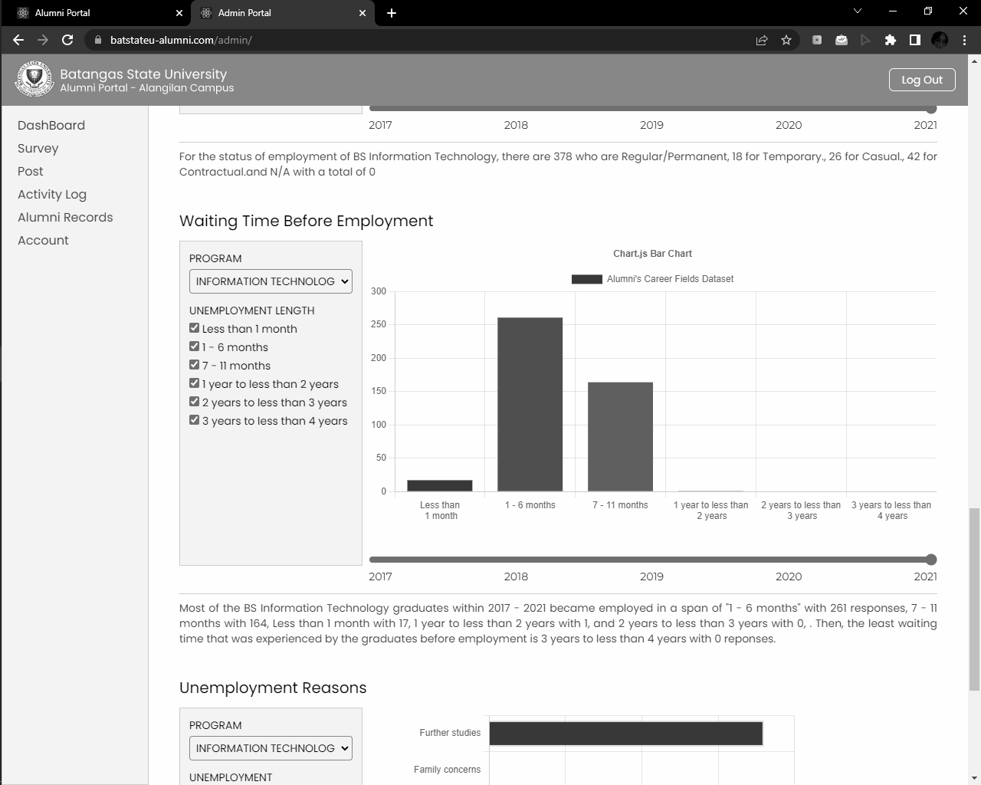*Figure 33.* Sample Analysis on Waiting Time Before Employment**

**In the reasons for unemployment, the top three reasons were classified by program in figure 34.**

**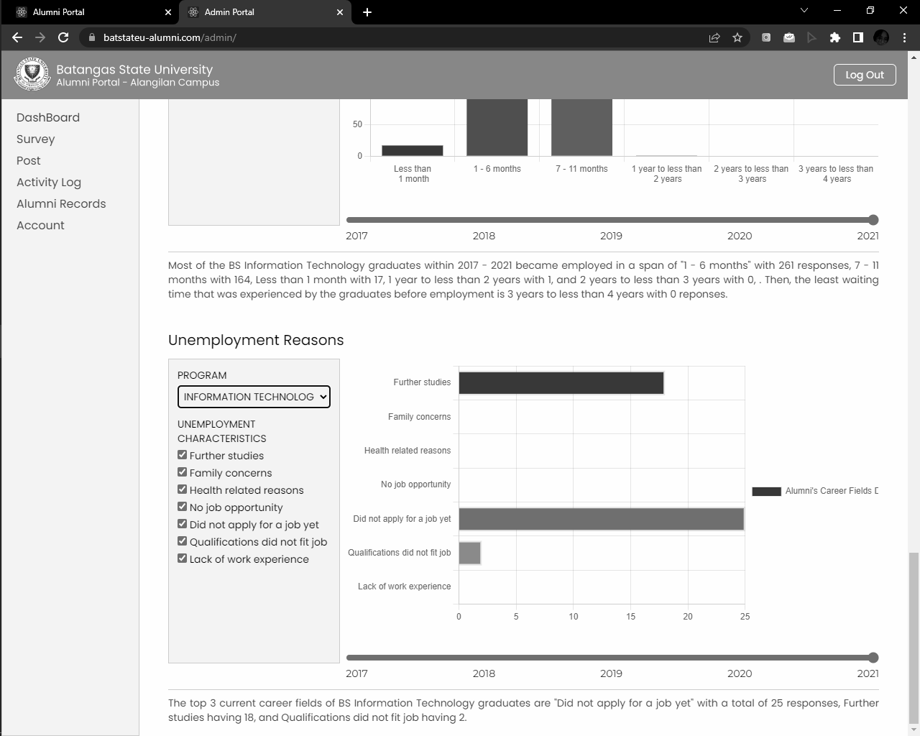*Figure 34.* Sample Analysis on Unemployment Reasons**

**These descriptive analyses were generated to provide an insightful outcome of what the graphs are all about.**

**Email Notifications**

**The email notifications were utilized to notify the alumni with regard to the registration and new posted announcements and surveys. This keeps the alumni updated about the university’s activities, news, and reminders.**

**The alumnus must provide an active email address for an email verification will be sent afterwards as shown in figure 35.**

**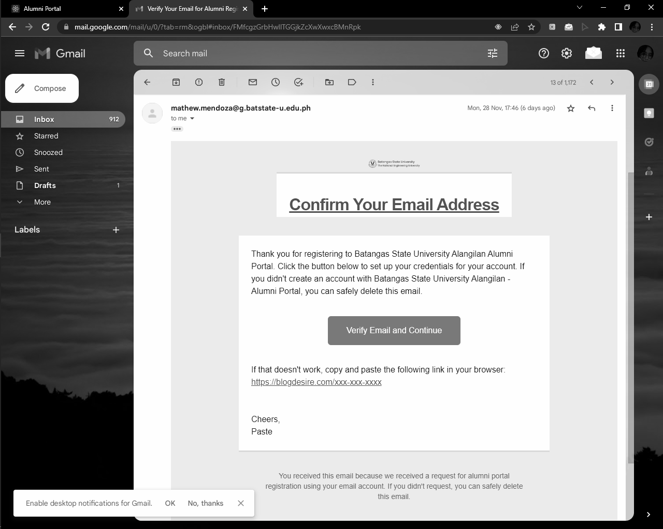 *Figure 35.* Email Verification**

**The fields of username and password must be filled out as displayed in figure 36.**

**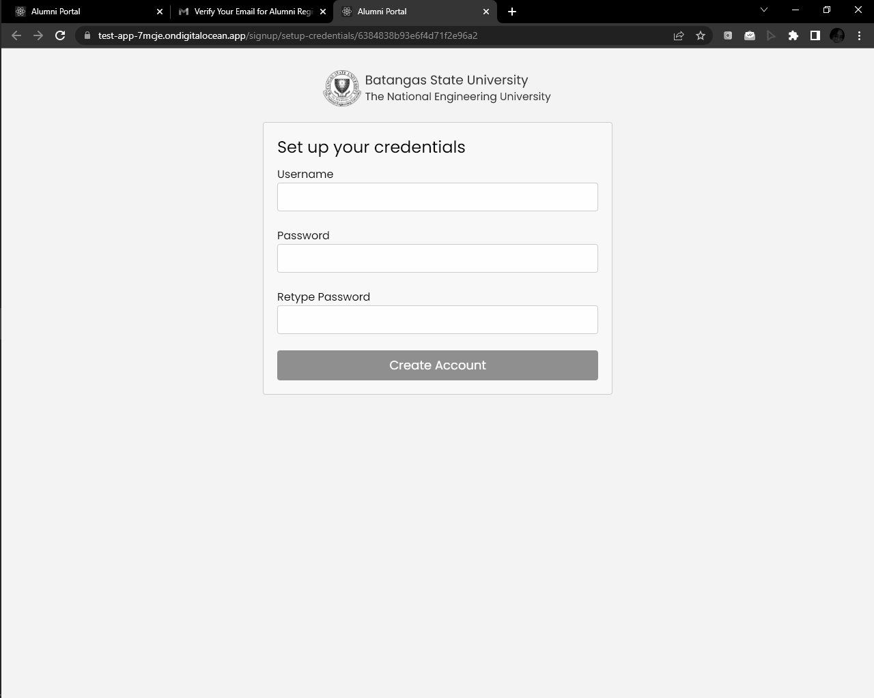*Figure 36.* Setup Credentials**

**The system is also requiring the alumnus to re-type the password for additional verification. Then, an account will be generated and will be used for the login portal of alumni.**

**When a new announcement was posted, the alumni will be notified through the email that they have provided as shown in figure 37.**

**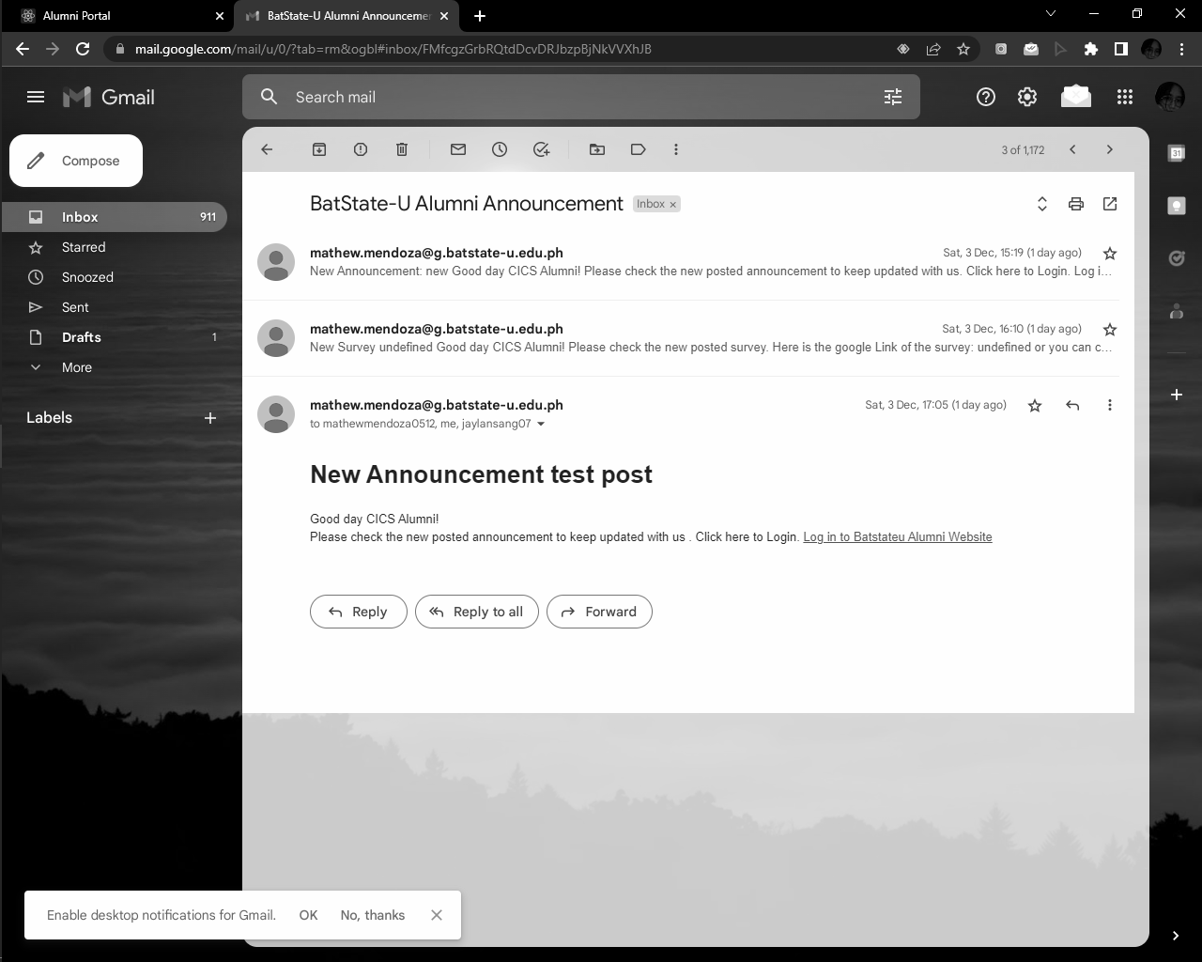*Figure 37.* Email Notification for New Announcement**

**Same goes when a new survey was posted in the alumni portal as displayed in figure 38.**

**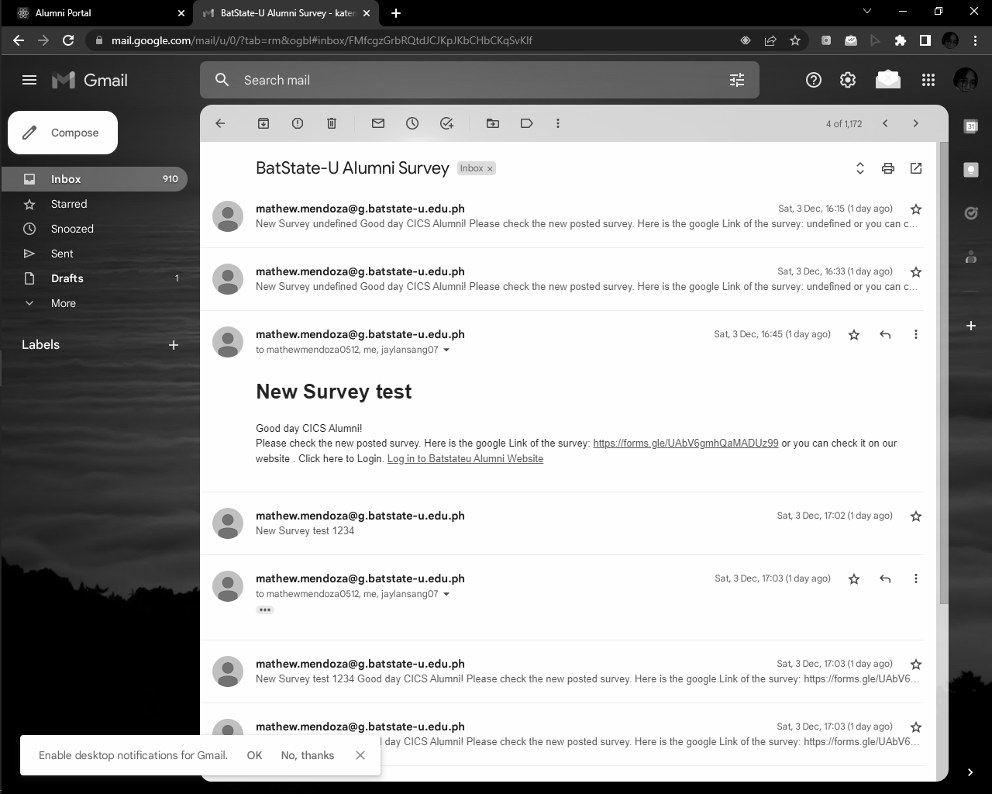*Figure 38.* Email Notification for New Survey**

**The alumnus can also access the alumni portal by clicking on the link of the website included in the email notification and must login to view the new announcement or survey.**

**Modules Management**

**Different modules were integrated in the alumni portal and tracking system. This includes the modules for the accounts, activity log, alumni records, announcements, dashboard, post, and survey.**

**Figure 39 presented the account page of an alumnus. It is composed of the username, degree, batch, address, email address, and phone number.**

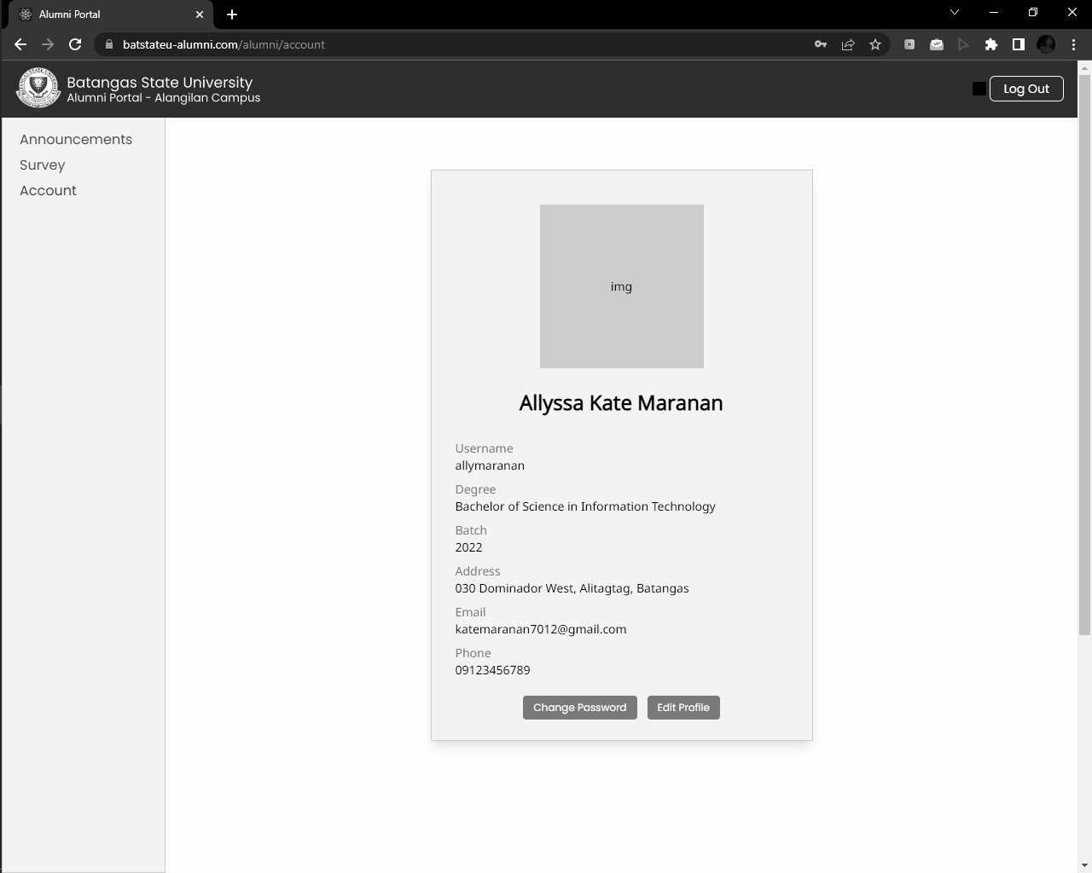

***Figure 39.* Alumni Account**

**For the admin account in Figure 40, it contains the username, address, phone number, and email address.**

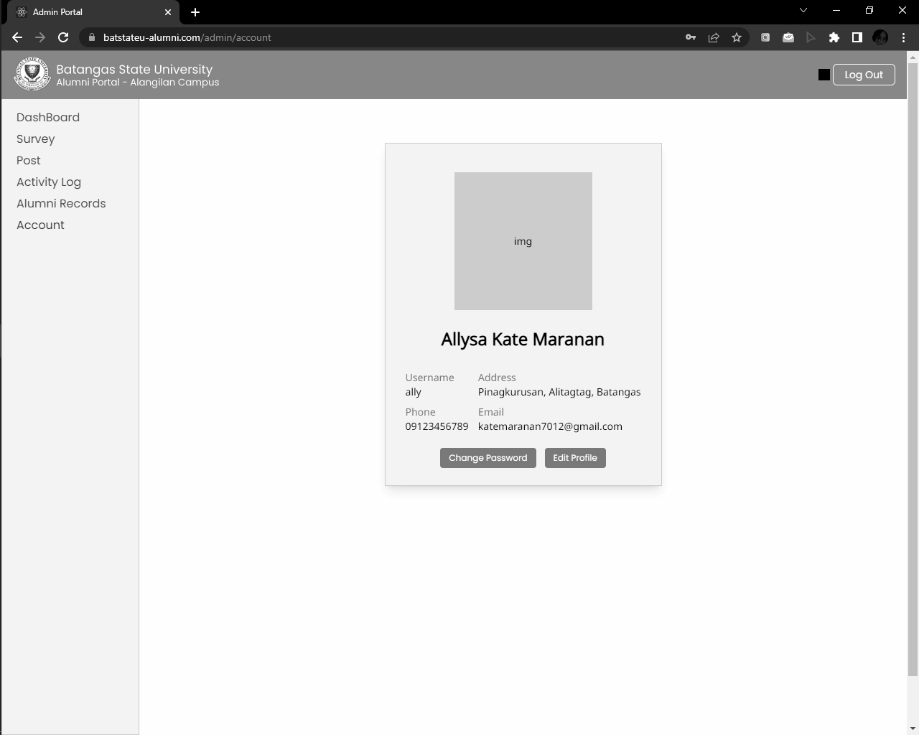

***Figure 40.* Admin Account**

**In the account module, the alumni and admin are capable of editing their profile and changing their password. In the edit profile of alumni, the information such as email address, phone number, and address can be updated the same goes with the edit profile of the admin account.**

**For the change password in the admin account, the admin will be asked to input the old password, new password, and retype of the new password. This is also the same with the change password of an alumni account.**

**The activity log records all the activity done by the admin as shown in Figure 41. The activities that can be recorded are the creating, editing, and deleting of announcements and surveys. The date and time of each activity is specified as well.**

**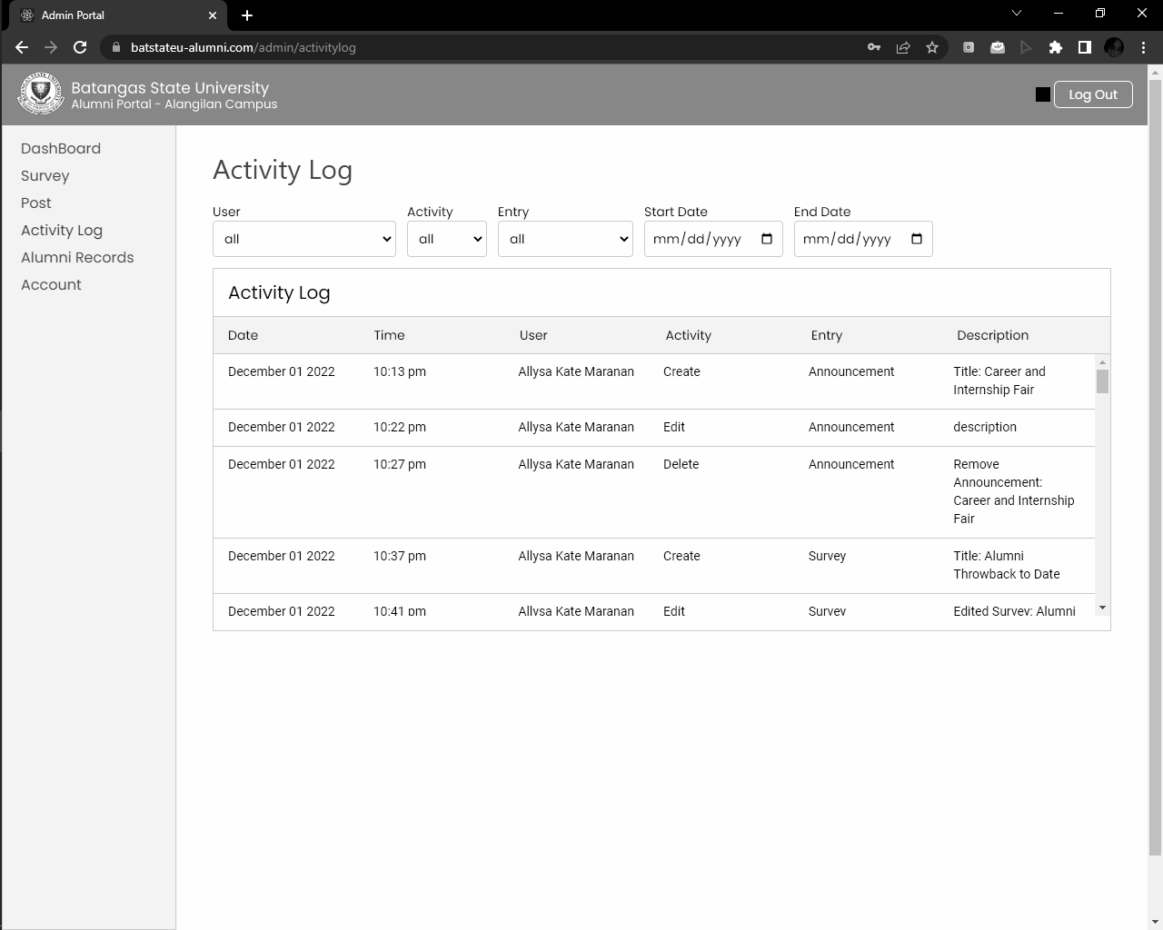*Figure 41.* Admin Activity Log**

**In addition, the activity log can be filtered based on the user, activity, entry, start date, and end date.**

**The alumni records contain the alumni information obtained from the survey form. In this page, the records can be filtered by batch and by program through clicking on the dropdown list as illustrated in figure 42.**

**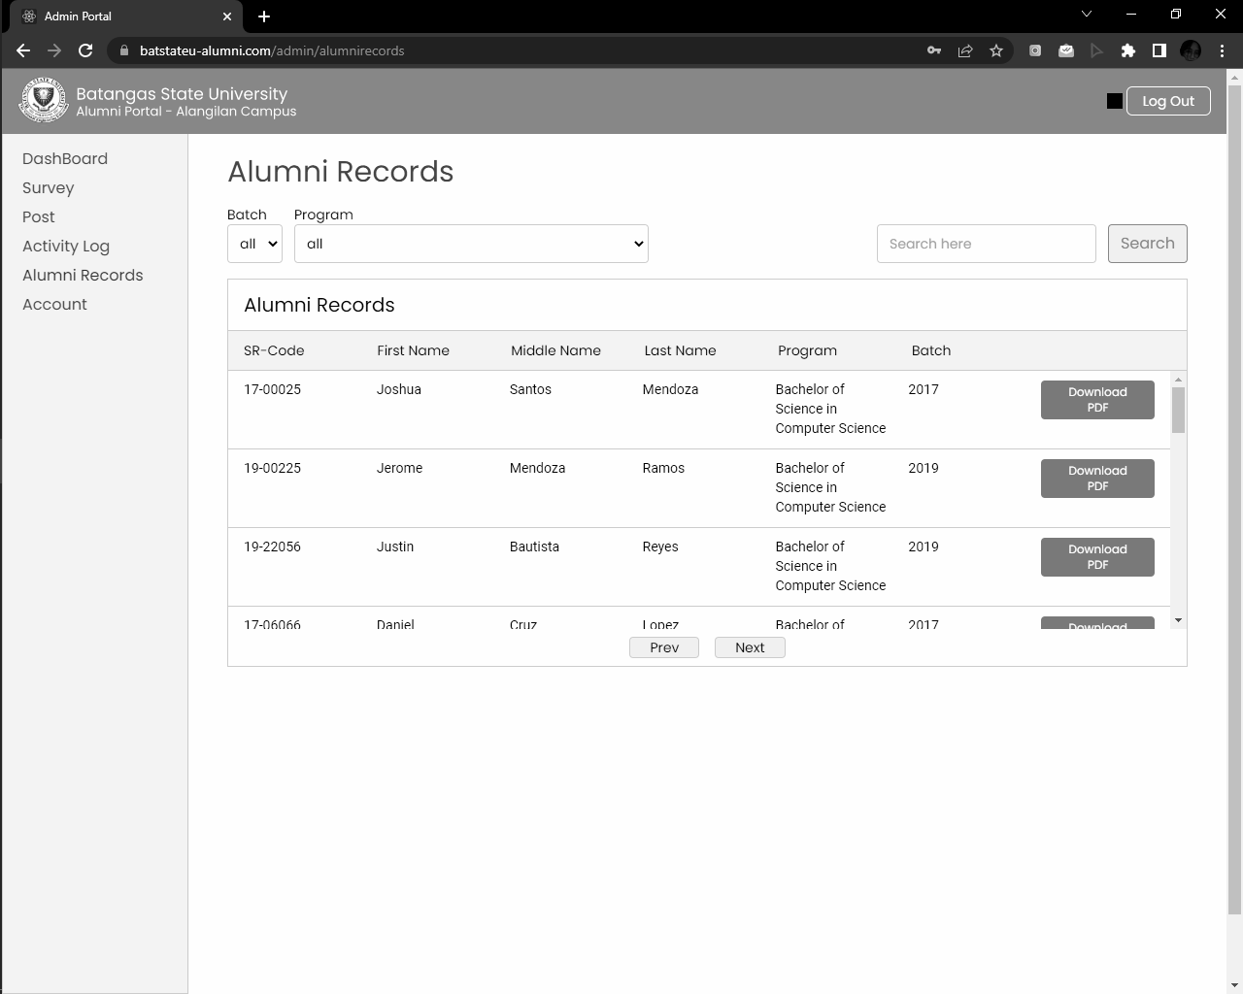*Figure 42.* Admin Alumni Records**

**A specific record can be searched through entering the correct sr-code of an alumnus. The information of an alumnus can also be downloaded in a form of pdf file.**

**In figure 43, the announcements module for the alumni is the default page when an alumnus logged in. The different announcements, messages, and news can be viewed. The alumni can also search an announcement by typing on the search bar and clicking the search button.**

**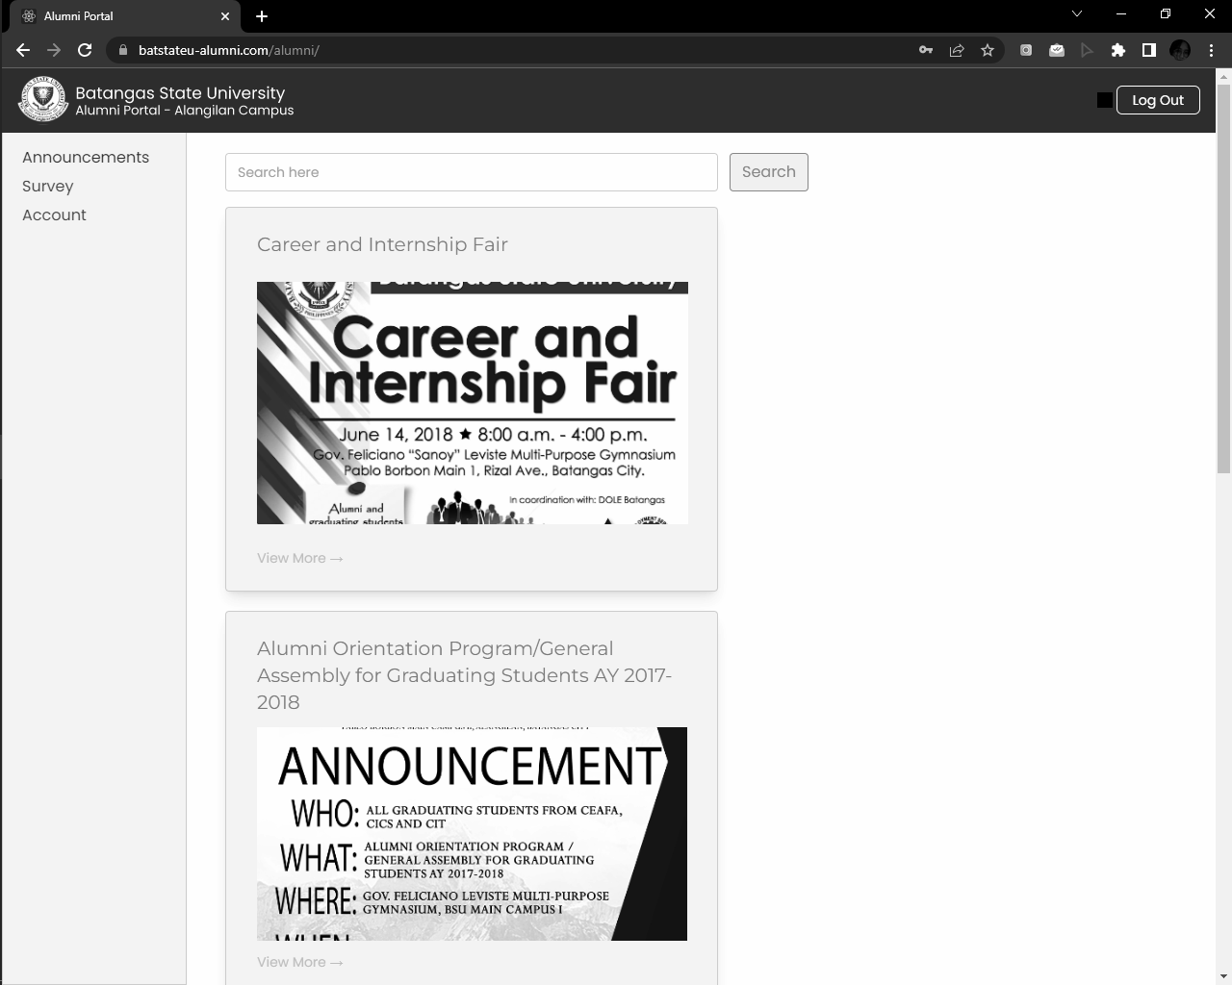*Figure 43.* Alumni Announcements**

**The full details of an announcement can be read by clicking the view more and the back button when viewed. There is also the next button to proceed to another page of announcements and the previous button to return.**

**The dashboard module of the admin in figure 44 is composed of the different visualizations with regard to the employability status of alumni, career fields, relevance of degree obtained to job, employment types of alumni, waiting time before employment, and unemployment reasons.**

** *Figure 44.* Admin Dashboard**

**Figure 45 presents the post module of the admin. In this part, the admin can post an announcement or survey.**

**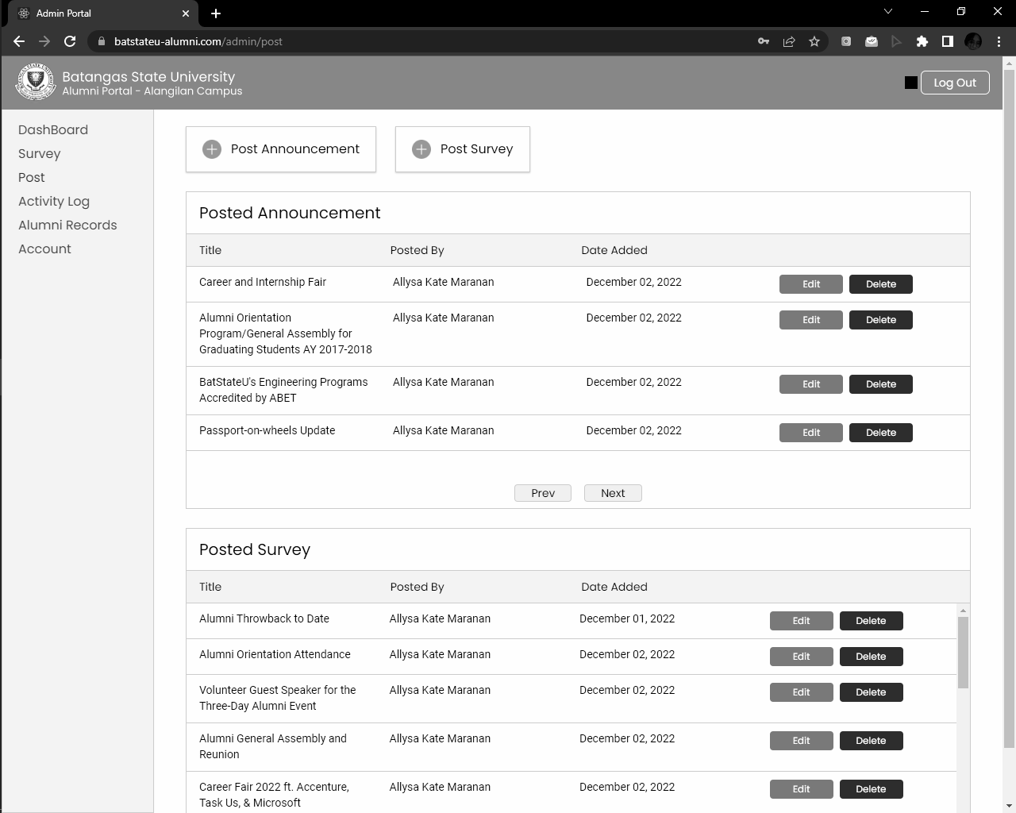*Figure 45.* Admin Post**

**In the post announcement, the admin must input the title, content, and an image as illustrated in figure 46, then click on the add announcement button.**

**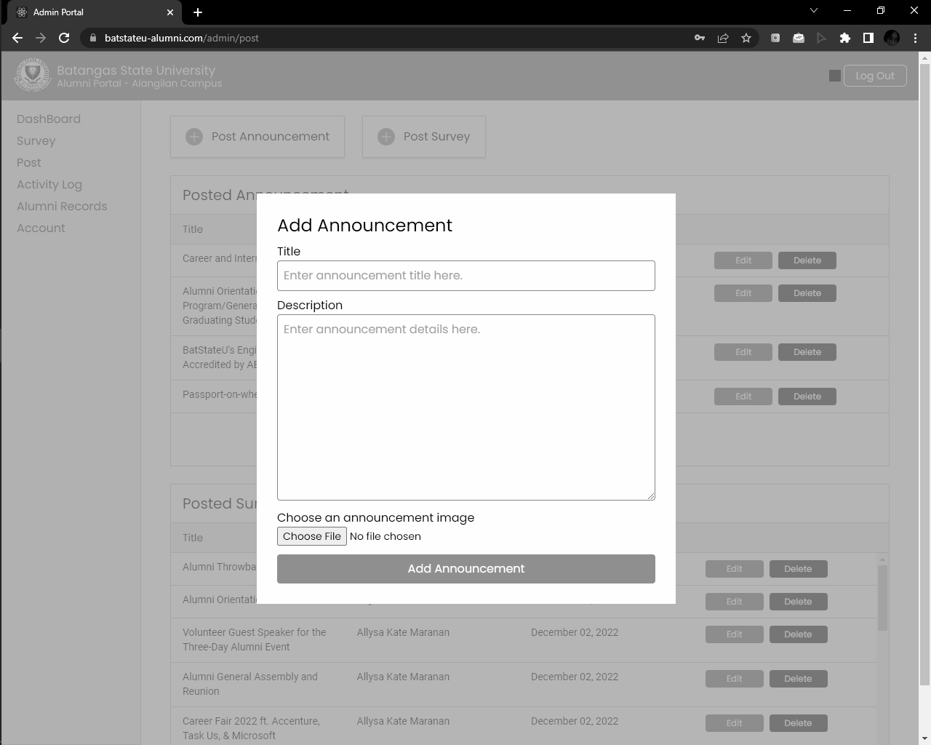*Figure 46.* Admin Add Announcement**

**For the post survey in figure 47, the admin must input the survey title, google form link, editable google form link, and description, then click on the post survey button.**

**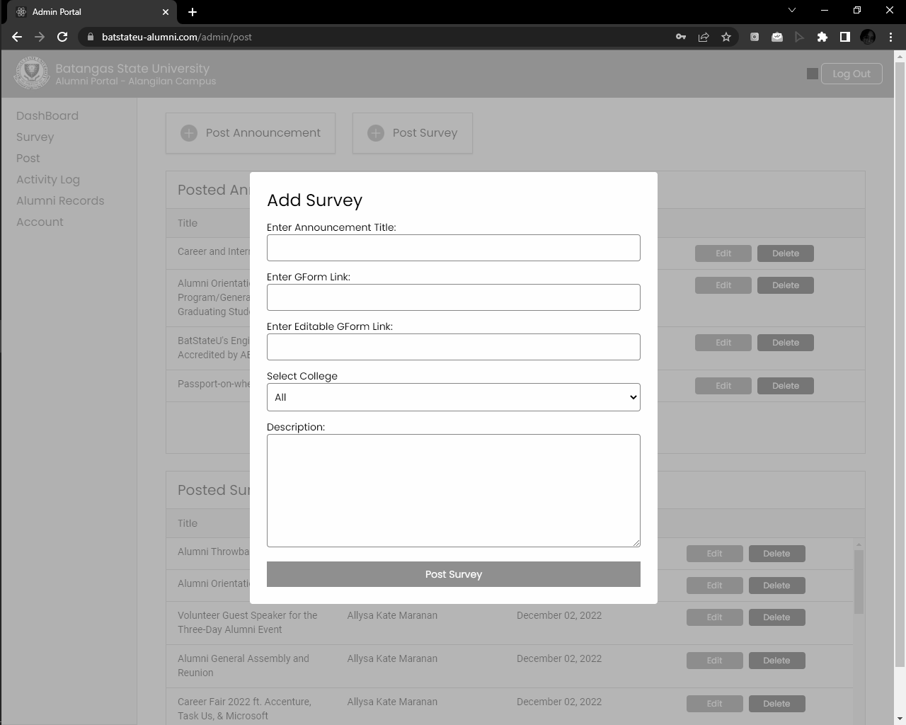*Figure 47.* Admin Add Survey**

**The posted survey and announcement can be monitored on their respective tables. The table includes the title, posted by, and date added. Moreover, the admin can edit or delete a specific announcement or survey.**

** *Figure 48.* Alumni Survey**

**Last but not least, the survey module of the alumni is divided into two sections such as alumni tracking surveys and surveys via google forms as shown in figure 48. The alumni will be redirected to the google form link when a survey must be answered via google form.**

**Survey and Testing Results**

**The researchers conducted a survey satisfying the six different testing covered by the ISO 9126 such as efficiency testing, maintainability testing, portability testing, reliability testing, functionality testing, and usability testing.**

**Table 13**

***Efficiency Testing***

| **Efficiency Testing Statements** | **Verbal Interpretation** | | | | **General Average** | **Verbal Interpretation** |
| --- | --- | --- | --- | --- | --- | --- |
| **Strongly Agree** | **Agree** | **Disagree** | **Strongly Disagree** |
| **1) There is no problem in the performance of the system.** | **38** | **2** | **0** | **0** | **3.9** | **Strongly Agree** |
| **2) The system was complex.** | **37** | **3** | **0** | **0** | **3.2** | **Strongly Agree** |
| **3) The user does not need technical support when using the system.** | **39** | **1** | **0** | **0** | **3.9** | **Strongly Agree** |
| **4) The various functions in the system were well integrated.** | **33** | **7** | **0** | **0** | **3.8** | **Strongly Agree** |
| **5) There is no inconsistency in the system.** | **39** | **1** | **0** | **0** | **3.9** | **Strongly Agree** |
| **6) Most people would learn to use the system very quickly.** | **38** | **2** | **0** | **0** | **3.9** | **Strongly Agree** |
| **7) I am confident using the system.** | **32** | **8** | **0** | **0** | **3.7** | **Strongly Agree** |
| **8) The information within the system is precise.** | **40** | **0** | **0** | **0** | **4** | **Strongly Agree** |
| **9) The system was easy to use.** | **37** | **3** | **0** | **0** | **3.9** | **Strongly Agree** |
| **10) Overall, I am satisfied with the system.** | **39** | **1** | **0** | **0** | **3.9** | **Strongly Agree** |
| **Composite Mean** | **37.2** | **2.8** | **0** | **0** | **3.9** | **Strongly Agree** |

**The researchers conducted an efficiency test to test the effectiveness of the portal. Survey was used by the researchers to conduct the efficiency test within the users. The users utilized and interacted with the portal before answering the survey questions. Table 13 shows the response of the users regarding the efficiency of the portal.**

**The target number of respondents for the survey is 40. Overall, the result of the survey conducted by the researchers was a success. The users strongly agree that they are satisfied with the system.**

**Table 14**

***Maintainability Testing***

| **Statements** | **Yes** | **No** |
| --- | --- | --- |
| 1. **Verified by the researchers, the development standards such as structured programming, standards for database approach, recognizable nomenclature and standards for the user interface.** | **✔** |  |
| 1. **Verified by the researchers, the data processing was split up into subtransactions.** | **✔** |  |
| 1. **Verified by the researchers, the input and output have been implemented separately.** | **✔** |  |
| 1. **Verified by the researchers, the programs have been parameterized under necessary conditions to promote reusability.** | **✔** |  |
| 1. **Verified by the researchers, the system was distributed.** | **✔** |  |
| 1. **Verified by the researchers, the algorithms are optimized.** | **✔** |  |
| 1. **Verified by the researchers, the system can be changed, modified, updated, and bug fixed.** | **✔** |  |

**Manual testing was used in maintainability testing conducted by the researchers. The developer of the system checked the statements in table # had verified the maintainability of the system.**

**Table 15**

***Alumni Portal Portability Testing***

| **Operating System** | **Browser** | **Version** | **Status** |
| --- | --- | --- | --- |
| **Windows** | **Mozilla Firefox** | **84.0** | **Passed** |
| **Windows** | **Mozilla Firefox** | **85.0** | **Passed** |
| **Mac OS** | **Chrome** | **105.0** | **Passed** |
| **Mac OS** | **Chrome** | **106.0** | **Passed** |
| **Mac OS** | **Mozilla Firefox** | **88.0** | **Passed** |
| **Mac OS** | **Mozilla Firefox** | **89.0** | **Passed** |
| **Linux** | **Table 15 (cont’d)**  **Chrome** | **105.0** | **Passed** |
| **Linux** | **Chrome** | **106.0** | **Passed** |
| **Linux** | **Mozilla Firefox** | **105.0** | **Passed** |

**Table 16**

***Admin Panel Portability Testing***

| **Operating System** | **Browser** | **Version** | **Status** |
| --- | --- | --- | --- |
| **Windows** | **Mozilla Firefox** | **84.0** | **Passed** |
| **Windows** | **Mozilla Firefox** | **85.0** | **Passed** |
| **Mac OS** | **Chrome** | **105.0** | **Passed** |
| **Mac OS** | **Chrome** | **106.0** | **Passed** |
| **Mac OS** | **Mozilla Firefox** | **88.0** | **Passed** |
| **Mac OS** | **Mozilla Firefox** | **89.0** | **Passed** |
| **Linux** | **Chrome** | **105.0** | **Passed** |
| **Linux** | **Chrome** | **106.0** | **Passed** |
| **Linux** | **Mozilla Firefox** | **105.0** | **Passed** |

**The researchers used automation testing to test the portability of the alumni portal and admin panel. Portability testing was used to determine whether the alumni portal and admin panel can be ported to various operating systems and browsers.**

**Comparium was used as the automation tool for the portability test. The results of portability testing on both alumni portal and admin panel generated by the use of automation testing both passed. The automation test included the operating system, name of the browser, browser version, and the status.**

**Table 17**

***Reliability Testing***

| **Label (Module)** | **No. of Iteration** | **Error Percentage (%)** |
| --- | --- | --- |
| **Alumni** |
| **SignUp** | **100** | **0.00%** |
| **Login** | **100** | **0.00%** |
| **Announcement** | **100** | **0.00%** |
| **Survey** | **100** | **0.00%** |
| **Account** | **100** | **0.00%** |
| **Admin** |  |  |
| **Login** | **100** | **0.00%** |
| **Dashboard** | **100** | **0.00%** |
| **Survey** | **100** | **0.00%** |
| **Post** | **100** | **0.00%** |
| **Activity Log** | **100** | **0.00%** |
| **Alumni Records** | **100** | **0.00%** |
| **Account** | **100** | **0.00%** |
| **TOTAL** | **1200** | **0.00%** |

**Automation testing was used for the reliability testing. Jmeter was used as the automation tool to conduct the reliability test. The test included the label or the module being tested, the number of iterations made on every module and the total number of iterations for all the modules, and the error percentage of every module.**

**Every module had 100 numbers of iteration with a total number of 1200 iterations. The error percentage of every iteration of modules is 0.00% which means that the alumni portal and admin panel had no errors or bugs.**

**Table 18**

***Usability Testing***

| **Usability Testing Statements** | **Verbal Interpretation** | | | | **General Average** | **Verbal Interpretation** |
| --- | --- | --- | --- | --- | --- | --- |
| **Strongly Agree** | **Agree** | **Disagree** | **Strongly Disagree** |
| **1) The system is simple to use and understand.** | **32** | **8** | **0** | **0** | **3.7** | **Strongly Agree** |
| **2) The interaction with the system is natural (the user does not have to wonder what to do next).)** | **9** | **29** | **2** | **0** | **3.2** | **Agree** |
| **3) The buttons within the system are appropriate, consistent, and clear.** | **38** | **2** | **0** | **0** | **3.9** | **Strongly Agree** |
| **4) The text sizes of the system are appropriate, consistent, and clear.** | **33** | **7** | **0** | **0** | **3.8** | **Strongly Agree** |
| **5) The system text and screen contrast are optimal.** | **39** | **1** | **0** | **0** | **3.9** | **Strongly Agree** |
| **6) The density of information on the system is appropriate.** | **38** | **2** | **0** | **0** | **3.9** | **Strongly Agree** |
| **7) The information provided by the system is accurate.** | **39** | **1** | **0** | **0** | **3.9** | **Strongly Agree** |
| **8) The interface of the system is pleasant.** | **40** | **0** | **0** | **0** | **4** | **Strongly Agree** |
| **9) The system has all the functions I expect it to have.** | **37** | **3** | **0** | **0** | **3.9** | **Strongly Agree** |
| **10) Overall, I am satisfied with the system.** | **39** | **1** | **0** | **0** | **3.9** | **Strongly Agree** |
| **Composite Mean** | **34.4** | **5.4** | **0.2** | **0** | **3.8** | **Strongly Agree** |

**The researchers conducted a usability test to understand how users interact with the portal. Survey was used by the researchers to conduct a usability test within the users. The users used and interacted with the portal before answering the survey questions. Table # shows the response of the users regarding the usability of the portal.**

**The target number of respondents for the survey are forty (40). Overall, the result of the survey conducted by the researchers was a success. The users strongly agree that they are satisfied with the system.**

**Testing is the process of evaluating the functional and non-functional requirements of the system in order to know whether the requirements are met accurately and properly. The researchers conducted unit testing for the modules of the alumni portal and tracking system. Unit testing is where individual modules of the system are tested to validate that each module is functioning as expected. The modules used for unit testing are accounts, activity log, alumni records, announcements, dashboard, post, and survey.**

**Table 19**

***Accounts Module Testing***

| **Project Name** | **Web-based Alumni Portal and Tracking System for Batangas State University - Alangilan** |  |  |  |  |  |  |  |  |
| --- | --- | --- | --- | --- | --- | --- | --- | --- | --- |
| **Module Name** | **Accounts** |  |  |  |  |  |  |  |  |
| **Created By** | **Allyssa Kate B. Maranan** |  |  |  |  |  |  |  |  |
| **Creation Date** | **11-07-2021** |  |  |  |  |  |  |  |  |
| **Reviewed By** | **Test Lead and Peers** |  |  |  |  |  |  |  |  |
| **Review Date** | **11-30-2021** |  |  |  |  |  |  |  |  |
|  |  |  |  |  |  |  |  |  |  |
| **Table 19 (cont’d)** | | | | | | | | | |
| **Test Scenario ID** | **Test Scenario Description** | **Test Case ID** | **Test Case Description** | **Test Steps** | **Preconditions** | **Test Data** | **Post Conditions** | **Actual Result** | **Status** |
| **TS_AP_001** | **Verify the login functionality of Alumni Portal login page.** | **TC_AP_Alumni_Login_001** | **Enter valid credentials for username and password** | **1.Go to the alumni portal website.**  **2.Enter valid username.**  **3.Enter valid password.**  **4.Click on the login button** | **Valid URL**  **Test Data** | **Username: allymaranan**  **Password: @Allymaranan1** | **User must be able to see and browse on the announcement page.** | **Successful login** | **Pass** |
| **TS_AP_001** | **Verify the login functionality of Alumni Portal login page.** | **TC_AP_Alumni_Login_002** | **Enter valid credential for username and invalid password** | **1.Go to the alumni portal website.**  **2.Enter valid username.**  **3.Enter invalid password.**  **4.Click on the login button** | **Valid URL**  **Test Data** | **Username: allymaranan**  **Password: allym123** | **Invalid password** | **A pop up box message to display an error that says, "Unauthorized".** | **Pass** |
| **TS_AP_001** | **Verify the login functionality of Alumni Portal login page.** | **TC_AP_Alumni_Login_003** | **Enter invalid credential for username and valid password** | **1.Go to the alumni portal website.**  **2.Enter invalid username.**  **3.Enter valid password.**  **4.Click on the login button** | **Valid URL**  **Test Data** | **Username: ally**  **Password: @Allymaranan1** | **Invalid username** | **A pop up box message to display an error that says, "Missing Username or Password".** | **Pass** |
| **Table 19 (cont’d)** | | | | | | | | | |
| **TS_AP_001** | **Verify the login functionality of Alumni Portal login page.** | **TC_AP_Alumni_Login_004** | **Enter invalid credentials for username and password** | **1.Go to the alumni portal website.**  **2.Enter invalid username.**  **3.Enter invalid password.**  **4.Click on the login button** | **Valid URL**  **Test Data** | **Username: ally**  **Password: 12345ally** | **Invalid username and password** | **A pop up box message to display an error that says, "Missing Username or Password".** | **Pass** |
| **TS_AP_001** | **Verify the login functionality of Alumni Portal login page.** | **TC_AP_Alumni_Login_005** | **No input for username and password** | **1.Go to the alumni portal website.**  **2.Click on the login button** | **Valid URL**  **No Test Data** | **Username:**  **Password:** | **No input for username and password** | **A pop up box message to display an error that says, "Missing Username or Password".** | **Pass** |
| **TS_AP_002** | **Verify the registration functionality of Alumni Portal** | **TC_AP_Signup_001** | **Proceed to sign up page** | **1.Go to the alumni portal website.**  **2.Click on the sign up button** | **Valid URL** | **Not Applicable** | **Users must be able to see the registration form page.** | **Directed to alumni registration form** | **Pass** |
| **TS_AP_002** | **Verify the registration functionality of Alumni Portal** | **TC_AP_Signup_002** | **Enter valid credentials for personal information (first, middle, and last name and address), contact information (email address and phone number), alumni information (SR-code, Program, Batch, and student email)** | **1.Go to the alumni portal website.**  **2.Click on the sign up button**  **3.Enter first name**  **4.Enter middle name**  **5.Enter last name**  **6.Enter address**  **7.Enter valid email address**  **8.Enter valid phone number**  **9.Enter valid sr-code**  **10.Enter program**  **11.Enter batch**  **12.Enter student email**  **12.Click on register button** | **Valid URL**  **Test Data** | **First Name: Allyssa Kate**  **Middle Name: Bonsol**  **Last Name: Maranan**  **Address: Dominador West, Alitagtag, Batangas**  **Email Address:** [**katemaranan7012@gmail.com**](mailto:katemaranan7012@gmail.com)  **Phone Number: 09284692676**  **SR-Code: 19-53297**  **Program: BS Information Technology**  **Batch: 2022**  **Student Email: allyssakate.maranan@g.batstate-u.edu.ph** | **An email verification for alumni registration is sent to the given email address.** | **User received an email verification for alumni registration** | **Pass** |
| **TS_AP_002** | **Verify the registration functionality of Alumni Portal** | **TC_AP_Signup_003** | **No input for the personal information (first, middle, and last name and address), contact information (email address and phone number), alumni information (SR-code, Program, Batch, and student email)** | **1.Go to the alumni portal website.**  **2.Click on the sign up button**  **3.Click on the register button** | **Valid URL**  **No Test Data** | **First Name:**  **Middle Name:**  **Last Name:**  **Address:**  **Email Address:**  **Phone Number:**  **SR-Code: Program: Student Email:** | **No inputs for first name, middle name, last name, address, email address, phone number, sr-code, program, student email** | **An alert below the input fields that says, “address is required” up to “batch is required”** | **Pass** |
| **TS_AP_003** | **Verify the login functionality of Admin Panel login page.** | **TC_AP_Admin_Login_001** | **Enter valid credentials for username and password** | **1.Go to the alumni portal website.**  **2.Enter valid username.**  **3.Enter valid password.**  **4.Click on the login button** | **Valid URL**  **Test Data** | **Username: ally**  **Password: helloally** | **User must be able to see the profile page.** | **Successful login** | **Pass** |
| **TS_AP_003** | **Verify the login functionality of Admin Panel login page.** | **TC_AP_Admin_Login_002** | **Enter valid credential for username and invalid password** | **1.Go to the alumni portal website.**  **2.Enter valid username.**  **3.Enter invalid password.**  **4.Click on the login button** | **Valid URL**  **Test Data** | **Username: ally**  **Password: helloallyssa** | **Invalid password** | **A pop up box message to display an error that says, "Unauthorized".** | **Pass** |
| **TS_AP_003** | **Verify the login functionality of Admin Panel login page.** | **TC_AP_Admin_Login_003** | **Enter invalid credential for username and valid password** | **1.Go to the alumni portal website.**  **2.Enter invalid username.**  **3.Enter valid password.**  **4.Click on the login button** | **Valid URL**  **Test Data** | **Username: allymrnn**  **Password: helloally** | **Invalid username** | **A pop up box message to display an error that says, "Login Failed".** | **Pass** |
| **Table 19 (cont’d)** | | | | | | | | | |
| **TS_AP_003** | **Verify the login functionality of Admin Panel login page.** | **TC_AP_Admin_Login_004** | **Enter invalid credential for username and password** | **1.Go to the alumni portal website.**  **2.Enter invalid username.**  **3.Enter invalid password.**  **4.Click on the login button** | **Valid URL**  **Test Data** | **Username: adminally**  **Password: 123456** | **Invalid Password** | **A pop up box message to display an error that says, "Login Failed".** | **Pass** |
| **TS_AP_003** | **Verify the login functionality of Admin Panel login page.** | **TC_AP_Admin_Login_005** | **No input for username and password** | **1.Go to the alumni portal website.**  **2.Click on the login button** | **Valid URL**  **No Test Data** | **Username:**  **Password:** | **No input for username and password** | **A pop up box message to display an error that says, "Login Failed".** | **Pass** |
| **TS_AP_04** | **Verify the edit profile functionality of alumni** | **TC_AP_Alumni_Profile_001** | **Updating alumni profile information** | **1.Go to the alumni portal website**  **2.Enter valid credentials for username and password**  **3.Click on login button**  **4.Click on the account**  **5.Click on edit profile button**  **6.Click on edit below the input field**  **7.Enter updated information**  **8.Click on save button** | **Valid URL**  **Registered Alumni User**  **Test data** | **Username: allymaranan**  **Password: @Allymaranan1**  **Email: alymaranan99@gmail.com**  **Phone: 09496063002**  **Address: 030 Dominador West, Alitagtag, Batangas** | **Updated credentials for email, phone number, and address** | **A pop up box message to display an error that says, "Saved".** | **Pass** |
| **TS_AP_05** | **Verify the edit profile functionality of admin** | **TC_AP_Admin_Profile_001** | **Updating admin profile information** | **1.Go to the admin panel**  **2.Enter valid credentials for username and password**  **3.Click on login button**  **4.Click on the account**  **5.Click on edit profile button**  **6.Click on edit below the input field**  **7.Enter updated information**  **8.Click on save button** | **Valid URL**  **Registered Admin User**  **Test data** | **Username: ally**  **Password: helloally**  **Email: alymaranan99@gmail.com**  **Phone: 09524851275**  **Address: Pinagkurusan, Alitagtag, Batangas** | **Updated credentials for email, phone number, and address** | **A pop up box message to display an error that says, "Saved".** | **Pass** |
| **TS_AP_06** | **Verify the change password functionality of admin** | **TC_AP_Admin_Pass_001** | **Changing of password in admin profile** | **1.Go to the admin panel**  **2.Enter valid credentials for username and password**  **3.Click on login button**  **4.Click on the account**  **5.Click on change password button**  **6.Fill out the old password field**  **7.Input new password**  **8.Retype new password**  **9.Click on save button** | **Valid URL**  **Registered Admin User**  **Test data** | **Username: ally**  **Password: helloally**  **Old password:**  **helloally**  **New password:**  **hellokate**  **Retype new password:**  **hellokate** | **Fields of old password, new password, and retype password are filled-out** | **A pop up box message that says, "Password Updated".** | **Pass** |
| **TS_AP_07** | **Verify the change password functionality of alumni** | **TC_AP_Alumni_Pass_001** | **Changing of password in alumni profile** | **2.Enter valid credentials for username and password**  **3.Click on login button**  **4.Click on the account**  **5.Click on change password button**  **6.Fill out the old password field**  **7.Input new password**  **8.Retype new password**  **9.Click on save button** | **Valid URL**  **Registered Alumni User**  **Test data** | **Username: allymaranan**  **Password: @Allymaranan1**  **Old password:**  **@Allymaranan1**  **New password:**  **@Katemaranan1**  **Retype new password:**  **@Katemaranan1** | **Fields of old password, new password, and retype password are filled-out** | **A pop up box message that says, "Password Updated".** | **Pass** |

**Table 20**

***Activity Log Module Testing***

| **Project Name** | **Web-based Alumni Portal and Tracking System for Batangas State University - Alangilan** |  |  |  |  |  |  |  |  |
| --- | --- | --- | --- | --- | --- | --- | --- | --- | --- |
| **Module Name** | **Activity Log** |  |  |  |  |  |  |  |  |
| **Created By** | **Allyssa Kate B. Maranan** |  |  |  |  |  |  |  |  |
| **Creation Date** | **11-07-2021** |  |  |  |  |  |  |  |  |
| **Reviewed By** | **Test Lead and Peers** |  |  |  |  |  |  |  |  |
| **Review Date** | **11-30-2021** |  |  |  |  |  |  |  |  |
| **Test Scenario ID** | **Test Scenario Description** | **Test Case ID** | **Test Case Description** | **Test Steps** | **Preconditions** | **Test Data** | **Post Conditions** | **Actual Result** | **Status** |
| **TS_Act_Log_001** | **Filter activity log** | **TC_Act_Log_Activity_001** | **Click dropdown on activity and select create** | **1.Go to admin panel**  **2.Enter valid username and password**  **3.Click on login button**  **4.Click on activity log**  **5.Click dropdown of activity**  **6.Click on create** | **Valid URL**  **Registered Admin User**  **Test Data** | **Username: ally**  **Password: helloally**  **List of activity logs**  **Activity:Create** | **Create filter under activity is selected** | **Activity log is filtered based on create activity** | **Pass** |
| **Table 20 (cont’d)** | | | | | | | | | |
| **TS_Act_Log_001** | **Filter activity log** | **TC_Act_Log_Activity_002** | **Click dropdown on activity and select edit** | **1.Go to admin panel**  **2.Enter valid username and password**  **3.Click on login button**  **4.Click on activity log**  **5.Click dropdown of activity**  **6.Click on edit** | **Valid URL**  **Registered Admin User**  **Test Data** | **Username: ally**  **Password: helloally**  **List of activity logs**  **Activity:Edit** | **Edit filter under activity is selected** | **Activity log is filtered based on edit activity** | **Pass** |
| **TS_Act_Log_001** | **Filter activity log** | **TC_Act_Log_Entry_003** | **Click dropdown on entry and select announcement** | **1.Go to admin panel**  **2.Enter valid username and password**  **3.Click on login button**  **4.Click on activity log**  **5.Click dropdown of entry**  **6.Click on announcement** | **Valid URL**  **Registered Admin User**  **Test Data** | **Username: ally**  **Password: helloally**  **List of activity logs**  **Entry:Announcement** | **Announcement filter under entry is selected** | **Activity log is filtered based on entry announcement** | **Pass** |
| **TS_Act_Log_001** | **Filter activity log** | **TC_Act_Log_Entry_004** | **Click dropdown on entry and select survey** | **1.Go to admin panel**  **2.Enter valid username and password**  **3.Click on login button**  **4.Click on activity log**  **5.Click dropdown of entry**  **6.Click on survey** | **Valid URL**  **Registered Admin User**  **Test Data** | **Username: ally**  **Password: helloally**  **List of activity logs**  **Entry:Survey** | **Survey filter under entry is selected** | **Activity log is filtered based on entry survey** | **Pass** |
| **TS_Act_Log_001** | **Filter activity log** | **TC_Act_Log_Date_005** | **Click on calendar icon under start date, then click on calendar icon under end date** | **1.Go to admin panel**  **2.Enter valid username and password**  **3.Click on login button**  **4.Click on activity log**  **5.Click on calendar icon of start date**  **6.Click on calendar icon of end date** | **Valid URL**  **Registered Admin User**  **Test Data** | **Username: ally**  **Password: helloally**  **List of activity logs**  **Start Date: 11/30/2022**  **End Date: 12/02/2022** | **Dates are selected from start date to end date** | **List of activity log is filtered based on the start date of 11/30/2022 to 12/02/2022** | **Pass** |
| **TS_Act_Log_001** | **Filter activity log** | **TC_Act_Log_Entry_006** | **Click dropdown on user and select a name** | **1 Enter valid username and password**  **2.Click on login button**  **3.Click on activity log**  **4.Click dropdown of user**  **5.Click on name** | **Valid URL**  **Registered Admin User**  **Test Data** | **Username: ally**  **Password: helloally**  **List of activity logs**  **User: Allyssa Kate Maranan** | **Survey filter under user named Allyssa Kate Maranan** | **List of activity log is filtered based on the user named Allyssa Kate Maranan** | **Pass** |

**Table 21**

***Alumni Records Module Testing***

| **Project Name** | **Web-based Alumni Portal and Tracking System for Batangas State University - Alangilan** |  |  |  |  |  |  |  |  |
| --- | --- | --- | --- | --- | --- | --- | --- | --- | --- |
| **Module Name** | **Alumni Records** |  |  |  |  |  |  |  |  |
| **Created By** | **Allyssa Kate B. Maranan** |  |  |  |  |  |  |  |  |
| **Creation Date** | **11-07-2021** |  |  |  |  |  |  |  |  |
| **Reviewed By** | **Test Lead and Peers** |  |  |  |  |  |  |  |  |
| **Review Date** | **11-30-2021** |  |  |  |  |  |  |  |  |
|  |  |  |  |  |  |  |  |  |  |
| **Test Scenario ID** | **Test Scenario Description** | **Test Case ID** | **Test Case Description** | **Test Steps** | **Preconditions** | **Test Data** | **Post Conditions** | **Actual Result** | **Status** |
| **TS_Alumni_Record_001** | **Filter alumni records** | **TC_Alumni_Record_Filter_001** | **Click on the dropdown of batch and select a year** | **1.Go to admin panel**  **2.Enter valid username and password**  **3.Click on login button**  **4.Click on alumni records**  **5.Click the dropdown of batch** | **Valid URL**  **Registered Admin User**  **Test Data** | **Username: ally**  **Password: helloally**  **Batch:2018** | **A batch is selected** | **The table presented alumni records from batch 2018** | **Pass** |
| **Table 21 (cont’d)** | | | | | | | | | |
| **TS_Alumni_Record_001** | **Filter alumni records** | **TC_Alumni_Record_Filter_002** | **Click on the dropdown of program and select degree** | **1.Go to admin panel**  **2.Enter valid username and password**  **3.Click on login button**  **4.Click on alumni records**  **5.Click the dropdown of program** | **Valid URL**  **Registered Admin User**  **Test Data** | **Username: ally**  **Password: helloally**  **Program: BS Information Technology** | **A degree is selected from program** | **The table presented alumni records graduates of BS Information Technology** | **Pass** |
| **TS_Alumni_Record_001** | **Filter alumni records** | **TC_Alumni_Record_Filter_003** | **Search a sr-code** | **1.Go to admin panel**  **2.Enter valid username and password**  **3.Click on login button**  **4.Click on alumni records**  **5.Click on the search bar**  **6.Input valid sr-code** | **Valid URL**  **Registered Admin User**  **Test Data** | **Username: ally**  **Password: helloally**  **Search: 19-00001** | **Valid sr-code** | **The table showed the alumnus with the sr-code of 19-00001** | **Pass** |

**Table 22**

***Announcements Module Testing***

| **Project Name** | **Web-based Alumni Portal and Tracking System for Batangas State University - Alangilan** |  |  |  |  |  |  |  |  |
| --- | --- | --- | --- | --- | --- | --- | --- | --- | --- |
| **Module Name** | **Announcements** |  |  |  |  |  |  |  |  |
| **Created By** | **Allyssa Kate B. Maranan** |  |  |  |  |  |  |  |  |
| **Creation Date** | **11-07-2021** |  |  |  |  |  |  |  |  |
| **Reviewed By** | **Test Lead and Peers** |  |  |  |  |  |  |  |  |
| **Review Date** | **11-30-2021** |  |  |  |  |  |  |  |  |
|  |  |  |  |  |  |  |  |  |  |
| **Test Scenario ID** | **Test Scenario Description** | **Test Case ID** | **Test Case Description** | **Test Steps** | **Preconditions** | **Test Data** | **Post Conditions** | **Actual Result** | **Status** |
| **TS_Alumni_Announcement_001** | **View announcement** | **TC_Alumni_Announcement_View_001** | **Click on view more to view announcement** | **1.Go to admin panel**  **2.Enter valid username and password**  **3.Click on login button**  **4.Click on announcements**  **5.Click on view more in one announcement** | **Valid URL**  **Registered Alumni User**  **Test Data** | **Username: allymaranan**  **Password: @Allymaranan1**  **Announcement** | **View more is clicked** | **User was able to view and browse the complete details of the selected announcement** | **Pass** |
| **TS_Alumni_Announcement_001** | **Pagination of announcements** | **TC_Alumni_Announcement_View_002** | **Click on the next button to proceed to the succeeding page** | **1.Go to admin panel**  **2.Enter valid username and password**  **3.Click on login button**  **4.Click on announcements**  **5.Click on the next button** | **Valid URL**  **Registered Alumni User**  **Test Data** | **Username: allymaranan**  **Password: @Allymaranan1**  **Announcement** | **Next button is clicked and page number is updated** | **User was able to proceed to the next page and the page number was updated** | **Pass** |
| **TS_Alumni_Announcement_001** | **Pagination of announcements** | **TC_Alumni_Announcement_View_003** | **Click on the previous button to proceed to the preceding page** | **1.Go to admin panel**  **2.Enter valid username and password**  **3.Click on login button**  **4.Click on announcements**  **5.Click on the next button**  **6.Click on the prev button** | **Valid URL**  **Registered Alumni User**  **Test Data** | **Username: allymaranan**  **Password: @Allymaranan1**  **Announcement** | **Next button is clicked and page number is updated then previous button is clicked** | **User was able to proceed to the next page and was able to return to the previous page and page number was updated** | **Pass** |

**Table 23**

***Dashboard Module Testing***

| **Project Name** | **Web-based Alumni Portal and Tracking System for Batangas State University - Alangilan** |  |  |  |  |  |  |  |  |
| --- | --- | --- | --- | --- | --- | --- | --- | --- | --- |
| **Module Name** | **Dashboard** |  |  |  |  |  |  |  |  |
| **Created By** | **Allyssa Kate B. Maranan** |  |  |  |  |  |  |  |  |
| **Creation Date** | **11-07-2021** |  |  |  |  |  |  |  |  |
| **Reviewed By** | **Test Lead and Peers** |  |  |  |  |  |  |  |  |
| **Review Date** | **11-30-2021** |  |  |  |  |  |  |  |  |
|  |  |  |  |  |  |  |  |  |  |
| **Test Scenario ID** | **Test Scenario Description** | **Test Case ID** | **Test Case Description** | **Test Steps** | **Preconditions** | **Test Data** | **Post Conditions** | **Actual Result** | **Status** |
| **TS_Dashboard_001** | **Filter visualizations** | **TC_Dashboard_Graph_001** | **Filter graph of employability status of CICS Alumni to BS Information Technology** | **1.Go to admin panel**  **2.Enter valid username and password**  **3.Click on login button**  **4.Click on dashboard**  **5.Unchecked BS Computer Science under Program** | **Valid URL**  **Registered Admin User**  **Test Data** | **Username: ally**  **Password: helloally**  **Graph of Employability Status of CICS Alumni**  **Uncheck:BS Computer Science** | **The program named BS Information Technology has check mark and uncheck mark for BS Computer Science** | **Graph displayed employability status of BS Information Technology graduates only** | **Pass** |
| **TS_Dashboard_001** | **Filter visualizations** | **TC_Dashboard_Graph_002** | **Filter graph of employability status of CICS Alumni to BS Information Technology and employed only** | **1.Go to admin panel**  **2.Enter valid username and password**  **3.Click on login button**  **4.Click on dashboard**  **5.Uncheck BS Computer Science under Program**  **6.Click on the legend of Information Technology-unemployed** | **Valid URL**  **Registered Admin User**  **Test Data** | **Username: ally**  **Password: helloally**  **Graph of Employability Status of CICS Alumni**  **Uncheck: BS Computer Science**  **Clicked Legend: Information Technology - unemployed** | **The program named BS Information Technology has check mark and legend for Information Technology-unemployed is clicked** | **Graph displayed employability status of BS Information Technology graduates who are employed** | **Pass** |
| **TS_Dashboard_001** | **Filter visualizations** | **TC_Dashboard_Graph_003** | **Filter graph of employability status of CICS Alumni to BS Information Technology and unemployed only** | **1.Go to admin panel**  **2.Enter valid username and password**  **3.Click on login button**  **4.Click on dashboard**  **5.Uncheck BS Computer Science under Program**  **6.Click on the legend of Information Technology-employed** | **Valid URL**  **Registered Admin User**  **Test Data** | **Username: ally**  **Password: helloally**  **Graph of Employability Status of CICS Alumni**  **Uncheck: BS Computer Science**  **Clicked Legend: Information Technology - employed** | **The program named BS Information Technology has check mark and legend for Information Technology-employed is clicked** | **Graph displayed employability status of BS Information Technology graduates who are unemployed** | **Pass** |
| **TS_Dashboard_001** | **Filter visualizations** | **TC_Dashboard_Graph_004** | **Filter graph of employability status of CICS Alumni to BS Computer Science** | **1.Go to admin panel**  **2.Enter valid username and password**  **3.Click on login button**  **4.Click on dashboard**  **5.Unchecked BS Information Technology Program** | **Valid URL**  **Registered Admin User**  **Test Data** | **Username: ally**  **Password: helloally**  **Graph of Employability Status of CICS Alumni**  **Uncheck: BS Information Technology** | **The program named BS Computer Science has check mark and uncheck mark for BS Information Technology** | **Graph displayed employability status of BS Computer Science graduates only** | **Pass** |
| **TS_Dashboard_001** | **Filter visualizations** | **TC_Dashboard_Graph_005** | **Filter graph of employability status of CICS Alumni to BS Computer Science and employed only** | **1.Go to admin panel**  **2.Enter valid username and password**  **3.Click on login button**  **4.Click on dashboard**  **5.Uncheck BS Information Technology under Program**  **6.Click on the legend of Computer Science-unemployed** | **Valid URL**  **Registered Admin User**  **Test Data** | **Username: ally**  **Password: helloally**  **Graph of Employability Status of CICS Alumni**  **Uncheck: BS Information Technology**  **Clicked Legend: Information Technology - unemployed** | **The program named BS Computer Science has check mark and legend for Computer Science-unemployed is clicked** | **Graph displayed employability status of BS Computer Science graduates who are employed** | **Pass** |
| **TS_Dashboard_001** | **Filter visualizations** | **TC_Dashboard_Graph_006** | **Filter graph of employability status of CICS Alumni to BS Computer Science and unemployed only** | **1.Go to admin panel**  **2.Enter valid username and password**  **3.Click on login button**  **4.Click on dashboard**  **5.Uncheck BS Information Technology under Program**  **6.Click on the legend of Information Technology-employed** | **Valid URL**  **Registered Admin User**  **Test Data** | **Username: ally**  **Password: helloally**  **Graph of Employability Status of CICS Alumni**  **Uncheck: BS Information Technology**  **Clicked Legend: Information Technology - employed** | **The program named BS Computer Science has check mark and legend for Computer Science-employed is clicked** | **Graph displayed employability status of BS Computer Science graduates who are unemployed** | **Pass** |
| **TS_Dashboard_001** | **Filter visualizations** | **TC_Dashboard_Graph_007** | **Filter graph of employability status of CICS Alumni by year through slicer** | **1.Go to admin panel**  **2.Enter valid username and password**  **3.Click on login button**  **4.Click on dashboard**  **5.Click on the year in the slicer.** | **Valid URL**  **Registered Admin User**  **Test Data** | **Username: ally**  **Password: helloally**  **Graph of Employability Status of CICS Alumni**  **Year:2020** | **The aligned year in the slicer is clicked** | **Graphs displayed employability status of CICS Alumni from batch 2017 to 2020 only** | **Pass** |
| **TS_Dashboard_001** | **Filter visualizations** | **TC_Dashboard_Graph_008** | **Filter graph of career fields of Information Technology graduates** | **1.Go to admin panel**  **2.Enter valid username and password**  **3.Click on login button**  **4.Click on dashboard**  **5. Uncheck fields of Communication, Government, Social Impact, and Health & Medicine** | **Valid URL**  **Registered Admin User**  **Test Data** | **Username: ally**  **Password: helloally**  **Graph of Career Fields**  **Program: Information Technology**  **Uncheck: Communication**  **Uncheck: Government**  **Uncheck: Social Impact**  **Uncheck: Health & Medicine** | **Fields of communication, government, social impact, and health & medicine are unchecked** | **Graphs displayed all career fields of BS Information Technology graduates except for the fields of communication, government, social impact, and health & medicine** | **Pass** |
| **TS_Dashboard_001** | **Filter visualizations** | **TC_Dashboard_Graph_009** | **Filter graph of career fields of Computer Science graduates** | **1.Go to admin panel**  **2.Enter valid username and password**  **3.Click on login button**  **4.Click on dashboard**  **5. Uncheck fields of Education, International. Arts & Entertainment, and Business** | **Valid URL**  **Registered Admin User**  **Test Data** | **Username: ally**  **Password: helloally**  **Graph of Career Fields**  **Program: Computer Science**  **Uncheck: Education**  **Uncheck: International**  **Uncheck: Arts & Entertainment**  **Uncheck: Business** | **Fields of education, international, arts & entertainment, and business are unchecked** | **Graphs displayed all career fields of BS Computer Science graduates except for the fields of education, international, arts & entertainment, and business** | **Pass** |
| **TS_Dashboard_001** | **Filter visualizations** | **TC_Dashboard_Graph_010** | **Filter graph of career fields of Information Technology graduates by year through slicer** | **1.Go to admin panel**  **2.Enter valid username and password**  **3.Click on login button**  **4.Click on dashboard**  **5.Select Information Technology in program**  **5.Click on the year in the slicer.** | **Valid URL**  **Registered Admin User**  **Test Data** | **Username: ally**  **Password: helloally**  **Graph of Career Fields**  **Program: Information Technology**  **Year:2017** | **The aligned year in the slicer is clicked** | **Graphs displayed career fields of BS Information Technology Graduates from batch 2017 only** | **Pass** |
| **TS_Dashboard_001** | **Filter visualizations** | **TC_Dashboard_Graph_011** | **Filter graph of career fields of Computer Science Graduates by year through slicer** | **1.Go to admin panel**  **2.Enter valid username and password**  **3.Click on login button**  **4.Click on dashboard**  **5.Select Computer Science in program**  **5.Click on the year in the slicer.** | **Valid URL**  **Registered Admin User**  **Test Data** | **Username: ally**  **Password: helloally**  **Graph of Career Fields**  **Program: Information Technology**  **Year:2021** | **The aligned year in the slicer is clicked** | **Graphs displayed career fields of BS Computer Science Graduates from batch 2017 to 2021 only** | **Pass** |
| **TS_Dashboard_001** | **Filter visualizations** | **TC_Dashboard_Graph_012** | **Filter graph of relevance of CICS alumni’s degree to job to BS Information Technology** | **1.Go to admin panel**  **2.Enter valid username and password**  **3.Click on login button**  **4.Click on dashboard**  **5.Go to graph of Relevance of CICS Alumni’s Degree to Job**  **6.Unchecked BS Computer Science under Program** | **Valid URL**  **Registered Admin User**  **Test Data** | **Username: ally**  **Password: helloally**  **Graph of Relevance of CICS Alumni’s Degree to Job**  **Uncheck:BS Computer Science** | **The program named BS Information Technology has check mark and uncheck mark for BS Computer Science** | **Graph displayed relevance of CICS alumni’s degree to job of BS Information Technology graduates only** | **Pass** |
| **TS_Dashboard_001** | **Filter visualizations** | **TC_Dashboard_Graph_013** | **Filter graph of relevance of CICS alumni’s degree to job to BS Information Technology and related only** | **1.Go to admin panel**  **2.Enter valid username and password**  **3.Click on login button**  **4.Click on dashboard**  **5.Go to graph of Relevance of CICS Alumni’s Degree to Job**  **6.Unchecked BS Computer Science under Program**  **6.Click on the legend of Information Technology-unrelated** | **Valid URL**  **Registered Admin User**  **Test Data** | **Username: ally**  **Password: helloally**  **Graph of Relevance of CICS Alumni’s Degree to Job**  **Uncheck: BS Computer Science**  **Clicked Legend: Information Technology - unrelated** | **The program named BS Information Technology has check mark and legend for Information Technology-unrelated is clicked** | **Graph displayed relevance of BS Information Technology degree to their job as related** | **Pass** |
| **TS_Dashboard_001** | **Filter visualizations** | **TC_Dashboard_Graph_014** | **Filter graph of relevance of CICS alumni’s degree to job to BS Information Technology and unrelated only** | **1.Go to admin panel**  **2.Enter valid username and password**  **3.Click on login button**  **4.Click on dashboard**  **5.Go to graph of Relevance of CICS Alumni’s Degree to Job**  **6.Unchecked BS Computer Science under Program**  **6.Click on the legend of Information Technology-related** | **Valid URL**  **Registered Admin User**  **Test Data** | **Username: ally**  **Password: helloally**  **Graph of Relevance of CICS Alumni’s Degree to Job**  **Uncheck: BS Computer Science**  **Clicked Legend: Information Technology - related** | **The program named BS Information Technology has check mark and legend for Information Technology-related is clicked** | **Graph displayed relevance of BS Information Technology degree to their job as unrelated** | **Pass** |
| **TS_Dashboard_001** | **Filter visualizations** | **TC_Dashboard_Graph_015** | **Filter graph of relevance of CICS alumni’s degree to job to BS Computer Science** | **1.Go to admin panel**  **2.Enter valid username and password**  **3.Click on login button**  **4.Click on dashboard**  **5.Go to graph of Relevance of CICS Alumni’s Degree to Job**  **6.Unchecked BS Information Technology under Program** | **Valid URL**  **Registered Admin User**  **Test Data** | **Username: ally**  **Password: helloally**  **Graph of Relevance of CICS Alumni’s Degree to Job**  **Uncheck:BS Information Technology** | **The program named BS Computer Science has check mark and uncheck mark for BS Information Technology** | **Graph displayed relevance of CICS alumni’s degree to job of BS Computer Science graduates only** | **Pass** |
| **TS_Dashboard_001** | **Filter visualizations** | **TC_Dashboard_Graph_016** | **Filter graph of relevance of CICS alumni’s degree to job to BS Computer Science and related only** | **1.Go to admin panel**  **2.Enter valid username and password**  **3.Click on login button**  **4.Click on dashboard**  **5.Go to graph of Relevance of CICS Alumni’s Degree to Job**  **6.Unchecked BS Information Technology under Program**  **6.Click on the legend of Computer Science-unrelated** | **Valid URL**  **Registered Admin User**  **Test Data** | **Username: ally**  **Password: helloally**  **Graph of Relevance of CICS Alumni’s Degree to Job**  **Uncheck: BS Information Technology**  **Clicked Legend: Computer Science - unrelated** | **The program named BS Computer Science has check mark and legend for Computer Science-unrelated is clicked** | **Graph displayed relevance of BS Computer Science degree to their job as related** | **Pass** |
| **TS_Dashboard_001** | **Filter visualizations** | **TC_Dashboard_Graph_017** | **Filter graph of relevance of CICS alumni’s degree to job to BS Computer Science and unrelated only** | **1.Go to admin panel**  **2.Enter valid username and password**  **3.Click on login button**  **4.Click on dashboard**  **5.Go to graph of Relevance of CICS Alumni’s Degree to Job**  **6.Unchecked BS Information Technology under Program**  **6.Click on the legend of Computer Science-related** | **Valid URL**  **Registered Admin User**  **Test Data** | **Username: ally**  **Password: helloally**  **Graph of Relevance of CICS Alumni’s Degree to Job**  **Uncheck: BS Information Technology**  **Clicked Legend: Computer Science - related** | **The program named BS Computer Science has check mark and legend for Computer Science-related is clicked** | **Graph displayed relevance of BS Computer Science degree to their job as unrelated** | **Pass** |
| **TS_Dashboard_001** | **Filter visualizations** | **TC_Dashboard_Graph_018** | **Filter graph of relevance of CICS alumni’s degree to job based from year through slicer** | **1.Go to admin panel**  **2.Enter valid username and password**  **3.Click on login button**  **4.Click on dashboard**  **5.Go to graph of Relevance of CICS Alumni’s Degree to Job**  **6.Click on the year in the slicer.** | **Valid URL**  **Registered Admin User**  **Test Data** | **Username: ally**  **Password: helloally**  **Graph of Relevance of CICS Alumni’s Degree to Job**  **Year:2018** | **The aligned year in the slicer is clicked** | **Graphdisplayed relevance of CICS alumni’s degree to job from batch 2017 to 2018 only** | **Pass** |
| **TS_Dashboard_001** | **Filter visualizations** | **TC_Dashboard_Graph_019** | **Filter graph of employment types of Information Technology graduates** | **1.Go to admin panel**  **2.Enter valid username and password**  **3.Click on login button**  **4.Click on dashboard**  **5.Go to graph of employment types of alumni**  **6. Uncheck fields of Casual, Contractual, and N/A** | **Valid URL**  **Registered Admin User**  **Test Data** | **Username: ally**  **Password: helloally**  **Graph of Employment Types of Alumni**  **Program: Information Technology**  **Uncheck: Casual**  **Uncheck: Contractual**  **Uncheck: N/A** | **Fields of casual, contractual, and N/A are unchecked** | **Graph displayed Information Technology graduates who have employment types of regular/permanent and temporary** | **Pass** |
| **TS_Dashboard_001** | **Filter visualizations** | **TC_Dashboard_Graph_020** | **Filter graph of employment types of Computer Science graduates** | **1.Go to admin panel**  **2.Enter valid username and password**  **3.Click on login button**  **4.Click on dashboard**  **5.Go to graph of employment types of alumni**  **6. Uncheck fields of Regular/Permanent and Temporary** | **Valid URL**  **Registered Admin User**  **Test Data** | **Username: ally**  **Password: helloally**  **Graph of Employment Types of Alumni**  **Program: Computer Science**  **Uncheck: Regular/Permanent**  **Uncheck: Temporary** | **Fields of regular/permanent and temporary are unchecked** | **Graph displayed Information Technology graduates who have employment types of casual, contractual, and N/A** | **Pass** |
| **TS_Dashboard_001** | **Filter visualizations** | **TC_Dashboard_Graph_021** | **Filter graph of employment types of alumni based from year through slicer** | **1.Go to admin panel**  **2.Enter valid username and password**  **3.Click on login button**  **4.Click on dashboard**  **5.Go to graph of Employment Types of Alumni**  **6.Click on the year in the slicer.** | **Valid URL**  **Registered Admin User**  **Test Data** | **Username: ally**  **Password: helloally**  **Graph of Employment Types of Alumni**  **Year:2019** | **The aligned year in the slicer is clicked** | **Graph displayed employment types of alumni from batch 2017 to 2019 only** | **Pass** |
| **TS_Dashboard_001** | **Filter visualizations** | **TC_Dashboard_Graph_022** | **Filter graph of waiting time before employment of Information Technology graduates** | **1.Go to admin panel**  **2.Enter valid username and password**  **3.Click on login button**  **4.Click on dashboard**  **5.Go to graph of waiting time before employment**  **6.Select Information Technology under program**  **7. Uncheck fields of 1 year to less than 2 years, 2 years to less than 3 years, and 3 years to less than 4 years** | **Valid URL**  **Registered Admin User**  **Test Data** | **Username: ally**  **Password: helloally**  **Graph of Waiting Time Before Employment**  **Program: Information Technology**  **Uncheck: 1 year to less than 2 years**  **Uncheck: 2 years to less than 3 years**  **Uncheck: 3 years to less than 4 years** | **Fields of 1 year to less than 2 years, 2 years to less than 3 years, and 3 years to less than 4 years**  **are unchecked** | **Graph displayed Information Technology graduates who waited for less than 1 month, 1-6 months, and 7-11 months before employment only** | **Pass** |
| **TS_Dashboard_001** | **Filter visualizations** | **TC_Dashboard_Graph_023** | **Filter graph of waiting time before employment of Computer Science graduates** | **1.Go to admin panel**  **2.Enter valid username and password**  **3.Click on login button**  **4.Click on dashboard**  **5.Go to graph of waiting time before employment**  **6. Select Computer Science under program**  **7. Uncheck fields of less than 1 month, 1-6 months, and 7-11 months** | **Valid URL**  **Registered Admin User**  **Test Data** | **Username: ally**  **Password: helloally**  **Graph of Waiting Time Before Employment**  **Program: Computer Science**  **Uncheck: less than 1 month**  **Uncheck:1-6 months**  **Uncheck: 7-11 months** | **Fields of 1 month, 1-6 months, and 7-11 months**  **are unchecked** | **Graph displayed Computer Science graduates who waited for l1 year to less than 2 years, 2 years to less than 3 years, and 3 years to less than 4 years before employment only** | **Pass** |
| **TS_Dashboard_001** | **Filter visualizations** | **TC_Dashboard_Graph_024** | **Filter graph of waiting time before employment of Information Technology graduates based from year through slicer** | **1.Go to admin panel**  **2.Enter valid username and password**  **3.Click on login button**  **4.Click on dashboard**  **5.Go to graph of Waiting Time Before Employment**  **6.Click on the year in the slicer.** | **Valid URL**  **Registered Admin User**  **Test Data** | **Username: ally**  **Password: helloally**  **Graph of Employment Types of Alumni**  **Program: Information Technology**  **Year:2019** | **The aligned year in the slicer is clicked** | **Graph displayed waiting time before employment of Information Technology graduates from batch 2017 to 2019 only** | **Pass** |
| **TS_Dashboard_001** | **Filter visualizations** | **TC_Dashboard_Graph_025** | **Filter graph of unemployment reasons of Information Technology graduates** | **1.Go to admin panel**  **2.Enter valid username and password**  **3.Click on login button**  **4.Click on dashboard**  **5.Go to graph of unemployment reasons**  **6.Select Information Technology under program**  **7. Uncheck fields of did not apply for a job yet, qualifications did not fit job, and lack of work experience** | **Valid URL**  **Registered Admin User**  **Test Data** | **Username: ally**  **Password: helloally**  **Graph of Unemployment Reasons**  **Program: Information Technology**  **Uncheck: Did not apply for a job yet**  **Uncheck: Qualifications did not fit job**  **Uncheck: Lack of work experience** | **Fields of did not apply for did not apply a job yet, qualifications did not fit job, and lack of work experience**  **are unchecked** | **Graph displayed unemployment reasons of Information Technology graduates for further studies, family concerns, health related reasons, and no job opportunity** | **Pass** |
| **TS_Dashboard_001** | **Filter visualizations** | **TC_Dashboard_Graph_026** | **Filter graph of unemployment reasons of Computer Science graduates** | **1.Go to admin panel**  **2.Enter valid username and password**  **3.Click on login button**  **4.Click on dashboard**  **5.Go to graph of unemployment reasons**  **6.Select Computer Science under program**  **7. Uncheck fields of further studies, family concerns, health related reasons, and no job opportunity** | **Valid URL**  **Registered Admin User**  **Test Data** | **Username: ally**  **Password: helloally**  **Graph of Unemployment Reasons**  **Program: Information Technology**  **Uncheck: Further studies**  **Uncheck: Family concerns**  **Uncheck: Health related reasons**  **Uncheck: No job opportunity** | **Fields of did not apply for further studies, family concerns, health related reasons, and no job opportunity**  **are unchecked** | **Graph displayed unemployment reasons of Computer Science graduates for for did not apply a job yet, qualifications did not fit job, and lack of work experience** | **Pass** |
| **Table 23 (cont’d)** | | | | | | | | | |
| **TS_Dashboard_001** | **Filter visualizations** | **TC_Dashboard_Graph_027** | **Filter graph of waiting time before employment of Computer Science graduates based from year through slicer** | **1.Go to admin panel**  **2.Enter valid username and password**  **3.Click on login button**  **4.Click on dashboard**  **5.Go to graph of unemployment reasons**  **6.Click on the year in the slicer.** | **Valid URL**  **Registered Admin User**  **Test Data** | **Username: ally**  **Password: helloally**  **Graph of Unemployment Reasons**  **Program: Computer Science**  **Year:2021** | **The aligned year in the slicer is clicked** | **Graph displayed unemployment reasons of Computer Science graduates from batch 2017 to 2021** | **Pass** |

**Table 24**

***Post Module Testing***

| **Project Name** | **Web-based Alumni Portal and Tracking System for Batangas State University - Alangilan** |  |  |  |  |  |  |  |  |
| --- | --- | --- | --- | --- | --- | --- | --- | --- | --- |
| **Module Name** | **Post** |  |  |  |  |  |  |  |  |
| **Created By** | **Allyssa Kate B. Maranan** |  |  |  |  |  |  |  |  |
| **Creation Date** | **11-07-2021** |  |  |  |  |  |  |  |  |
| **Reviewed By** | **Test Lead and Peers** |  |  |  |  |  |  |  |  |
| **Review Date** | **11-30-2021** |  |  |  |  |  |  |  |  |
|  |  |  |  |  |  |  |  |  |  |
| **Table 24 (cont’d)** | | | | | | | | | |
| **Test Scenario ID** | **Test Scenario Description** | **Test Case ID** | **Test Case Description** | **Test Steps** | **Preconditions** | **Test Data** | **Post Conditions** | **Actual Result** | **Status** |
| **TS_Post_001** | **Add announcement** | **TC_Post_Announcement_001** | **Enter announcement title, description, and image** | **1.Go to admin panel**  **2.Enter valid username and password**  **3.Click on login button**  **4. Click on post**  **5.Click on post announcement button**  **6.Enter title**  **7.Enter description**  **8.Select image**  **9.Click on add announcement button** | **Valid URL**  **Registered Admin User**  **Test Data** | **Username: ally**  **Password: helloally**  **Title: Career and Internship Fair**  **Description: Alumni and graduating students are invited to apply for the career and internship fair to be held on…**  **Image: careerfair.png** | **Announcement title, description, and image are filled-out** | **A pop up message that says, “announcement successfully added”.**  **The created announcement was posted to the announcement page of alumni. The posted announcement was recorded in the activity log and post** | **Pass** |
| **TS_Post_001** | **Edit announcement** | **TC_Post_Announcement_002** | **Edit announcement description** | **1.Go to admin panel**  **2.Enter valid username and password**  **3.Click on login button**  **4. Click on post**  **5.Click on edit button**  **6. Edit description**  **7.Click on edit announcement button** | **Valid URL**  **Registered Admin User**  **Test Data** | **Username: ally**  **Password: helloally**  **Description: add “Good day, everyone!”** | **Announcement description is edited** | **A pop up message that says, “announcement successfully edited”.**  **The created announcement was updated to the announcement page of alumni. The edited announcement was recorded in the activity log and post** | **Pass** |
| **TS_Post_001** | **Delete announcement** | **TC_Post_Announcement_003** | **Delete created announcement** | **1.Go to admin panel**  **2.Enter valid username and password**  **3.Click on login button**  **4. Click on post**  **5.Click on delete button**  **6.Select “yes” button** | **Valid URL**  **Registered Admin User**  **Test Data** | **Username: ally**  **Password: helloally**  **Created announcement** | **User must click the yes button** | **A pop up message that says, “deleted”.**  **The created announcement was deleted from the announcement page of alumni. The deleted announcement was recorded in the activity log and post** | **Pass** |
| **TS_Post_001** | **Add survey** | **TC_Post_Survey_001** | **Enter survey title, gform link, editable gform link, and description** | **1.Go to admin panel**  **2.Enter valid username and password**  **3.Click on login button**  **4. Click on post**  **5.Click on post survey button**  **6.Enter title**  **7.Enter gform link**  **8.Enter editable gform link**  **9.Enter description** | **Valid URL**  **Registered Admin User**  **Test Data** | **Username: ally**  **Password: helloally**  **Title: Alumni Throwback Date**  **GForm Link: https://forms.gle/UMzPDU3k1jiEqVpy6**  **Editable GForm Link: https://docs.google.com/forms/d/1pkBhZDcMhVrHYlcsw7RX9IgTEYoRp0aYBCzb6Vh2LqE/edit**  **Description: This survey is intended to gather memorable moments of the alumni on their stay at the university…** | **Survey title, gform link, editable gform link, and description**  **are filled-out** | **A pop up message that says, “success”.**  **The created survey was posted to the survey page of alumni. The posted survey was recorded in the activity log and post** | **Pass** |
| **TS_Post_001** | **Edit survey** | **TC_Post_Survey_002** | **Edit survey description** | **1.Go to admin panel**  **2.Enter valid username and password**  **3.Click on login button**  **4. Click on post**  **5.Click on edit button**  **6. Edit description**  **7.Click on edit survey button** | **Valid URL**  **Registered Admin User**  **Test Data** | **Username: ally**  **Password: helloally**  **Description: add “Good day, everyone!”** | **Survey description is edited** | **A pop up message that says, “success”.**  **The edited survey was updated to the announcement page of alumni. The edited survey was recorded in the activity log and post** | **Pass** |
| **Table 24 (cont’d)** | | | | | | | | | |
| **TS_Post_001** | **Delete survey** | **TC_Post_Survey_003** | **Delete created survey** | **1.Go to admin panel**  **2.Enter valid username and password**  **3.Click on login button**  **4. Click on post**  **5.Click on delete button**  **6.Select “yes” button** | **Valid URL**  **Registered Admin User**  **Test Data** | **Username: ally**  **Password: helloally**  **Created survey** | **User must click the yes button** | **A pop up message that says, “deleted”.**  **The created survey was deleted from the announcement page of alumni. The deleted survey was recorded in the activity log and post** | **Pass** |

**Table 25**

***Survey Module Testing***

| **Project Name** | **Web-based Alumni Portal and Tracking System for Batangas State University - Alangilan** |  |  |  |  |  |  |  |  |
| --- | --- | --- | --- | --- | --- | --- | --- | --- | --- |
| **Module Name** | **Survey** |  |  |  |  |  |  |  |  |
| **Created By** | **Allyssa Kate B. Maranan** |  |  |  |  |  |  |  |  |
| **Creation Date** | **11-07-2021** |  |  |  |  |  |  |  |  |
| **Reviewed By** | **Test Lead and Peers** |  |  |  |  |  |  |  |  |
| **Review Date** | **11-30-2021** |  |  |  |  |  |  |  |  |
|  |  |  |  |  |  |  |  |  |  |
| **Test Scenario ID** | **Test Scenario Description** | **Test Case ID** | **Test Case Description** | **Test Steps** | **Preconditions** | **Test Data** | **Post Conditions** | **Actual Result** | **Status** |
| **TS_Survey_001** | **View responses of posted survey** | **TC_Survey_Admin_001** | **Click on view responses of the survey** | **1.Go to admin panel**  **2.Enter valid username and password**  **3.Click on login button**  **4.Click on survey**  **5.Click on view responses** | **Valid URL**  **Registered Admin User**  **Test Data** | **Username: ally**  **Password: helloally**  **Survey: Alumni Throwback to Date** | **Click view responses of alumni throwback to date survey** | **Admin user was redirected to the new page of editable gform link and was able to view survey responses** | **Pass** |
| **TS_Survey_001** | **Answer survey via gforms** | **TC_Survey_Alumni_001** | **Click on answer via gforms of the survey** | **1.Go to admin panel**  **2.Enter valid username and password**  **3.Click on login button**  **4.Click on survey**  **5.Click on answer via gforms** | **Valid URL**  **Registered Admin User**  **Test Data** | **Username: ally**  **Password: helloally**  **Survey: Alumni Throwback to Date** | **Click answer via gforms of alumni throwback to date survey** | **Alumni user was redirected to the new page of answerable gform link and was able fill out the form** | **Pass** |

**Furthermore, the researchers also conducted testing for the non-functional requirements of the alumni portal and tracking system namely performance, security, and usability.**

**The non functional testing conducted in the project was essential to confirm the security, performance, and usability of the project. This includes the security testing, performance testing, and usability testing.**

**Table 26**

***Security Test Plan***

| **Test Case No.** | **Test Case Description** | **Test Steps** | **Actual Result** | **Status** |
| --- | --- | --- | --- | --- |
| **TC_Login_Alumni_001** | **Enter valid credentials for username and password.** | **1.Go to the alumni portal website.**  **2.Enter invalid username.**  **3.Enter valid password.**  **4.Click on the login button** | **Successful login** | **Pass** |
| **TC_Login_Alumni_002** | **Enter valid credentials for username and invalid password.** | **1.Go to the alumni portal website.**  **2.Enter invalid username.**  **3.Enter valid password.**  **4.Click on the login button** | **A pop up box message to display an error that says, "Unauthorized".** | **Pass** |
| **TC_Login_Alumni_003** | **Enter invalid credentials for username and password.** | **1.Go to the alumni portal website.**  **2.Enter invalid username.**  **3.Enter valid password.**  **4.Click on the login button** | **A pop up box message to display an error that says, "Missing Username or Password".** | **Pass** |
| **TC_Login_Alumni_004** | **Enter invalid credentials for username and invalid password.** | **1.Go to the alumni portal website.**  **2.Enter invalid username.**  **3.Enter valid password.**  **4.Click on the login button** | **A pop up box message to display an error that says, "Missing Username or Password".** | **Pass** |
| **TC_Login_Alumni_005** | **No input for username and password.** | **1.Go to the alumni portal website.**  **2.Click on the login button** | **A pop up box message to display an error that says, "Missing Username or Password".** | **Pass** |
| **TC_SignUp_Alumni_001** | **Proceed to sign up page** | **1.Go to the alumni portal website.**  **2.Click on the sign up button** | **Directed to alumni registration form** | **Pass** |
| **TC_SignUp_Alumni_002** | **Enter valid credentials for personal information (first, middle, and last name and address), contact information (email address and phone number), alumni information (SR-code, Program, Batch, and student email)** | **1.Go to the alumni portal website.**  **2.Click on the sign up button**  **3.Enter first name**  **4.Enter middle name**  **5.Enter last name**  **6.Enter address**  **7.Enter valid email address**  **8.Enter valid phone number**  **9.Enter valid sr-code**  **10.Enter program**  **11.Enter batch**  **12.Enter student email**  **12.Click on register button** | **User received an email verification for alumni registration** | **Pass** |
| **TC_SignUp_Alumni_003** | **No input for the personal information (first, middle, and last name and address), contact information (email address and phone number), alumni information (SR-code, Program, Batch, and student email)** | **1.Go to the alumni portal website.**  **2.Click on the sign up button**  **3.Click on the register button** | **An alert below the input fields that says, “address is required” up to “batch is required”** | **Pass** |
| **TC_Login_Admin_001** | **Enter valid credentials for username and password** | **1.Go to the alumni portal website.**  **2.Enter valid username.**  **3.Enter valid password.**  **4.Click on the login button** | **Successful login** | **Pass** |
| **TC_Login_Admin_002** | **Enter valid credential for username and invalid password** | **1.Go to the alumni portal website.**  **2.Enter valid username.**  **3.Enter invalid password.**  **4.Click on the login button** | **A pop up box message to display an error that says, "Unauthorized".** | **Pass** |
| **TC_Login_Admin_003** | **Enter invalid credential for username and valid password** | **1.Go to the alumni portal website.**  **2.Enter invalid username.**  **3.Enter valid password.**  **4.Click on the login button** | **A pop up box message to display an error that says, "Login Failed".** | **Pass** |
| **TC_Login_Admin_004** | **Enter invalid credential for username and password** | **1.Go to the alumni portal website.**  **2.Enter invalid username.**  **3.Enter invalid password.**  **4.Click on the login button** | **A pop up box message to display an error that says, "Login Failed".** | **Pass** |
| **TC_Login_Admin_005** | **No input for username and password** | **1.Go to the alumni portal website.**  **2.Click on the login button** | **A pop up box message to display an error that says, "Login Failed".** | **Pass** |

**The security testing verifies the protection of information within the system. Test plan was used by the researchers to verify the security of the system. In the test plan, different scenarios were generated and performed to ensure the security of the system. The test plan includes test case number, test case description, test steps, actual result, and status. Test case number was used to identify and count test cases within a test plan. Test case description was used to describe the tester’s course of action. Test steps were used by the researchers to describe the steps used in the test case description. Actual result shows the result of the action in test case description. And lastly, the status was used to verify if the test scenario passed or failed.**

**Table 26 shows the different test scenarios, test descriptions, test steps and their corresponding results and statuses. Overall, the results and statuses of test cases passed.**

**Table 27**

***Alumni Performance Testing***

| **Label** | **# Samples** | **Error%** | **Throughput** | **Received KB/sec** | **Sent KB/sec** | **Avg. Bytes** |
| --- | --- | --- | --- | --- | --- | --- |
| **SignUp** | **100** | **0.00%** | **9.3/sec** | **17.30** | **2.52** | **1895.0** |
| **Login** | **100** | **0.00%** | **9.5/sec** | **17.07** | **2.29** | **1847.0** |
| **Announcement** | **100** | **0.00%** | **9.5/sec** | **17.46** | **2.42** | **1888.0** |
| **Survey** | **100** | **0.00%** | **9.5/sec** | **17.53** | **2.55** | **1895.0** |
| **Account** | **100** | **0.00%** | **9.5/sec** | **17.55** | **2.57** | **1896.0** |
| **TOTAL** | **500** | **0.00%** | **46.2/sec** | **84.94** | **12.08** | **1884.2** |

**The performance testing used by the researcher for the alumni portal was automation testing. Using the apache jmeter, the researchers test the performance of different modules in the alumni portal. This includes the signup, login, announcement, survey, and account. The performance automation testing shows the module label, number of samples, error percentage, throughput, received KB per second, sent KB per second, and average bytes.**

**The number of iterations on every module was 100, while the error rate for all the modules was 0.00%. The average throughput was 9.46 per second, average received kb per second was 17.38 while the average sent kb per second was 2.47. The average bytes on all of the modules was 1884.2.**

**Table 28**

***Admin Performance Testing***

| **Label** | **# Samples** | **Error%** | **Throughput** | **Received KB/sec** | **Sent KB/sec** | **Avg. Bytes** |
| --- | --- | --- | --- | --- | --- | --- |
| **Login** | **100** | **0.00%** | **8.8/sec** | **16.25** | **2.32** | **1892.0** |
| **Dashboard** | **100** | **0.00%** | **8.8/sec** | **16.27** | **2.24** | **1887.0** |
| **Survey** | **100** | **0.00%** | **8.8/sec** | **16.35** | **2.36** | **1894.0** |
| **Post** | **100** | **0.00%** | **8.8/sec** | **16.33** | **2.33** | **1892.0** |
| **Table 28 (cont’d)** | | | | | | |
| **Activity Log** | **100** | **0.00%** | **8.8/sec** | **16.40** | **2.45** | **1899.0** |
| **Alumni Records** | **100** | **0.00%** | **8.8/sec** | **16.42** | **2.49** | **1901.0** |
| **Account** | **100** | **0.00%** | **8.8/sec** | **16.37** | **2.38** | **1895.0** |
| **TOTAL** | **700** | **0.00%** | **60.5/sec** | **111.99** | **16.23** | **1894.3** |

**The performance testing used by the researcher for the admin panel was automation testing. Using the apache jmeter, the researchers test the performance of different modules in the admin panel. This includes the login, dashboard, survey, post, activity log, alumni records, and account. The performance automation testing shows the module label, number of samples, error percentage, throughput, received KB per second, sent KB per second, and average bytes.**

**The number of iterations on every module was 100 and the error rate on every module was 0.00%. The average throughput for all the modules was 8.8 per second. The average received kb per second for all the modules was 16.34 while the average sent kb per second was 2.37. The average bytes for all the modules was 1894.3.**

**CHAPTER V**

**SUMMARY, CONCLUSION, AND RECOMMENDATION**

**This chapter presents the summary of findings, conclusions, and recommendations based from the analysis and developed system by the researchers.**

**Summary of Findings**

**The study aims to develop a Web-based Alumni Portal and Tracking System for Batangas State University - Alangilan that automates the process of manual monitoring of alumni records and tracks the employability of the alumni. There are various related studies and systems that further strengthened the developed system. The existing system also paved the way for the researchers to gain a better understanding of the study.**

**The utilization of software development tools was considered to be able to achieve the requirements of the developed system. The researchers used the agile methodology for the study undergone with frequent modifications and changes and this also enabled the researchers to have constant collaborations. Different diagrams were designed to analyze, identify, and understand the flow and functional requirements of the system. With this, the researchers were able to satisfy the objectives and requirements of the study.**

1. **The developed system has an alumni survey to be used for monitoring and tracking. The created survey was classified into two parts which are the alumni information survey and alumni tracking survey. The alumni must register and login with their valid credentials to be able to access the aforesaid surveys. The alumni information survey consists of personal information, family background, training programs, and membership in organizations. And, the alumni tracking survey has personal information, alumni information, and employability information with two sections, job and curriculum relevance.**
2. **The developed system has a dashboard that visualizes the employability status of alumni, career fields, relevance of degree to job, employment types of alumni, waiting time before employment, and unemployment reasons. Each graph has a descriptive analysis of what can be derived from the graphical representations of the said fields.**
3. **The developed system is capable of notifying the alumni regarding their registration, new announcements, and surveys. The alumni must provide a working email in the registration phase to be able to receive the email verification and set up their credentials that will be used for the login phase of the alumni portal. In addition, the alumni can also access the website by clicking on the link incorporated in the email notification.**
4. **The developed system is composed of different modules such as the accounts, activity log, alumni records, announcements, dashboard, post, and survey. The alumni have access to the account, announcement, and survey page. They can view announcements and answer different surveys. Their accounts can also be updated by editing their profile and changing their password when desired. On the other hand, the admin has similar capability with the alumni in terms of the account page. The admin can monitor the alumni records, acquire insights from the dashboard, keep track of the activity log, and post surveys and announcements to keep the alumni updated.**

**Conclusions**

**The researchers came up with the alumni portal and tracking system intended for Batangas State University - Alangilan for there are difficulties on the monitoring of alumni records and manual transaction of alumni registration. The system could benefit the alumni coordinator and alumni on the registration process, dissemination of information, and tracking of records.**

1. **The developed portal and tracking system has alumni information and tracking surveys to keep track of the alumni records. The alumni can only access the surveys when they are verified on the registration phase and able to login with valid credentials.**
2. **The developed portal and tracking system has a dashboard to visualize the necessary data gathered from the tracking surveys and has descriptive analysis for better understanding of each visualization.**
3. **The developed portal and tracking system has a survey and announcements page to keep alumni posted. This feature is also important for the verification of the email provided in the registration phase. There is an email notification to ensure that the alumni are informed about the new announcements and surveys.**
4. **The developed portal and tracking system has key modules namely accounts, activity log, alumni records, announcements, dashboard, post and survey that functions properly with one another.**

**Recommendations**

**The findings and conclusions paved the way for the following recommendations.**

1. **For the database of the system, SQL database can be utilized as it supports more business intelligence tools.**
2. **The use of next js can improve Search Engine Optimization (SEO).**

**BIBLIOGRAPHY**

**Abi Hamid, M., Aribowo, D., & Anggraini, R. (2021). Design and Development of Alumni Career Information System using PHP MySQL. Elinvo (Electronics, Informatics, and Vocational Education), 6(1).**

**Albina, A. C., & Sumagaysay, L. P. (2020). Employability tracer study of Information Technology Education graduates from a state university in the Philippines. Social Sciences & Humanities Open, 2(1), 100055.**

**Aliyu, M. M., Junaidu, S., Zimit, S. I., Salisu, B., & Ahmed, A. (2021). Web–Based Academic Information System for Nigerian Universities.**

**Anggraini, N., Putra, M. J. D., & Hakiem, N. (2019, November). Development of an Islamic Higher Education Institution Tracer Study Information System and It's Performance Analysis using ISO/IEC 25010. In 2019 7th International Conference on Cyber and IT Service Management (CITSM) (Vol. 7, pp. 1-6). IEEE.**

**Apollon, L., Flokos, C., & Nabahani, J. (2020). Enhancing Alumni Engagement and Alumni Database Management for African Community Education.**

**Ardiansyah, T. M. (2021). Web-Based Abulyatama Alumni Information System. International Journal Education and Computer Studies (IJECS), 1(2), 38-42.**

**Babu, M., Sandhiya, K., & Preetha, V. (2021, August). Design of Alumni Portal with Data Security. In *2021 Second International Conference on Electronics and Sustainable Communication Systems (ICESC)* (pp. 1-7). IEEE.**

**Bista, B., Shakya, A., Joshi, B., Pokhrel, A., Dangol, L., Kedia, M., & Baral, D. S. (2021). An Alumni Portal and Tracking System. *Journal of the Institute of Engineering*, *16*(1), 7-14.**

**Brush & Burns. (2020, February 20). *What is data visualization and why is it important?* SearchBusinessAnalytics.** [**https://www.techtarget.com/searchbusinessanalytics/definition/data-visualization**](https://www.techtarget.com/searchbusinessanalytics/definition/data-visualization)

**Capili-Kummer, M. G., & Corpuz-Batugal, M. L. (2021). Dynamic Alumni Monitoring with Decision Support System.**

**Chowdary, V. V., Dasu, S., & Machineni, S. (2015). GSU Alumni Portal.**

**Corpuz, E. R. P. (2020). Tracer Study of Nueva Ecija University of Science and Technology Graduates (Atate Campus). International Journal of English Literature and Social Sciences, 5(2), 434-440.**

**Cuadra, L. J., Aure, M. R. K. L., & Gonzaga, G. L. (2019). The use of tracer study in improving undergraduate programs in the university. Asia Pacific Higher Education Research Journal (APHERJ), 6(1).**

**GHOSH, S., & PATEL, H. (2021). STUDENT ALUMNI PORTAL.**

**Hafiz, M., & Dewayani, E. (2020, December). Development of Tarumanagara University Tracer Study Information System. In IOP Conference Series: Materials Science and Engineering (Vol. 1007, No. 1, p. 012117). IOP Publishing.**

**Hazaymeh, E. N., & Dela Peña, M. K. (2017). A tracer study of La Salle University College of Engineering graduates. Retrieved August, 18(1), 52-68.**

**Iskandar, H., & Siswantini. (2021). “Pensil Juara” a Web Based Tracer Study of SMK Negeri 2 Bandung for Ensuring Alumni Quality and Public Trust. Cometra Education, 1(1). Retrieved from http://cometrajournal.com/index.php/education/article/view/17**

**Khasanah, U. (2019). Tracer study as an effort to improve higher islamic education quality and relevance. ATTARBIYAH: Journal of Islamic Culture and Education, 4(2), 121-143.**

**Levy, S. (2022). *Graphical user interface*. Encyclopedia Britannica.** [**https://www.britannica.com/technology/graphical-user-interface**](https://www.britannica.com/technology/graphical-user-interface)

**Liferay Inc. (2020, July 21). *What is a web Portal?* Digital Experience Software Tailored to Your Needs | Liferay.** [**https://www.liferay.com/resources/l/web-portal**](https://www.liferay.com/resources/l/web-portal)

**Mangiduyos, G. P., & Subia, G. S. (2021). Twenty-First (21st) Century Skills of College of Education Alumni. Open Journal of Social Sciences, 9(9), 330-337.**

**Marisa, F., & Mumpuni, I. D. (2018). Portal of Tracer Study System Based on Multiple Platform and Social Network Approach to Improve Alumni Participation. Advanced Science Letters, 24(11), 8742-8747.**

**McCombes, S. (2022, July 21). *Survey research | Definition, examples & methods*. Scribbr.** [**https://www.scribbr.com/methodology/survey-research/**](https://www.scribbr.com/methodology/survey-research/)

**Microsoft. (2022). *What is a data dashboard*. Data Visualization | Microsoft Power BI.** [**https://powerbi.microsoft.com/en-us/data-dashboards/**](https://powerbi.microsoft.com/en-us/data-dashboards/)

**Mukherjee, A., Roy, A., Lath, M. K., Ghosal, A., & Sengupta, D. (2019, February). Centralized alumni management system (CAMS)-A prototype proposal. In *2019 Amity International Conference on Artificial Intelligence (AICAI)* (pp. 967-971). IEEE.**

**Navarro, E. C. (2022). Development of an Alumni Databank: The Case of Nueva Ecija University of Science and Technology. Engineering, Technology & Applied Science Research, 12(3), 8542-8547.**

**Nti Asamoah, J., Obiri-Yeboah, A., Amoah, A. S., & Acquah, P. (2021). GRADUATE TRACKING OF KUMASI TECHNICAL UNIVERSITY ALUMNI: THE CASE OF CIVIL ENGINEERING DEPARTMENT. European Journal of Engineering and Technology, 9(1).**

**Octafian, D. T. (2019, November). Design of The Web-Based Tracer Study Application of STMIK PalComTech. In Journal of Physics: Conference Series (Vol. 1361, No. 1, p. 012082). IOP Publishing.**

**Permana, F. C., Hernawan, A. H., Firmansyah, F. H., & Sari, I. P. (2020, February). Developing a Tracer Study Information System Based on SMS Gateway to Support Career Development Program in UPI, Cibiru Campus. In International Conference on Educational Research and Innovation (ICERI 2019) (pp. 252-256). Atlantis Press.**

**Ponte, A. P., Dacalos, K. C. G., Lina, P. R., & MM-HRM, R. (2019). ONLINE GRADUATE TRACER WITH MOBILE APPLICATION: A MODEL. Innovatus, 2(1), 1-1.**

**Pontillas, V. V. (2018). Tracer study on bachelor of science in electrical engineering graduates of a polytechnic college in the Philippines from 2007 to 2010. Asia Pacific Journal of Multidisciplinary Research, 6(2), 36-46.**

**Putra, A. B. N. R., Subandi, M. S., Susanto, H., Hakim, G. R. U., & Basuki, I. A. (2021, September). The Technology of Tracking System Integrated Big Data based on Tracer Study to Improve Social Networking of Graduates in The Era of Society 5.0. In 2021 7th International Conference on Education and Technology (ICET) (pp. 128-132). IEEE.**

**Quitevis, C. Q., Lopez, F. D., Binay-an, I., & Sanidad, R. A. (2019). Tracking the Alumni of the Graduate School in a Philippine Higher Education Institution. Asia Pacific Journal of Multidisciplinary Research, 7(3).**

**Rami, D., Patel, M., Bhatiya, D., Chauhan, S., & Soni, M. (2019). Survey on Alumni Web Portal. Technix International Journal for Engineering Research, 6(1), 101-106.https://doi.org/10.1007/978-3-030-28364-3_16**

**Random House Unabridged Dictionary. (2022). *Alumni*. www.dictionary.com.** [**https://www.dictionary.com/browse/alumni**](https://www.dictionary.com/browse/alumni)

**Razak, F., & Kamaruddin, R. (2019). Tracer study STKIP alumni andi matappa. Global Science Education Journal, 1(2), 194-203.**

**Reusia, D. H. R., Danilo Jr, V. R., & Andres, K. P. (2020). Science education graduates of a state university from 2008-2018: A tracer study. The Normal Lights, 14(1).**

**Rohman, M., Kholis, N., & Baskoro, F. (2022, March). Development Of Employability Of Fresh Graduate Alumni Through Tracer Study By Evaluating The Likert Scale Method. In Proceeding Series of International Conference on Arts and Humanities (Vol. 1, No. 2).**

**Rosa, A. P. D., & Galang, G. (2021). Bachelor of Science in Information Technology at Bulacan State University: A Graduate Tracer Study. Int. J. English Lit. Soc. Sci, 6(3), 265-272.**

**Rosnita, L., Afrillia, Y., Fhonna, R. P., & Ilyatin, U. (2021). Development of Web-Based Tracer Alumni Information System. Journal of Computer Science, Information Technology and Telecommunication Engineering (JCoSITTE), 2(2), 202-210.**

**Sabri, S. Q., Ahmad, A. M., & Abdulrazaq, M. B. (2017). Design and Implementation of Student and Alumni Web Portal. *Science Journal of University of Zakho*, *5*(3), 272-277.**

**SendPulse. (2022). *What is email notification: Definition, tips, examples - Definition | SendPulse*.** [**https://sendpulse.com/support/glossary/email-notification**](https://sendpulse.com/support/glossary/email-notification)

**Shinu, A. A., Keerthi, V., Manoj, M., Shaheer, M., Nair, N. S., & John, A. (2019, May). Customized Alumni Portal implementing Natural Language Processing Techniques. In 2019 International Conference on Intelligent Computing and Control Systems (ICCS) (pp. 927-931). IEEE.**

**Singh, R., Parmar, R. S., Tripathi, S., Khalhar, R., & Patil, S. (2017). BVDUCOE College Alumni Portal. *International Journal of Computer Science Trends and Technology (IJCST)*, *5*(2), 359-362.**

**Soegoto, H. S., Wahdiniwaty, R., Warlina, L., & Heryandi, A. (2018). E-tracer study implementation of Indonesia Computer University alumni. Journal of Educational Research and Reviews, 6(2), 38-46.**

**Stauffer, B. (2020, May 12). *What is a curriculum and how do you make one?* CTE Curriculum for Middle and High School Teachers | AES Education.** [**https://www.aeseducation.com/blog/what-is-a-curriculum**](https://www.aeseducation.com/blog/what-is-a-curriculum)

**Sturm, R. (2017). *Web-Based Application*. Science Direct.** [**https://www.sciencedirect.com/topics/computer-science/web-based-application**](https://www.sciencedirect.com/topics/computer-science/web-based-application)

**Sucipto, S., Dewi, E. K., Resti, N. C., & Santi, I. H. (2020). Improving The Performance of Alumni Achievement Assessment by Integrating Website-Based Tracer Study Information Systems and Telegram. TEKNIK, 41(1), 72-77.**

**Supriyadi, S., Isnaeni, W., & Rusilowati, A. (2020). The Development Of Tracer Study System For PEP Alumni Graduate School Unnes By Online Based On The Website.**

**Suryani, K., & Syahmaidi, E. (2017). Online tracer study of Bung Hatta University. GEOMATE Journal, 13(37), 20-27.**

**Tajidan, T. (2020). Tracer Study for Alumni and Graduated Users of Agricultural Faculty Mataram University. Tracer Study for Alumni and Graduated Users of Agricultural Faculty Mataram University, 8(10), 2166-2184.**

**Thomas, G. G., & Wagiu, E. (2019). ALUMNI TRACER STUDY SYSTEM DESIGN USING WEB-BASED GPS (CASE STUDY OF UNIVERSITAS ADVENT INDONESIA). Abstract Proceedings International Scholars Conference, 7(1), 1826-1841.**

**WorkPlace Testing. (2018, January 8). *What is employability? - Definition from WorkplaceTesting*. WorkPlaceTesting.com.** [**https://www.workplacetesting.com/definition/2433/employability**](https://www.workplacetesting.com/definition/2433/employability)

**Yunanto, P. W., Idrus, A., Santi, V. M., & Hanif, A. S. (2021, March). Tracer study information system for higher education. In IOP Conference Series: Materials Science and Engineering (Vol. 1098, No. 5, p. 052107). IOP Publishing.**

**APPENDICES**

**APPENDIX A: SCHEDULE AND TIMELINE**

| **Year** | **Month** | **List of Activities** |
| --- | --- | --- |
| **2022** | **March** | * **Groupings** * **Researching of Possible Topics** * **Topic Brainstorming** * **Submission of Topic Proposals** * **Monitoring of Submitted Topic Proposals** |
| **April** | * **Modifications on the Proposals Submitted** * **Submitted Revised Abstract** |
| **May** | * **Approved Topic Abstract** * **Overview on Chapter I, II, and III** * **Signed Acceptance Form of Capstone Adviser** * **Consultation with Capstone Adviser** * **Documentation of Chapter I, II, and III** |
| **June** | * **Consultation with Capstone Adviser** * **Finalized Documentation of Chapter I, II, and III** * **Capstone Project I Defense** |
| **July** | * **System Design and Development** |
| **August** | * **System Design and Development** * **Constructed Compliance Matrix** * **Consultation with Capstone Adviser** |
| **September** | * **System Design and Development** * **Consultation with Capstone Adviser and Instructor** * **Revised Chapter I, II, and III** |
| **October** | * **System Design and Development** * **Consultation with Capstone Adviser and Instructor** * **Revised Chapter I, II, and III** * **Documentation Draft of Chapter IV** |
| **November** | * **System Development** * **Consultation with Capstone Adviser and Instructor** * **Finalized Documentation of Chapter I, II, and III** * **Testing and Evaluation Process** * **Documentation of Chapter IV and V** |
| **December** | * **Consultation with Capstone Adviser and Instructor** * **Finalized Documentation of Chapter I, II, III, IV, V, Preliminary Pages, and Appendices** * **Deployment** |

**APPENDIX B: PROJECT TEAM AND RESPONSIBILITIES**

| **Name** | **Responsibility** | **Additional Information** |
| --- | --- | --- |
| **Lansang, Joseph Daniel G.** | **Project Assistant Manager** | **josephdaniel.lansang@g.batstate-u.edu.ph** |
|  | **Tester and Quality Assurance** | **Mataas na Bayan, Lemery, Batangas** |
|  | **Writer of Capstone Project** | **+63-927-794-7737** |
| **Maranan, Allyssa Kate B.** | **Project Manager** | **allyssakate.maranan@g.batstate-u.edu.ph** |
|  | **Tester and Quality Assurance** | **Dominador West, Alitagtag, Batangas** |
|  | **Writer of Capstone Project** | **+63-928-469-2676** |
| **Mendoza, Mathew L.** | **Project Assistant Manager** | **mathew.mendoza@g.batstate-u.edu.ph** |
|  | **Backend and Frontend Developer** | **Sampaga, Balayan, Batangas** |
|  | **Writer of Capstone Project** | **+63-968-307-2870** |

**APPENDIX C: BUDGET COST AND MANAGEMENT PLAN**

| **Cost Fields** | | **Amount** | | | **Contribution per Member** |
| --- | --- | --- | --- | --- | --- |
| **Domain** | **GoDaddy** | **Php 949.00 per year** | | | **Php 317** |
| **Cloud Database** | **MongoDB** | **Php 3,000 per month** | | | **Php 1,000** |
| **Hosting** | **Digital Ocean** | **Php 668 per month** | **668 x 2** | **Php 1,336** | **Php 446** |
| **Internet Connection** | **PLDT** | **Php 1,500 per month** | **1500 x 5** | **Php 7,500** | **Php 2,500** |
| **Miscellaneous Fees** | | **Php 20,000** | | | **Php 6,667** |
| **Transportation Fees** | | **Php 10,000** | | | **Php 3,334** |
| **Total** | | **Php 42,785** | | | |

**APPENDIX D: SOURCE CODE**

**Frontend Development**

**Activity Log**

**ActivityLog.js**

**import { FiltersSection } from "./FiltersSection";**

**import { ActivitylogTable } from "./ActivityLogTable";**

**import {**

**activityLogReducer,**

**INITIAL_STATE,**

**} from "../reducer/ActivityLogReducer";**

**import { useReducer } from "react";**

**import { useFectchActivityLog } from "../hooks/useFetchActivityLog";**

**const ActivityLog = () => {**

**const [state, dispatch] = useReducer(activityLogReducer, INITIAL_STATE);**

**const activityLog = useFectchActivityLog(state, dispatch);**

**return (**

**<>**

**<h1 className="my-2 text-3xl text-grey-400">Activity Log</h1>**

**<FiltersSection**

**state={state}**

**dispatch={dispatch}**

**data={activityLog}**

**/>**

**<ActivitylogTable data={activityLog} />**

**</>**

**);**

**};**

**export { ActivityLog };**

**ActivityLogTable.js**

**import { Table } from "../table/Table";**

**import { Row } from "../table/Row";**

**import { Columns } from "../table/Columns";**

**const ActivitylogTable = ({ data }) => {**

**const columns = [**

**"Date",**

**"Time",**

**"User",**

**"Activity",**

**"Entry",**

**"Description",**

**];**

**const selectedKeys = [**

**"updatedAt",**

**"time",**

**"user",**

**"activity",**

**"entry",**

**"description",**

**];**

**return (**

**<Table name="Activity Log">**

**<Columns columns={columns} />**

**<Row data={data} selectedKeys={selectedKeys} />**

**</Table>**

**);**

**};**

**export { ActivitylogTable };**

**Admin**

**AdminPage.js**

**import { AdminLayout } from "../layout/AdminLayout";**

**import { Outlet, Navigate } from "react-router-dom";**

**import AdminAuthContext from "../context/AdminAuthContext";**

**import { useContext } from "react";**

**const AdminPage = () => {**

**const { authAdmin } = useContext(AdminAuthContext);**

**return (**

**<>**

**{authAdmin.token ? (**

**<AdminLayout>**

**<Outlet />**

**</AdminLayout>**

**) : (**

**<Navigate to="/admin/auth" />**

**)}**

**</>**

**);**

**};**

**export { AdminPage };**

**Alumni**

**AlumniPage.js**

**import AlumniLayout from "../layout/AlumniLayout";**

**// import Announcements from "../announcements/Announcements";**

**// import Profile from "../profile/Profile.js";**

**import { Outlet, Navigate } from "react-router-dom";**

**import { useContext } from "react";**

**import AuthContext from "../context/AuthContext";**

**const AlumniPage = () => {**

**const { auth } = useContext(AuthContext);**

**console.log("auth: ", auth);**

**return (**

**<>**

**{auth.token ? (**

**<AlumniLayout>**

**<Outlet />**

**</AlumniLayout>**

**) : (**

**<Navigate to="/" />**

**)}**

**</>**

**);**

**};**

**export { AlumniPage };**

**Alumni Records**

**AlumniRecords.js**

**import { FilterSection } from "./FilterSection";**

**import { AlumniRecordsTable } from "./AlumniRecordsTable";**

**import {**

**alumniRecordReucer,**

**INITIAL_STATE,**

**} from "../reducer/AlumniRecordsReducer";**

**import { useReducer } from "react";**

**import { useFectchAlumniInformation } from "../hooks/useFetchAlumniInformation";**

**const AlumniRecords = () => {**

**const [state, dispatch] = useReducer(alumniRecordReucer, INITIAL_STATE);**

**const data = useFectchAlumniInformation(state, dispatch);**

**console.log("data: ", data);**

**return (**

**<div className="flex flex-col gap-4">**

**<h1 className="font-poppins text-3xl text-grey-400">**

**Alumni Records**

**</h1>**

**<FilterSection data={data} state={state} dispatch={dispatch} />**

**<AlumniRecordsTable data={data} state={state} dispatch={dispatch} />**

**</div>**

**);**

**};**

**export { AlumniRecords };**

**Announcements**

**Announcements.js**

**import "../search_bar/SearchBar.js";**

**import SearchBar from "../search_bar/SearchBar.js";**

**import { AnnouncementCard } from "./components/AnnouncementCard.js";**

**import { announcementDummy } from "../dummy_data/announcements";**

**import { useState, useEffect, useContext } from "react";**

**import { client } from "../api/api";**

**import AuthContext from "../context/AuthContext";**

**const Announcements = () => {**

**console.log("rendered");**

**const [announcements, setAnnouncements] = useState([]);**

**const [isLoading, setIsLoading] = useState(false);**

**const [page, setPage] = useState(0);**

**const [totalPage, setTotalPage] = useState(0);**

**const [searchValue, setSearchValue] = useState("");**

**console.log("at announcements");**

**console.log("\n\n !!!env var", process.env);**

**useEffect(() => {**

**const fetchAnnouncements = async () => {**

**try {**

**console.log("mounted");**

**setIsLoading(true);**

**let query = searchValue**

**? `/announcement/search?title=${page}`**

**: `/announcement?page=${page}`;**

**const res = await client.get(query, {**

**withCredentials: true,**

**});**

**console.log("announcements: ", res.data.data);**

**setAnnouncements(res.data.data);**

**setTotalPage(searchValue ? totalPage : res.data.totalPage);**

**} catch (error) {**

**console.log(error);**

**} finally {**

**setIsLoading(false);**

**}**

**};**

**fetchAnnouncements();**

**}, [page, searchValue]);**

**const handlePrev = () => {**

**setPage(Math.max(0, page - 1));**

**};**

**const handleNext = () => {**

**setPage(Math.min(totalPage - 1, page + 1));**

**};**

**return (**

**<>**

**{isLoading ? (**

**"...loading"**

**) : (**

**<>**

**<SearchBar />**

**<ul className="w-full py-4 flex flex-wrap gap-x-10 gap-y-5 justify-start items-center">**

**{announcements.map((announcement) => (**

**<li key={announcement.annnouncementId}>**

**<AnnouncementCard**

**announcementId={announcement._id}**

**title={announcement.title}**

**image={announcement.image}**

**/>**

**</li>**

**))}**

**</ul>**

**{searchValue.length == 0 && (**

**<div className="self-center flex gap-4">**

**<button**

**className="bg-zinc-200 text-grey border text-sm rounded border-grey-200 py px-5 hover:bg-white hover:text-blue hover:border-blue"**

**onClick={handlePrev}**

**>**

**Prev**

**</button>**

**<p className="text-sm font-poppins text-grey-300 pointer">**

**{`Page ${page + 1} out of ${totalPage}`}**

**</p>**

**<button**

**className="bg-zinc-200 text-grey text-sm border rounded border-grey-200 py px-5 hover:bg-white hover:text-blue hover:border-blue"**

**onClick={handleNext}**

**>**

**Next**

**</button>**

**</div>**

**)}**

**</>**

**)}**

**</>**

**);**

**};**

**export default Announcements;**

**Dashboard**

**Dashboard,js**

**import { EmployabilityAnalysis } from "./analysis/employability/EmployabilityAnalysis";**

**import { CareerFieldsAnalysis } from "./analysis/careerFields/CareerFieldsAnalysis";**

**import { JobRelevanceAnalysis } from "./analysis/jobRelevance/JobRelevanceAnalysis";**

**import { EmploymentCharacteristicsAnalysis } from "./analysis/employmentCharacteristics/EmploymentCharacteristicsAnalysis";**

**import { UnemploymentPeriodAnalysis } from "./analysis/unemploymentPeriod/UnemploymentPeriodAnalysis";**

**import { UnemploymentReasonsAnalysis } from "./analysis/unemploymentReasons/UnemploymentReasonsAnalysis";**

**import { StudyUsefullnessAnalysis } from "./analysis/studyUsefulness/StudyUsefullnessAnalysis";**

**const Dashboard = () => {**

**return (**

**<div className="font-poppins flex flex-col gap-10">**

**<EmployabilityAnalysis />**

**<CareerFieldsAnalysis />**

**<JobRelevanceAnalysis />**

**<EmploymentCharacteristicsAnalysis />**

**<UnemploymentPeriodAnalysis />**

**<UnemploymentReasonsAnalysis />**

**<StudyUsefullnessAnalysis />**

**</div>**

**);**

**};**

**export { Dashboard };**

**Post**

**AnnouncementPostsTable.js**

**import { Table } from "../table/Table";**

**import { Row } from "../table/Row";**

**import { Columns } from "../table/Columns";**

**import { ButtonTableColumn } from "./ButtonTableColumn";**

**import { useFetchAnnouncement } from "../hooks/useFetchAnnouncements";**

**import AnnouncementInputContext from "../context/AnnouncementInputContext";**

**import AdminAuthContext from "../context/AdminAuthContext";**

**import DeleteDataContext from "../context/DeleteDataContext";**

**import { useContext, useState } from "react";**

**import { client } from "../api/api";**

**//Table that contains added announcement with title,**

**const AnnouncementPostsTable = ({**

**setDisplayModalEditAnnouncement,**

**setDisplayModalDeleteNotice,**

**}) => {**

**const [page, setPage] = useState(0);**

**const [limit, setLimit] = useState(0);**

**const { announcements, isLoading, totalPage } = useFetchAnnouncement(**

**page,**

**limit**

**);**

**const { announcementInput, setAnnouncementInput } = useContext(**

**AnnouncementInputContext**

**);**

**const { authAdmin } = useContext(AdminAuthContext);**

**const { setDataToDelete } = useContext(DeleteDataContext);**

**//the empty string in cols array are for action column which makes the rows and column align**

**const cols = ["Title", "Posted By", "Date Added", ""];**

**const handlePrev = () => {**

**setPage(Math.max(0, page - 1));**

**};**

**const handleNext = () => {**

**setPage(Math.min(totalPage - 1, page + 1));**

**};**

**const handleEditAnnouncement = (event) => {**

**const announcementId = event.target.parentNode.parentNode.id;**

**const getAnnouncementData = async () => {**

**try {**

**const res = await client.get(**

**`/announcement/${announcementId}`,**

**{**

**headers: {**

**authorization: `Bearer ${authAdmin.token}`,**

**},**

**}**

**);**

**setAnnouncementInput({**

**title: res.data.title,**

**body: res.data.body,**

**image: res.data.image,**

**endpoint: `/announcement/edit/${announcementId}`,**

**});**

**console.log("announcement input: ", announcementInput);**

**setDisplayModalEditAnnouncement(true);**

**} catch (error) {**

**alert("Error");**

**console.log("Error: ", error);**

**}**

**};**

**getAnnouncementData();**

**};**

**const handleDeleteAnnouncement = (event) => {**

**const announcementId = event.target.parentNode.parentNode.id;**

**setDataToDelete({**

**endpoint: `/announcement/delete/${announcementId}`,**

**});**

**setDisplayModalDeleteNotice(true);**

**};**

**const tablePagingRow = (**

**<div className="flex flex-row gap-4">**

**<>**

**<button**

**className="bg-zinc-200 text-grey border text-sm rounded border-grey-200 py px-5 hover:bg-white hover:text-blue hover:border-blue"**

**onClick={handlePrev}**

**>**

**Prev**

**</button>**

**<button**

**className="bg-zinc-200 text-grey border text-sm rounded border-grey-200 py px-5 hover:bg-white hover:text-blue hover:border-blue"**

**onClick={handleNext}**

**>**

**Next**

**</button>**

**</>**

**</div>**

**);**

**return (**

**<>**

**{isLoading ? (**

**<p>loading</p>**

**) : (**

**<>**

**<Table name="Posted Announcement" paging={tablePagingRow}>**

**<Columns columns={cols} />**

**<Row**

**data={announcements}**

**actionColumn={**

**<ButtonTableColumn**

**setDisplayModalEdit={**

**setDisplayModalEditAnnouncement**

**}**

**setDisplayModalDeleteNotice={**

**setDisplayModalDeleteNotice**

**}**

**handleEditCLick={handleEditAnnouncement}**

**handleDeleteClick={handleDeleteAnnouncement}**

**/>**

**}**

**/>**

**</Table>**

**</>**

**)}**

**</>**

**);**

**};**

**export { AnnouncementPostsTable };**

**SurveyPostsTable,js**

**import { Table } from "../table/Table";**

**import { Row } from "../table/Row";**

**import { Columns } from "../table/Columns";**

**import { ButtonTableColumn } from "./ButtonTableColumn";**

**import { useFetchSurvey } from "../hooks/useFetchSurveys";**

**import SurveyFormInputContext from "../context/SurveyFormInputContext";**

**import DeleteDataContext from "../context/DeleteDataContext";**

**import { useContext } from "react";**

**import { client } from "../api/api";**

**const SurveyPostsTable = ({**

**setDisplayModalEditSurvey,**

**setDisplayModalDeleteNotice,**

**}) => {**

**const cols = ["Title", "Posted By", "Date Added", ""];**

**const selectedKeys = ["title", "postedBy", "updatedAt"];**

**const { surveyList, isLoading } = useFetchSurvey();**

**const { setSurveyFormInput } = useContext(SurveyFormInputContext);**

**const { setDataToDelete } = useContext(DeleteDataContext);**

**const handleEditCLick = (e) => {**

**const fetchSurveyData = async () => {**

**try {**

**const surveyId = e.target.parentNode.parentNode.id;**

**const res = await client.get(`/survey/${surveyId}`);**

**console.log(**

**"survey data at edit handle click post: ",**

**res.data**

**);**

**setSurveyFormInput({**

**title: res.data.title,**

**link: res.data.link,**

**description: res.data.description,**

**college: res.data.college,**

**endpoint: `/survey/update/${surveyId}`,**

**});**

**setDisplayModalEditSurvey(true);**

**} catch (err) {**

**alert(err);**

**console.log(err);**

**}**

**};**

**fetchSurveyData();**

**};**

**const handleDeleteClick = (e) => {**

**console.log("Invoked at SurveyPostTable");**

**const surveyId = e.target.parentNode.parentNode.id;**

**setDataToDelete({**

**endpoint: `/survey/delete/${surveyId}`,**

**});**

**setDisplayModalDeleteNotice(true);**

**};**

**return (**

**<Table name="Posted Survey">**

**<Columns columns={cols} />**

**{isLoading ? (**

**"loading"**

**) : (**

**<Row**

**data={surveyList}**

**selectedKeys={selectedKeys}**

**actionColumn={**

**<ButtonTableColumn**

**setDisplayModalEdit={setDisplayModalEditSurvey}**

**setDisplayModalDeleteNotice={**

**setDisplayModalDeleteNotice**

**}**

**handleEditCLick={handleEditCLick}**

**handleDeleteClick={handleDeleteClick}**

**/>**

**}**

**/>**

**)}**

**</Table>**

**);**

**};**

**export { SurveyPostsTable };**

**Survey**

**Survey.js**

**import { useState, useEffect } from "react";**

**import { surveyDummy } from "../dummy_data/surveyDummy";**

**import { SurveyCard } from "./components/SurveyCard";**

**import { client } from "../api/api";**

**import { format, parseISO } from "date-fns";**

**const Survey = () => {**

**console.log("rendered");**

**console.log("dummy: ", surveyDummy);**

**const [surveys, setSurveys] = useState([]);**

**const [isLoading, setIsLoading] = useState(false);**

**useEffect(() => {**

**const fetchAnnouncements = async () => {**

**try {**

**setIsLoading(true);**

**const res = await client.get("/survey", {**

**withCredentials: true,**

**});**

**const formattedDateSurveyData = res.data.map((surveyData) => ({**

**...surveyData,**

**updatedAt: format(**

**parseISO(surveyData.updatedAt),**

**"MMMM dd, yyyy"**

**),**

**}));**

**setSurveys(formattedDateSurveyData);**

**console.log("res: ", formattedDateSurveyData);**

**} catch (err) {**

**console.log(err);**

**} finally {**

**setIsLoading(false);**

**}**

**};**

**console.log("mounted");**

**fetchAnnouncements();**

**// setIsLoading(true);**

**// setSurveys(surveyDummy);**

**// setIsLoading(false);**

**}, []);**

**console.log("surveys: ", surveys);**

**console.log("surey length: ", surveys.length);**

**return (**

**<div className="flex flex-col gap-4">**

**<h1 className="text-xl font-poppins">Alumni Tracking Surveys</h1>**

**<div className="flex flex-wrap gap-5">**

**<SurveyCard**

**link="../alumni-tracking-survey"**

**title={"Alumni Tracking Survey"}**

**description={**

**"This survey form is intended to gather information with regard to your - Personal Information, Alumni Information and Employability (Job and Curriculum Relevance). The data to be gathered will be used to track the employability of the alumni, to determine the effectiveness of the course curriculum taken to their current profession, and for record purposes. Rest assured that the data provided in this form will only be used for the said purpose in accordance to all the provisions of the Republic Act No. 10173 or the Data Privacy of 2012. "**

**}**

**/>**

**<SurveyCard**

**link="../alumni-info-survey"**

**title={"Alumni Information Survey"}**

**description={**

**"This survey form is intended to gather information with regard to your - Personal Information, Family Background, Training Programs, and other information which will be utilized for monitoring and tracking of records. Rest assured that the data provided in this form will only be used for the said purpose in accordance to all the provisions of the Republic Act No. 10173 or the Data Privacy of 2012."**

**}**

**/>**

**</div>**

**<h1 className="text-xl font-poppins">Surveys via Gforms</h1>**

**<ul className="flex flex-wrap gap-5">**

**{isLoading**

**? "loading..."**

**: surveys.length === 0**

**? "No Posted Announcement Yet"**

**: surveys.map((survey) => (**

**<li key={survey._id}>**

**<SurveyCard**

**gLink={survey.gLink}**

**title={survey.title}**

**description={survey.description}**

**date={survey.updatedAt}**

**/>**

**</li>**

**))}**

**</ul>**

**</div>**

**);**

**};**

**export { Survey };**

**Backend Development**

**Controllers**

**activityLogController.js**

**const ActivityLog = require("../models/ActivityLog");**

**const handleActivityLog = async (req, res) => {**

**const includesDate = req.query.hasOwnProperty("startDate");**

**const activityLog = includesDate**

**? await ActivityLog.findWithDateRange(req.query)**

**: await ActivityLog.find(req.query);**

**res.status(200).json(activityLog);**

**};**

**module.exports = { handleActivityLog };**

**adminController.js**

**const Admin = require("../models/Admin");**

**const bcrypt = require("bcrypt");**

**const saltRounds = 10;**

**const jwt = require("jsonwebtoken");**

**const asyncHandler = require("express-async-handler");**

**const controllersUtilities = require("../utilities/controllersUtilities");**

**require("dotenv").config();**

**const createAdmin = asyncHandler(async (req, res) => {**

**const requiredKeys = [**

**"firstName",**

**"lastName",**

**"username",**

**"password",**

**"avatar",**

**"role",**

**"phone",**

**"cellphone",**

**"address",**

**];**

**let missingProperty = controllersUtilities.findMissingProp(**

**requiredKeys,**

**req.body**

**);**

**// checks if all required data are included**

**if (missingProperty.length !== 0) {**

**res.status(400);**

**throw new Error(**

**`missing property for creating alumni: ${missingProperty}`**

**);**

**}**

**//checks if username is taken**

**const foundUser = await Admin.findOne({ username: req.body.username });**

**if (foundUser) {**

**res.status(409);**

**throw new Error(`Username ${req.body.username} is taken.`);**

**}**

**console.log(foundUser);**

**const adminRegistrationData = {**

**name: {**

**firstName: req.body.firstName,**

**lastName: req.body.lastName,**

**},**

**username: req.body.username,**

**password: req.body.password,**

**role: req.body.role,**

**refreshToken: "",**

**contact: {**

**phone: req.body.phone,**

**cellphone: req.body.cellphone,**

**},**

**address: req.body.address,**

**};**

**//hasing pass**

**const hashedPass = await bcrypt.hash(req.body.password, saltRounds);**

**adminRegistrationData.password = hashedPass;**

**const newAdmin = await Admin.create(adminRegistrationData);**

**console.log("newAdmin: ", newAdmin);**

**//jwt ref**

**const token = jwt.sign(**

**{ username: newAdmin.username },**

**process.env.SECRET_KEY,**

**{**

**expiresIn: "6h",**

**}**

**);**

**res.status(200).json({**

**username: newAdmin.username,**

**firstName: newAdmin.name.firstName,**

**lastName: newAdmin.name.lastName,**

**token: token,**

**avatar: "",**

**});**

**});**

**const authenticateAdmin = asyncHandler(async (req, res) => {**

**console.log("authenticateAdmin controller: ", req.body);**

**const requiredKeys = ["username", "password"];**

**const missingProp = controllersUtilities.findMissingProp(**

**requiredKeys,**

**req.body**

**);**

**//check if username and password are in request body**

**if (missingProp.length !== 0) {**

**res.status(400);**

**throw new Error(**

**`${missingProp.includes("Username") ? username : ""} ${**

**missingProp.includes("password") ? "and Password" : ""**

**} ${missingProp.length > 1 ? "are" : "is"} required.`**

**);**

**}**

**const foundUser = await Admin.findOne({ username: req.body.username });**

**//check if user exist**

**if (!foundUser) {**

**res.status(404);**

**throw new Error("user does no exist");**

**}**

**//decrypting pass and comparing to password input**

**const matchedPass = await bcrypt.compare(**

**req.body.password,**

**foundUser.password**

**);**

**if (!matchedPass) {**

**res.status(401);**

**throw new Error("Wrong Password");**

**}**

**//creates token**

**const accessToken = jwt.sign(**

**{ username: foundUser.username },**

**process.env.ACCESS_TOKEN_SECRET,**

**{**

**expiresIn: "2h",**

**}**

**);**

**const refreshToken = jwt.sign(**

**{ username: foundUser.username },**

**process.env.REFRESH_TOKEN_SECRET,**

**{**

**expiresIn: "1d",**

**}**

**);**

**//save refresh token in the databse for preventing refresh token reuse, a kind of exploiting resources with refresh token**

**console.log("foundUser: ", foundUser);**

**foundUser.refreshToken = refreshToken;**

**const updatedUser = await foundUser.save();**

**console.log("refresh token in authuser: ", updatedUser.refreshToken);**

**if (!updatedUser) {**

**throw new Error("mongoose did not update refresh token");**

**}**

**console.log(updatedUser);**

**res.cookie("jwt", refreshToken, {**

**httpOnly: true,**

**sameSite: "none",**

**secure: true,**

**maxAge: 24 * 60 * 60 * 1000,**

**});**

**res.status(200).json({**

**username: foundUser.username,**

**firstName: foundUser.name.firstName,**

**lastName: foundUser.name.lastName,**

**token: accessToken,**

**//include avatar when image buffer are coded\**

**avatar: "",**

**});**

**});**

**const editAdmin = asyncHandler(async (req, res) => {**

**const requiredKeys = ["avatar", "address", "phone", "email"];**

**let missingProperty = controllersUtilities.findMissingProp(**

**requiredKeys,**

**req.body**

**);**

**// check if required properties are in request body**

**if (missingProperty.length !== 0) {**

**res.status(400);**

**throw new Error(**

**`Missing ${**

**missingProperty.length > 1 ? "properties" : "property"**

**}: ${missingProperty}`**

**);**

**}**

**//filtering out the properties with null values**

**const filteredUpdateObj = controllersUtilities.removeEmptyProp(req.body);**

**console.log("updated: ", filteredUpdateObj);**

**console.log("user: ", req.user);**

**//formatting the objects for $set operator**

**const formattedUpdateQuery =**

**controllersUtilities.formatUpdateData(filteredUpdateObj);**

**console.log("formated!!!!!!: ", formattedUpdateQuery);**

**console.log("user: ", req.user);**

**const foundUser = await Admin.findOneAndUpdate(**

**{ username: req.user },**

**formattedUpdateQuery,**

**{ new: true }**

**).exec();**

**if (!foundUser) {**

**res.status(404);**

**throw new Error("User not found and not updated");**

**}**

**res.status(200).json({**

**message: "account Updated",**

**});**

**});**

**const getAdminUser = asyncHandler(async (req, res) => {**

**const { username } = req.params;**

**const user = await Admin.findOne({ username: username }).exec();**

**if (!user) {**

**res.status(400);**

**throw new Error("User not found.");**

**}**

**res.status(200).json({**

**avatar: user.avatar,**

**firstname: user.name.firstName,**

**lastname: user.name.lastName,**

**username: user.username,**

**role: user.role,**

**address: user.address,**

**phone: user.contact.phone,**

**cellphone: user.contact.cellphone,**

**email: user.contact.email,**

**});**

**});**

**const handleEditPass = asyncHandler(async (req, res) => {**

**console.log("\n\n");**

**console.log("at pass \n\n body: ", req.body);**

**console.log("user: ", req.user);**

**const foundAdmin = await Admin.findOne({ username: req.user });**

**if (!foundAdmin) {**

**res.status(404);**

**throw new Error("Unauthorized");**

**}**

**const matchedPass = await bcrypt.compare(**

**req.body.oldPassword,**

**foundAdmin.password**

**);**

**if (!matchedPass) {**

**res.status(401);**

**throw new Error("Wrong Old Password");**

**}**

**const hashedPass = await bcrypt.hash(req.body.newPassword, saltRounds);**

**foundAdmin.password = hashedPass;**

**await foundAdmin.save();**

**res.status(200).json({ message: "Password Updated!" });**

**});**

**module.exports = {**

**authenticateAdmin,**

**createAdmin,**

**getAdminUser,**

**editAdmin,**

**handleEditPass,**

**};**

**announcementController.js**

**const Announcement = require("../models/Announcement");**

**const Alumni = require("../models/Alumni");**

**const { sendVerificationEmail } = require("../mailer.js");**

**const asyncHandler = require("express-async-handler");**

**const path = require("path");**

**const { body } = require("express-validator/check");**

**const handlePostAnnouncement = asyncHandler(async (req, res) => {**

**const announcement = { ...req.body };**

**console.log("announcement from controller : ", announcement);**

**if (!(announcement.title && announcement.body)) {**

**res.status(400);**

**throw new Error("Incomplete anouncement parameter");**

**}**

**const newAnnouncement = await Announcement.createAndRecordOnLog(**

**{**

**...announcement,**

**},**

**req.file.location**

**);**

**if (!newAnnouncement) {**

**res.sendStatus(400);**

**throw new Error("Announement not created");**

**}**

**//email users after posting an announcement**

**const alumniContacts = await Alumni.find({}, "contact.email -_id");**

**const emailList = alumniContacts.map((data) => data.contact.email);**

**console.log("email list: ", emailList);**

**await sendVerificationEmail({**

**multipleUsers: emailList,**

**announcementTitle: newAnnouncement.title,**

**});**

**res.sendStatus(201);**

**});**

**const handleEditAnnouncement = asyncHandler(async (req, res) => {**

**if (!req.params.id) {**

**res.statusCode(400);**

**throw new Error("ID is missing.");**

**}**

**const announcement = req.body;**

**console.log("announcement data from edit controller: ", announcement);**

**if (**

**!announcement.title &&**

**!announcement.body &&**

**!announcement.image &&**

**!announcement.description**

**) {**

**console.log("validated!!!");**

**res.sendStatus(400);**

**}**

**const updatedAnnouncement = await Announcement.updateAndRecordOnLog(**

**req.params.id,**

**req.body**

**);**

**if (!updatedAnnouncement) {**

**throw new Error("Announcement can not update.");**

**}**

**console.log("Upadated Announcement: ", updatedAnnouncement);**

**res.status(200).send(updatedAnnouncement);**

**});**

**const handleDeleteAnnouncement = asyncHandler(async (req, res) => {**

**if (!req.params.id) {**

**res.sendStatus(400);**

**}**

**const foundAnnouncement = await Announcement.findById(req.params.id);**

**console.log("foundAnnouncement: ", foundAnnouncement);**

**if (!foundAnnouncement) {**

**res.sendStatus(204);**

**return;**

**}**

**foundAnnouncement.remove();**

**res.status(200).send("deleted");**

**});**

**const handleGetAllAnnouncement = asyncHandler(async (req, res) => {**

**const page = parseInt(req.query.page || "0");**

**console.log("page: ", page);**

**const pageLimit = 4;**

**const total = await Announcement.countDocuments({});**

**console.log("total page: ", total / pageLimit);**

**const announcements = await Announcement.find({})**

**.limit(pageLimit)**

**.skip(pageLimit * page);**

**res.status(200).json({**

**totalPage: Math.ceil(total / pageLimit),**

**data: announcements,**

**});**

**});**

**const handleGetAnnouncementsByTitle = async (req, res) => {**

**console.log("search ");**

**// const announcements = await Announcement.find({**

**// title: "new",**

**// // { $regex: req.query.title, $options: "i" },**

**// });**

**res.status(200).json({ message: `query: ${req.query.title}` });**

**};**

**const handleGetOneAnnounncement = asyncHandler(async (req, res) => {**

**if (!req.params.id) {**

**res.sendStatus(400);**

**}**

**const announcement = await Announcement.findById(req.params.id);**

**if (!announcement) {**

**res.sendStatus(404);**

**}**

**console.log("Announcement: ", announcement);**

**res.status(200).json(announcement);**

**});**

**const handleGetAnnouncementImage = asyncHandler(async (req, res) => {**

**console.log("image route");**

**if (!req.params.filename) {**

**res.sendStatus(400);**

**return;**

**}**

**console.log("query: ", req.params.filename);**

**const root = path.dirname(require.main.filename);**

**const imageDirectory = path.join(**

**root,**

**"/uploads/images/announcements",**

**req.params.filename**

**);**

**res.status(200).sendFile(imageDirectory);**

**});**

**//not done**

**const validate = (method) => {**

**switch (method) {**

**case "handlePostAnnouncement": {**

**return [**

**body("title", "Title is required").exists(),**

**body("authorName", "Title is required").exists(),**

**body("image", "Title is required").exists(),**

**body("body", "Title is required").exists(),**

**];**

**}**

**case "handleEditAnnouncement": {**

**return [];**

**}**

**default:**

**throw new Error("Invalid Method");**

**}**

**};**

**module.exports = {**

**handlePostAnnouncement,**

**handleEditAnnouncement,**

**handleDeleteAnnouncement,**

**handleGetAllAnnouncement,**

**handleGetOneAnnounncement,**

**handleGetAnnouncementImage,**

**handleGetAnnouncementsByTitle,**

**validate,**

**};**

**Models**

**ActivityLog.js**

**const mongoose = require("mongoose");**

**const { Schema } = mongoose;**

**const activityLogSchema = new Schema(**

**{**

**user: String,**

**activity: String,**

**entry: String,**

**description: String,**

**},**

**{ timestamps: true }**

**);**

**activityLogSchema.statics.findWithDateRange = async (query) => {**

**try {**

**const { startDate, endDate, ...newQuery } = query;**

**newQuery.updatedAt = {**

**$gte: startDate,**

**...(endDate !== undefined && { $lte: endDate }),**

**};**

**console.log("new query: ", newQuery);**

**const activityLog = await ActivityLog.find(newQuery);**

**return activityLog;**

**} catch (error) {**

**throw new Error(error);**

**}**

**};**

**const ActivityLog = mongoose.model("ActivityLog", activityLogSchema);**

**module.exports = ActivityLog;**

**Admin.js**

**const mongoose = require("mongoose");**

**const { Schema } = mongoose;**

**const adminSchema = new Schema({**

**name: {**

**firstName: String,**

**lastName: String,**

**},**

**username: String,**

**password: String,**

**gender: String,**

**avatar: String,**

**role: String,**

**refreshToken: {**

**type: String,**

**default: null,**

**},**

**contact: {**

**phone: String,**

**email: String,**

**},**

**address: {**

**type: String,**

**},**

**});**

**const Admin = mongoose.model("Admin", adminSchema);**

**module.exports = Admin;**

**Alumni.js**

**const mongoose = require("mongoose");**

**const { Schema } = mongoose;**

**const alumniSchema = new Schema({**

**name: {**

**firstName: String,**

**middleName: String,**

**lastName: String,**

**},**

**username: { type: String, default: null, unique: true },**

**password: { type: String, default: null },**

**verified: Boolean,**

**avatar: String,**

**refreshToken: {**

**type: String,**

**default: null,**

**},**

**contact: {**

**phone: String,**

**cellphone: String,**

**email: String,**

**},**

**address: {**

**type: String,**

**},**

**alumniBackground: {**

**srCode: String,**

**program: String,**

**batch: Number,**

**studentEmail: { type: String, default: null },**

**},**

**});**

**const Alumni = mongoose.model("Alumni", alumniSchema);**

**module.exports = Alumni;**

**Survey.js**

**const mongoose = require("mongoose");**

**const { Schema } = mongoose;**

**const ActivityLog = require("../models/ActivityLog");**

**const controllersUtilities = require("../utilities/controllersUtilities");**

**const surveySchema = new Schema(**

**{**

**title: {**

**type: String,**

**},**

**description: {**

**type: String,**

**},**

**college: {**

**type: String,**

**},**

**gLink: {**

**type: String,**

**},**

**editableGLink: {**

**type: String,**

**},**

**postedBy: {**

**type: String,**

**},**

**},**

**{ timestamps: true }**

**);**

**surveySchema.statics.createAndRecordOnLog = async (surveyData) => {**

**console.log("survey data at create: ", surveyData);**

**const survey = await Survey.create({**

**title: surveyData.title,**

**description: surveyData.description,**

**college: surveyData.college,**

**gLink: surveyData.gLink,**

**editableGLink: surveyData.editableGLink,**

**postedBy: surveyData.postedBy,**

**});**

**console.log("Survey created at statics: ", survey);**

**if (!survey) {**

**throw new Error("Survey not found");**

**}**

**const activityLog = await ActivityLog.create({**

**user: survey.postedBy,**

**activity: "Create",**

**entry: "Survey",**

**description: `Title: ${survey.title}`,**

**});**

**if (!activityLog) {**

**throw new Error("error on activity log document");**

**}**

**console.log("Survey: ", survey);**

**return survey;**

**};**

**surveySchema.statics.updateAndRecordOnLog = async (id, surveyData) => {**

**const filteredSurveyData = controllersUtilities.removeEmptyProp(surveyData);**

**const formattedSurveyQuery =**

**controllersUtilities.formatUpdateData(filteredSurveyData);**

**const survey = await Survey.findByIdAndUpdate(**

**{ _id: id },**

**{**

**$set: formattedSurveyQuery,**

**},**

**{**

**new: true,**

**}**

**);**

**if (!survey) {**

**throw new Error("Survey not found");**

**}**

**const activityLog = await ActivityLog.create({**

**user: survey.postedBy,**

**activity: "Edit",**

**entry: "Survey",**

**description: `Edited Survey: ${survey.title}`,**

**});**

**if (!activityLog) {**

**throw new Error("error on activity log document");**

**}**

**console.log("Activity Log: ", activityLog);**

**return survey;**

**};**

**surveySchema.pre("remove", async function (next) {**

**console.log("REMOVE MIDDLEWARE INVOKED!!!");**

**const survey = this;**

**const activityLog = await ActivityLog.create({**

**user: survey.postedBy,**

**activity: "Delete",**

**entry: "Survey",**

**description: `Remove Survey: ${survey.title}`,**

**});**

**if (!activityLog) {**

**throw new Error("error on activity log document");**

**}**

**console.log("Activity log: ", activityLog);**

**next();**

**});**

**const Survey = mongoose.model("Survey", surveySchema);**

**module.exports = Survey;**

**Routes**

**activityLog.js**

**const express = require("express");**

**const router = express.Router();**

**const authMiddleware = require("../middleware/authMiddleware");**

**const activityLogHandler = require("../controllers/activityLogController");**

**router.get(**

**"/",**

**//authMiddleware.verifyJWT,**

**activityLogHandler.handleActivityLog**

**);**

**module.exports = router;**

**admin.js**

**const express = require("express");**

**const router = express.Router();**

**const adminController = require("../controllers/adminController.js");**

**const refreshTokenController = require("../controllers/refreshTokenController.js");**

**const authMiddleware = require("../middleware/authMiddleware.js");**

**const logoutController = require("../controllers/logoutController.js");**

**router.post("/auth", adminController.authenticateAdmin);**

**router.post("/signup", adminController.createAdmin);**

**router.get(**

**"/account/:username",**

**authMiddleware.verifyJWT,**

**adminController.getAdminUser**

**);**

**router.put("/edit", authMiddleware.verifyJWT, adminController.editAdmin);**

**router.get("/refresh", refreshTokenController.handleAdminRefreshToken);**

**router.get("/logout", logoutController.handleAdminLogout);**

**router.post(**

**"/edit-pass",**

**authMiddleware.verifyJWT,**

**adminController.handleEditPass**

**);**

**module.exports = router;**

**alumni.js**

**const express = require("express");**

**const router = express.Router();**

**const alumniController = require("../controllers/alumniController");**

**const refreshTokenController = require("../controllers/refreshTokenController");**

**const authMiddleware = require("../middleware/authMiddleware");**

**const logoutController = require("../controllers/logoutController");**

**router.post("/auth", alumniController.authenticateAlumni);**

**router.post("/signup", alumniController.createAlumni);**

**router.get(**

**"/account/:username",**

**authMiddleware.verifyJWT,**

**alumniController.getAlumniUser**

**);**

**const multer = require("multer");**

**const { v4: uuidv4 } = require("uuid");**

**const path = require("path");**

**const storage = multer.diskStorage({**

**destination: (req, file, callback) => {**

**callback(null, "./uploads/images/alumni");**

**},**

**filename: (req, file, callback) => {**

**callback(**

**null,**

**uuidv4() + "-" + Date.now() + path.extname(file.originalname)**

**);**

**},**

**});**

**const upload = multer({ storage: storage });**

**router.put("/edit", authMiddleware.verifyJWT, alumniController.editAlumni);**

**router.get("/refresh", refreshTokenController.handleAlumniRefreshToken);**

**router.get(**

**"/logout",**

**authMiddleware.verifyJWT,**

**logoutController.handleAlumniLogout**

**);**

**router.post(**

**"/edit-pass",**

**authMiddleware.verifyJWT,**

**alumniController.handleEditPass**

**);**

**module.exports = router;**

**announcement.js**

**const express = require("express");**

**const router = express.Router();**

**const authMiddleware = require("../middleware/authMiddleware.js");**

**const announcementController = require("../controllers/announcementController.js");**

**const multer = require("multer");**

**const { v4: uuidv4 } = require("uuid");**

**const path = require("path");**

**const { upload } = require("../configs/multer.js");**

**// const storage = multer.diskStorage({**

**// destination: (req, file, callback) => {**

**// callback(null, "./uploads/images/announcements");**

**// },**

**// filename: (req, file, callback) => {**

**// callback(**

**// null,**

**// uuidv4() + "-" + Date.now() + path.extname(file.originalname)**

**// );**

**// },**

**// });**

**// const upload = multer({ storage: storage });**

**router.get(**

**"/",**

**announcementController.validate("handleEditAnnouncement"),**

**announcementController.handleGetAllAnnouncement**

**);**

**router.get(**

**"/:id",**

**// authMiddleware.verifyJWT,**

**announcementController.handleGetOneAnnounncement**

**);**

**router.post(**

**"/add",**

**authMiddleware.verifyJWT,**

**upload("announcementImage"),**

**announcementController.handlePostAnnouncement**

**);**

**router.post(**

**"/edit/:id",**

**authMiddleware.verifyJWT,**

**// announcementController.validate('handleEditAnnouncement'),**

**upload("announcementImage"),**

**announcementController.handleEditAnnouncement**

**);**

**router.delete(**

**"/delete/:id",**

**announcementController.validate("handleEditAnnouncement"),**

**announcementController.handleDeleteAnnouncement**

**);**

**router.get(**

**"/image/:filename",**

**authMiddleware.verifyJWT,**

**announcementController.handleGetAnnouncementImage**

**);**

**router.get(**

**"/search",**

**authMiddleware.verifyJWT,**

**announcementController.handleGetAnnouncementsByTitle**

**);**

**module.exports = router;**

**Utilities**

**controllersUtilities.js**

**const findMissingProp = (keyArray, requestBody) => {**

**const missingKeys = [];**

**console.log("requestBody: ", requestBody);**

**keyArray.forEach((key) => {**

**if (!(key in requestBody)) {**

**console.log("Incomplete key: ", key);**

**missingKeys.push(key);**

**} else {**

**return null;**

**}**

**});**

**return missingKeys;**

**};**

**//removes empty valued string properties from req.body**

**const removeEmptyProp = (obj) => {**

**const updateObject = { ...obj };**

**const keys = Object.keys(updateObject);**

**keys.forEach((key) => {**

**if (!updateObject[key]) {**

**delete updateObject[key];**

**}**

**});**

**return updateObject;**

**};**

**//converts the req.body as a dot notation object for $set operator**

**//$set operators requires to update nested property in dot notation**

**const formatUpdateData = (updateObj) => {**

**const contactKeys = ["phone", "email"];**

**console.log("type from format: ", updateObj);**

**let queryString = "";**

**const updateQuery = {};**

**const updateKeys = Object.keys(updateObj);**

**console.log("keys: ", updateKeys);**

**updateKeys.forEach((key) => {**

**if (contactKeys.includes(key)) {**

**updateQuery[`contact.${key}`] = updateObj[key];**

**} else {**

**updateQuery[key] = updateObj[key];**

**}**

**});**

**console.log("Query string: ", queryString);**

**return updateQuery;**

**// const filteredKeys = Object.keys(updateObj);**

**// filteredKeys.forEach((key) => {**

**// if (addressKeys.includes(key)) {**

**// filteredUpdate.address[key] = updateObj[key];**

**// } else if (contactKeys.includes(key)) {**

**// filteredUpdate.contact[key] = updateObj[key];**

**// } else {**

**// console.log("else: ", key);**

**// filteredUpdate[key] = updateObj[key];**

**// }**

**// });**

**};**

**//creates a query object that fields are like this: "parentKey.childKey" : "value";**

**// this makes to query only with selected nested fields**

**const parseToNestedFieldQuery = (data) => {**

**// removes empty value data on fields to avoid updating fields to have empty value**

**const removeEmptyPropHelper = (rawData) => {**

**const cleanedData = { ...rawData };**

**for (key in cleanedData) {**

**if (typeof cleanedData === "object") {**

**for (nestedKey in cleanedData[key]) {**

**if (cleanedData[key][nestedKey] === "") {**

**delete cleanedData[key][nestedKey];**

**}**

**}**

**} else {**

**if (cleanedData[key] === "") {**

**delete cleanedData[key][nestedKey];**

**}**

**}**

**}**

**return cleanedData;**

**};**

**let cleanedData = removeEmptyPropHelper(data);**

**console.log("\n\n cleaned data: ", cleanedData);**

**let parsedQuery = {};**

**for (parentKey in cleanedData) {**

**if (typeof cleanedData[parentKey] === "object") {**

**for (let key in cleanedData[parentKey]) {**

**parsedQuery[`${parentKey}.${key}`] =**

**cleanedData[parentKey][key];**

**}**

**} else {**

**parsedQuery[parentKey] = cleanedData[parentKey];**

**}**

**}**

**console.log("parsed: ", parsedQuery);**

**return parsedQuery;**

**};**

**//removes empty string in objects**

**// const removeEmptyProp = (obj) => {**

**// //checks type of the current property**

**// console.log("from remove empty prop util, input: ", obj);**

**// const properties = Object.keys(obj);**

**// const newObj = { ...obj };**

**// properties.forEach((prop) => {**

**// if (newObj[prop] === "") {**

**// delete newObj[prop];**

**// }**

**// //recursive call for object type**

**// else {**

**// //bug at if else**

**// removeEmptyProp(newObj);**

**// }**

**// });**

**// return newObj;**

**// };**

**const matchCollege = (program) => {**

**const colleges = {**

**CICS: [**

**"Bachelor of Science in Information Technology",**

**"Bachelor of Science in Computer Science",**

**],**

**CIT: [**

**"Bachelor of Industrial Technology: Major in Automotive Technology",**

**"Bachelor of Industrial Technology: Major in Civil Technology",**

**"Bachelor of Industrial Technology: Major in Computer Technology",**

**"Bachelor of Industrial Technology: Major in Drafting Technology",**

**"Bachelor of Industrial Technology: Major in Electrical Technology",**

**"Bachelor of Industrial Technology: Major in Food Technology",**

**"Bachelor of Industrial Technology: Major in Computer Technology",**

**"Bachelor of Industrial Technology: Major in Drafting Technology",**

**"Bachelor of Industrial Technology: Major in Electrical Technology",**

**"Bachelor of Industrial Technology: Major in Food Technology",**

**"Bachelor of Industrial Technology: Major in Control Technology",**

**"Bachelor of Industrial Technology: Major in Mechanical Technology",**

**"Bachelor of Industrial Technology: Major in Mechatronics Technology",**

**"Bachelor of Industrial Technology: Major in Welding and Fabrication Technology",**

**],**

**CEAFA: [**

**"Bachelor of Science in Chemical Engineering",**

**"Bachelor of Science in Civil Engineering",**

**"Bachelor of Science in Computer Engineering",**

**"Bachelor of Science in Electrical Engineering",**

**"Bachelor of Science in Electronics Engineering",**

**"Bachelor of Science in Food Engineering",**

**"Bachelor of Science in Industrial Engineering",**

**"Bachelor of Science in Instrumentation & Control Engineering",**

**"Bachelor of Science in Mechanical Engineering",**

**"Bachelor of Science in Mechatronics Engineering",**

**"Bachelor of Science in Petroleum Engineering",**

**"Bachelor of Science in Sanitary Engineering",**

**"Bachelor of Science in Automotive Engineering",**

**"Bachelor of Science in Aerospace Engineering",**

**"Bachelor of Science in Transportation Engineering",**

**"Bachelor of Science in Biomedical Engineering",**

**"Bachelor of Science in Geodetic Engineering",**

**"Bachelor of Science in Geological Engineering",**

**"Bachelor of Science in Ceramics Engineering",**

**"Bachelor of Science in Metallurgical Engineering",**

**"Bachelor of Science in Naval Architecture and Marine Engineering",**

**"Bachelor of Science in Architecture",**

**"Bachelor of Fine Arts and Design major in Visual Communication",**

**"Bachelor of Science in Interior Design",**

**],**

**};**

**let college = "";**

**for (key in colleges) {**

**if (colleges[key].includes(program)) {**

**college = key;**

**break;**

**}**

**}**

**return college;**

**};**

**let updateObjFormatter = (obj, prefix, result) => {**

**result = result || {};**

**for (let key of Object.keys(obj)) {**

**let keyExpr = prefix ? `${prefix}.${key}` : `${key}`;**

**if (typeof obj[key] === "object") {**

**flatten(obj[key], keyExpr, result);**

**} else {**

**result[keyExpr] = obj[key];**

**}**

**}**

**return result;**

**};**

**module.exports = {**

**findMissingProp,**

**updateObjFormatter,**

**formatUpdateData,**

**removeEmptyProp,**

**matchCollege,**

**parseToNestedFieldQuery,**

**};**

**emailHTMLTemplate.js**

**const verificationTemplate = (userId) => `**

**<html>**

**<head>**

**<meta charset="utf-8">**

**<meta http-equiv="x-ua-compatible" content="ie=edge">**

**<title>Email Confirmation</title>**

**<meta name="viewport" content="width=device-width, initial-scale=1">**

**<style type="text/css">**

**/\*\***

**\* Google webfonts. Recommended to include the .woff version for cross-client compatibility.**

**\*/**

**@media screen {**

**@font-face {**

**font-family: 'Source Sans Pro';**

**font-style: normal;**

**font-weight: 400;**

**src: local('Source Sans Pro Regular'), local('SourceSansPro-Regular'), url(https://fonts.gstatic.com/s/sourcesanspro/v10/ODelI1aHBYDBqgeIAH2zlBM0YzuT7MdOe03otPbuUS0.woff) format('woff');**

**}**

**@font-face {**

**font-family: 'Source Sans Pro';**

**font-style: normal;**

**font-weight: 700;**

**src: local('Source Sans Pro Bold'), local('SourceSansPro-Bold'), url(https://fonts.gstatic.com/s/sourcesanspro/v10/toadOcfmlt9b38dHJxOBGFkQc6VGVFSmCnC_l7QZG60.woff) format('woff');**

**}**

**}**

**/\*\***

**\* Avoid browser level font resizing.**

**\* 1. Windows Mobile**

**\* 2. iOS / OSX**

**\*/**

**body,**

**table,**

**td,**

**a {**

**-ms-text-size-adjust: 100%; /* 1 */**

**-webkit-text-size-adjust: 100%; /* 2 */**

**}**

**/\*\***

**\* Remove extra space added to tables and cells in Outlook.**

**\*/**

**table,**

**td {**

**mso-table-rspace: 0pt;**

**mso-table-lspace: 0pt;**

**}**

**/\*\***

**\* Better fluid images in Internet Explorer.**

**\*/**

**img {**

**-ms-interpolation-mode: bicubic;**

**}**

**/\*\***

**\* Remove blue links for iOS devices.**

**\*/**

**a[x-apple-data-detectors] {**

**font-family: inherit !important;**

**font-size: inherit !important;**

**font-weight: inherit !important;**

**line-height: inherit !important;**

**color: inherit !important;**

**text-decoration: none !important;**

**}**

**/\*\***

**\* Fix centering issues in Android 4.4.**

**\*/**

**div[style*="margin: 16px 0;"] {**

**margin: 0 !important;**

**}**

**body {**

**width: 100% !important;**

**height: 100% !important;**

**padding: 0 !important;**

**margin: 0 !important;**

**}**

**/\*\***

**\* Collapse table borders to avoid space between cells.**

**\*/**

**table {**

**border-collapse: collapse !important;**

**}**

**a {**

**color: #1a82e2;**

**}**

**img {**

**height: auto;**

**line-height: 100%;**

**text-decoration: none;**

**border: 0;**

**outline: none;**

**}**

**</style>**

**</head>**

**<body style="background-color: #e9ecef;">**

**<!-- start preheader -->**

**<div class="preheader" style="display: none; max-width: 0; max-height: 0; overflow: hidden; font-size: 1px; line-height: 1px; color: #fff; opacity: 0;">**

**A preheader is the short summary text that follows the subject line when an email is viewed in the inbox.**

**</div>**

**<!-- end preheader -->**

**<!-- start body -->**

**<table border="0" cellpadding="0" cellspacing="0" width="100%">**

**<!-- start logo -->**

**<tr>**

**<td align="center" bgcolor="#e9ecef">**

**<!--[if (gte mso 9)|(IE)]>**

**<table align="center" border="0" cellpadding="0" cellspacing="0" width="600">**

**<tr>**

**<td align="center" valign="top" width="600">**

**<![endif]-->**

**<table border="0" cellpadding="0" cellspacing="0" width="100%" style="max-width: 600px;">**

**<tr>**

**<td align="center" valign="top" style="padding: 36px 24px;">**

**<a href='https://postimg.cc/XB4gL83C' target='_blank' style="display: inline-block;"><img src='https://i.postimg.cc/XB4gL83C/reg-logo.png' alt='reg-logo' border="0" width="100" style="display: block; width: 100px; max-width: 100px; min-width: 100px;/></a>**

**</td>**

**</tr>**

**</table>**

**<!--[if (gte mso 9)|(IE)]>**

**</td>**

**</tr>**

**</table>**

**<![endif]-->**

**</td>**

**</tr>**

**<!-- end logo -->**

**<!-- start hero -->**

**<tr>**

**<td align="center" bgcolor="#e9ecef">**

**<table border="0" cellpadding="0" cellspacing="0" width="100%" style="max-width: 600px;">**

**<tr>**

**<td align="left" bgcolor="#ffffff" style="padding: 36px 24px 0; font-family: 'Source Sans Pro', Helvetica, Arial, sans-serif; border-top: 3px solid #d4dadf;">**

**<h1 style="margin: 0; font-size: 32px; font-weight: 700; letter-spacing: -1px; line-height: 48px;">Confirm Your Email Address</h1>**

**</td>**

**</tr>**

**</table>**

**</td>**

**</tr>**

**<!-- end hero -->**

**<!-- start copy block -->**

**<tr>**

**<td align="center" bgcolor="#e9ecef">**

**<!--[if (gte mso 9)|(IE)]>**

**<table align="center" border="0" cellpadding="0" cellspacing="0" width="600">**

**<tr>**

**<td align="center" valign="top" width="600">**

**<![endif]-->**

**<table border="0" cellpadding="0" cellspacing="0" width="100%" style="max-width: 600px;">**

**<!-- start copy -->**

**<tr>**

**<td align="left" bgcolor="#ffffff" style="padding: 24px; font-family: 'Source Sans Pro', Helvetica, Arial, sans-serif; font-size: 16px; line-height: 24px;">**

**<p style="margin: 0;">Thank you for registering to Batangas State University Alangilan Alumni Portal. Click the button below to set up your credentials for your account. If you didn't create an account with Batangas State University Alangilan - Alumni Portal, you can safely delete this email.</p>**

**</td>**

**</tr>**

**<!-- end copy -->**

**<!-- start button -->**

**<tr>**

**<td align="left" bgcolor="#ffffff">**

**<table border="0" cellpadding="0" cellspacing="0" width="100%">**

**<tr>**

**<td align="center" bgcolor="#ffffff" style="padding: 12px;">**

**<table border="0" cellpadding="0" cellspacing="0">**

**<tr>**

**<td align="center" bgcolor="#1a82e2" style="border-radius: 6px;">**

**<a href="${process.env.DOMAIN}/signup/setup-credentials/${userId}" target="_blank" style="display: inline-block; padding: 16px 36px; font-family: 'Source Sans Pro', Helvetica, Arial, sans-serif; font-size: 16px; color: #ffffff; text-decoration: none; border-radius: 6px;">Verify Email and Continue</a>**

**</td>**

**</tr>**

**</table>**

**</td>**

**</tr>**

**</table>**

**</td>**

**</tr>**

**<!-- end button -->**

**<!-- start copy -->**

**<tr>**

**<td align="left" bgcolor="#ffffff" style="padding: 24px; font-family: 'Source Sans Pro', Helvetica, Arial, sans-serif; font-size: 16px; line-height: 24px;">**

**<p style="margin: 0;">If that doesn't work, copy and paste the following link in your browser:</p>**

**<p style="margin: 0;"><a href="https://blogdesire.com" target="_blank">https://blogdesire.com/xxx-xxx-xxxx</a></p>**

**</td>**

**</tr>**

**<!-- end copy -->**

**<!-- start copy -->**

**<tr>**

**<td align="left" bgcolor="#ffffff" style="padding: 24px; font-family: 'Source Sans Pro', Helvetica, Arial, sans-serif; font-size: 16px; line-height: 24px; border-bottom: 3px solid #d4dadf">**

**<p style="margin: 0;">Cheers,<br> Paste</p>**

**</td>**

**</tr>**

**<!-- end copy -->**

**</table>**

**<!--[if (gte mso 9)|(IE)]>**

**</td>**

**</tr>**

**</table>**

**<![endif]-->**

**</td>**

**</tr>**

**<!-- end copy block -->**

**<!-- start footer -->**

**<tr>**

**<td align="center" bgcolor="#e9ecef" style="padding: 24px;">**

**<!--[if (gte mso 9)|(IE)]>**

**<table align="center" border="0" cellpadding="0" cellspacing="0" width="600">**

**<tr>**

**<td align="center" valign="top" width="600">**

**<![endif]-->**

**<table border="0" cellpadding="0" cellspacing="0" width="100%" style="max-width: 600px;">**

**<!-- start permission -->**

**<tr>**

**<td align="center" bgcolor="#e9ecef" style="padding: 12px 24px; font-family: 'Source Sans Pro', Helvetica, Arial, sans-serif; font-size: 14px; line-height: 20px; color: #666;">**

**<p style="margin: 0;">You received this email because we received a request for alumni portal registration using your email account. If you didn't request, you can safely delete this email.</p>**

**</td>**

**</tr>**

**<!-- end permission -->**

**<!-- start unsubscribe -->**

**</table>**

**<!--[if (gte mso 9)|(IE)]>**

**</td>**

**</tr>**

**</table>**

**<![endif]-->**

**</td>**

**</tr>**

**<!-- end footer -->**

**</table>**

**<!-- end body -->**

**</body>**

**</html>`;**

**module.exports = { verificationTemplate };**

**postsEmailTemplate.js**

**const postsEmailTemplate = ({ announcementTitle, surveyTitle, glink }) => {**

**console.log("\n\n survey-title: ", surveyTitle);**

**console.log("\n\n link: ", glink);**

**return `**

**<html>**

**<head>**

**<meta charset="utf-8">**

**<meta http-equiv="x-ua-compatible" content="ie=edge">**

**<title>Email Confirmation</title>**

**<meta name="viewport" content="width=device-width, initial-scale=1">**

**<style type="text/css">**

**/\*\***

**\* Google webfonts. Recommended to include the .woff version for cross-client compatibility.**

**\*/**

**@media screen {**

**@font-face {**

**font-family: 'Source Sans Pro';**

**font-style: normal;**

**font-weight: 400;**

**src: local('Source Sans Pro Regular'), local('SourceSansPro-Regular'), url(https://fonts.gstatic.com/s/sourcesanspro/v10/ODelI1aHBYDBqgeIAH2zlBM0YzuT7MdOe03otPbuUS0.woff) format('woff');**

**}**

**@font-face {**

**font-family: 'Source Sans Pro';**

**font-style: normal;**

**font-weight: 700;**

**src: local('Source Sans Pro Bold'), local('SourceSansPro-Bold'), url(https://fonts.gstatic.com/s/sourcesanspro/v10/toadOcfmlt9b38dHJxOBGFkQc6VGVFSmCnC_l7QZG60.woff) format('woff');**

**}**

**}**

**/\*\***

**\* Avoid browser level font resizing.**

**\* 1. Windows Mobile**

**\* 2. iOS / OSX**

**\*/**

**body,**

**table,**

**td,**

**a {**

**-ms-text-size-adjust: 100%; /* 1 */**

**-webkit-text-size-adjust: 100%; /* 2 */**

**}**

**/\*\***

**\* Remove extra space added to tables and cells in Outlook.**

**\*/**

**table,**

**td {**

**mso-table-rspace: 0pt;**

**mso-table-lspace: 0pt;**

**}**

**/\*\***

**\* Better fluid images in Internet Explorer.**

**\*/**

**img {**

**-ms-interpolation-mode: bicubic;**

**}**

**/\*\***

**\* Remove blue links for iOS devices.**

**\*/**

**a[x-apple-data-detectors] {**

**font-family: inherit !important;**

**font-size: inherit !important;**

**font-weight: inherit !important;**

**line-height: inherit !important;**

**color: inherit !important;**

**text-decoration: none !important;**

**}**

**/\*\***

**\* Fix centering issues in Android 4.4.**

**\*/**

**div[style*="margin: 16px 0;"] {**

**margin: 0 !important;**

**}**

**body {**

**width: 100% !important;**

**height: 100% !important;**

**padding: 0 !important;**

**margin: 0 !important;**

**}**

**/\*\***

**\* Collapse table borders to avoid space between cells.**

**\*/**

**a {**

**img {**

**height: auto;**

**line-height: 100%;**

**text-decoration: none;**

**border: 0;**

**outline: none;**

**}**

**button {**

**padding: 1rem;**

**background: #50C878;**

**color: #fff**

**}**

**p {**

**margin-top: 1rem;**

**margin-bottom: 1rem;**

**}**

**</style>**

**</head>**

**<body>**

**<h1>New ${**

**announcementTitle**

**? `Announcement ${announcementTitle}`**

**: `Survey ${surveyTitle}`**

**}</h1>**

**<p>**

**Good day CICS Alumni!**

**<br>**

**Please check the new posted ${**

**announcementTitle**

**? "announcement to keep updated with us"**

**: `survey. Here is the google Link of the survey: ${glink} or you can check it on our website`**

**} . Click here to Login.**

**<a href="https://batstateu-alumni.com/">Log in to Batstateu Alumni Website</a>**

**<p>**

**</body>**

**<html>`;**

**};**

**module.exports = { postsEmailTemplate };**

**APPENDIX E: USER’S GUIDE**

**USER’S MANUAL FOR ALUMNI**

1. ***Registration***
2. **The user must go to** [**https://batstateu-alumni.com/**](https://batstateu-alumni.com/)**.**
3. **Then, click on the sign up button.**
4. **The user must fill-out the needed information in the alumni registration form.**
5. **The user must input a valid email address.**
6. **And, click on the register button afterwards.**
7. ***Setup Credentials***
8. **The user should proceed to gmail.**
9. **Use the email address provided in the alumni registration form.**
10. **Click on the email notification.**
11. **Click on the verify email and continue button.**
12. **The user is redirected to the setup credential page.**
13. **The user must enter a username.**
14. **The user must enter a password.**
15. **Then, retype the password.**
16. **Click on the create account button.**
17. ***Login***
18. **The user must go to** [**https://batstateu-alumni.com/**](https://batstateu-alumni.com/)**.**
19. **The user must enter their valid username.**
20. **The user must enter their valid password.**
21. **Click on the login button.**
22. ***Announcement***
23. **To view the announcement, click on the view more button.**
24. **When an announcement is viewed, the user may click on the back button to return to the announcement main page.**
25. **The user may browse the announcement page by scrolling or dragging the scroll bar on the right side.**
26. **When the end of the announcement page is reached, the user may click on the next button to proceed to the succeeding page.**
27. **The user may also click on the previous button to return to the preceding page.**
28. ***Survey***
29. **For alumni tracking surveys, the user may click on the answer survey button then, fill-out the necessary information and click on the submit button afterwards.**
30. **For the survey via gforms, the user may click on the answer via gforms button. The user will be redirected to the google form link of the clicked survey, then fill-out the needed information and click on the submit button.**
31. ***Account***
32. **The user will be able to view their information.**
33. **The user may edit their profile by clicking on the edit profile button.**
34. **Upon clicking, the user will be able to edit their email, phone number, or address by clicking on the edit text under each field.**
35. **The user must click the save button afterwards for the changes to be made.**
36. **Then, the user may also change their password by clicking on the change password button.**
37. **The user must enter their old password, new password, and retype the new password by clicking on the edit text below each field.**
38. **The user must click on the save button afterwards for the new password to be saved.**
39. ***Logout***
40. **The user may exit from the portal system by clicking the logout button on the upper right corner.**

**USER’S MANUAL FOR ADMIN**

1. ***Login***
2. **The user must go to** [**https://batstateu-alumni.com/admin/auth**](https://batstateu-alumni.com/admin/auth)**.**
3. **The user must enter their valid username and password.**
4. **Then, click on the login button.**
5. ***Account***
6. **Upon logging in, the user will be able to see their profile.**
7. **The user may edit their profile by clicking on the edit profile button.**
8. **Upon clicking, the user will be able to edit their email, phone number, or address by clicking on the edit text under each field.**
9. **The user must click the save button afterwards for the changes to be made.**
10. **Then, the user may also change their password by clicking on the change password button.**
11. **The user must enter their old password, new password, and retype the new password by clicking on the edit text below each field.**
12. **The user must click on the save button afterwards for the new password to be saved.**
13. ***Activity Log***
14. **The user must click the activity log button.**
15. **The user will be able to see the different information regarding the activity log which contains date, time, user, activity, entry, and description.**
16. **The user may filter the activity log by clicking on the dropdown of user, activity, or entry.**
17. **The user may also filter the activity log in terms of date by clicking on the calendar icon to set a start date and end date.**
18. ***Alumni Records***
19. **The user must click the alumni records button.**
20. **The user will be able to see the records of alumni in a table form.**
21. **The user may filter the records by clicking on the dropdown of batch or program.**
22. **The user must click the next button to view the next set of alumni records and previous button to return.**
23. ***Dashboard***
24. **The user must click the dashboard button.**
25. **The user will be able to see the different visualizations based on the acquired data from the survey.**
26. **The user may interact with the chart by selecting/deselecting programs or fields, clicking on the legends, or clicking on the slicer for the batch.**
27. ***Post***
28. **The user must click the post button.**
29. **This page allows the user to post an announcement or survey.**
30. **For posting an announcement, the user must click on the post announcement button. The user must input the announcement title, description, and upload an image, then click on the add announcement button.**
31. **For posting a survey, the user must click on the post survey button. The user must input the survey title, gform link, editable gform link, and description, then click on the add announcement button.**
32. **The posted announcement or survey are listed on their respective tables.**
33. **An announcement or survey may be edited by clicking on the edit button, then clicking on the edit announcement or survey to save changes.**
34. **An announcement or survey may be deleted by clicking on the delete button, The user will be asked again to delete or not an announcement or survey.**
35. ***Survey***
36. **The user must click on the survey button.**
37. **This page shows the posted surveys.**
38. **The responses of the posted survey can be viewed by clicking on the view responses button.**
39. ***Logout***
40. **The user may exit from the portal system by clicking the logout button on the upper right corner.**

**APPENDIX F: BIONOTE**

**Joseph Daniel G, Lansang is a 4th year BS Information Technology student majoring in Business Analytics at Batangas State University, Alangilan Campus. He has an intermediate skill on Photoshop C6S and has basic knowledge in programming including HTML, CSS, PHP, Visual Studio, C, C++, and Python. He also has basic knowledge on video editing using Filmora and VSDC, on troubleshooting Windows OS problems, mobile video, and pictures editing. He is a team player, dedicated and hard working, fast learner and very much willing to preserve and learn new ideas, observant, and has good communication skills.**

**Allyssa Kate B. Maranan is a 4th year BS Information Technology student majoring in Business Analytics at Batangas State University, Alangilan Campus. She experienced creating and designing layouts for websites using HTML and CSS. Created console application with the use of C++ programming language and applied object oriented programming using Java. She was also able to create an application using Python. Being adept in various word processing computer applications such as MS Word, Powerpoint, and Excel is also one of her skills. She has good communication skills, able to adapt to any situation, and can work under pressure. She also attended several seminars and webinars. Some of which are CARE STARS: Conference of Academic Researchers in Education-Students’ Academic Research, World Trade Center Science Fair, Robotics: A Multi- Disciplinary Approach to Learning FAITH Astra Battle 2017, SOURCE: Accessing the World of Freelancing, BANDWIDTH: Expanding the Range of Ideas – Webinar for IT & CS Students.** 

**Mathew L. Mendoza is a 4th year BS Information Technology student majoring in Business Analytics at Batangas State University, Alangilan Campus. He has programming skills on algorithm design and analysis, data structures, web development, database design and implementation. In addition, he is knowledgeable on programming technologies such as HTML, CSS, JavaScript, C++, Python, SQL, Sass, Bootstrap, JQuery, React/Redux, TypeScript, NodeJS, Django, MongoDB, and MySQL. He also has good communication skills, technical skills, and analytical skills.**